

A Comparative Analysis of CNN and Chatgpt-based Detection of Lung Cancer in Bangladeshi Patients Through CT Image Processing

by

Aranya Apsara (212016009)

Ehsan Abdullah Siddiq (212016002)

Mahir-Al-Jabir (192016012)

A project report submitted in partial fulfilment of the requirements for the degree of Bachelor of Science in Electrical and Electronic Engineering

Supervisor:
A O M Shamsuddoha
Lecturer

Department of Electrical and Electronic Engineering

University of Liberal Arts Bangladesh

688 Beribadh Road

Mohammadpur, Dhaka -1207,

Bangladesh.

12 May, 2025

DECLARATION

This Final year Capstone Project report is submitted to the department of Electrical and Electronic Engineering, University of Liberal Arts Bangladesh in partial fulfillment of the requirements for the degree of Bachelor of Science. So, we hereby, declare that this report is based on the work done by us. Materials of work found by other researchers are mentioned by reference. This project report, neither in whole, nor in part, has been previously submitted for any degree.

1. | Name: | ARANYA APSARA
 | Signature: |  | Date: | 12.05.2025
2. | Name: | EHSAN ABDULLAH SIDDIQ
 | Signature: |  | Date: | 12.05.2025
3. | Name: | MAHIR-AL-JABIR
 | Signature: |  | Date: | 12.05.2025

SUPERVISOR’S CERTIFICATION / APPROVAL

The Final year Capstone Project report entitled “A Comparative Analysis of CNN and ChatGPT-based Detection of Lung Cancer in Bangladeshi Patients Through CT Image Processing” is submitted to the department of Electrical and Electronic Engineering, University of Liberal Arts Bangladesh, Dhaka in partial fulfillment of the requirements for the degree of Bachelor of Science.

 | A O M Shamsuddoha
Internal Supervisor
Lecturer
 | Department of Electrical and Electronic Engineering | Signature
 | University of Liberal Arts Bangladesh | Date:

 | Abul Barkat Mollah Sayeed Ud Doulah, PhD
External Supervisor
Associate Professor
 | Department of Electrical and Electronic Engineering | Signature
 | Southeast University | Date:

 | S.M Mahabubur Rahman, PhD
Head of Department
Professor
 | Department of Electrical and Electronic Engineering | Signature
 | University of Liberal Arts Bangladesh | Date:

ACKNOWLEDGEMENT

First and foremost, I would like to express my sincere gratitude to my supervisor for their invaluable guidance, continuous support, and encouragement throughout this research. Their insight, patience, and expertise have been instrumental in shaping the direction and success of this work.
I also wish to extend my heartfelt thanks to my research group members, whose collaboration, constructive discussions, and camaraderie have greatly enriched my experience and contributed meaningfully to the progress of this study.
A special acknowledgment is extended to IBN SINA Trust for generously providing the cancer CT scan data used in this research. Their contribution was essential to the successful completion of this study.
Finally, I am deeply thankful to everyone who supported me in various ways as I pursued my degree.

Abstract
This study compares Convolutional Neural Network (CNN) and Chatgpt-based models for lung cancer detection in Bangladeshi patients using CT scan images. Cancer detection remains a critical healthcare challenge in Bangladesh, with accurate and efficient diagnostic tools essential for early intervention. The research utilises a dataset provided by IBN SINA Trust, comprising DICOM files of 44,000 CT slices from 40 patients categorised into malignant, benign, and noncancerous classes. The CNN model, developed using EfficientNetB0 through transfer learning, achieved an overall accuracy of 76%, with a precision of 0.76 and F1-score of 0.82 for malignant cases, and a precision of 0.77 and F1-score of 0.65 for typical cases. These results reflect strong performance in identifying malignant tumours, though some limitations in detecting normal tissue remain, likely due to class imbalance and feature overlap. In contrast, the ChatGPT-based model, trained on extracted radiomic features from a reduced subset of 500 slices, attained lower performance metrics, with an overall accuracy of 57% with precision scores of 0.42 and 0.82, and F1-scores of 0.55 and 0.58 for classes 0 (non-cancerous) and 1 (cancerous), respectively. While the Chatgpt model demonstrated promising precision for detecting malignant cases, it suffered from lower recall and generalisation issues, particularly in identifying non-cancerous samples. These findings confirm that CNNS outperform feature-based LLM approaches in raw image classification tasks, particularly in medical imaging. However, the ChatGPT model shows potential as a supplementary tool offering feature-level reasoning and interpretability.
Keywords: CNN, Chatgpt, Transfer Learning, Large Language Model (LLM), DICOM, XGBoost, Precision, F1-Score.

Table of Contents
CHAPTER | TITLE | PAGE
 | Title Page
 | Declaration | ii
 | Supervisor’s Approval | iii
 | Acknowledgement | iv
 | Abstract | v
 | Table of Contents | vi
 | List of Tables | vii
 | List of Figures | viii
 | List of Abbreviations | ix
1 | Introduction | 1
 | - Background | 1
 | - Problem Statement  - Motivation | 2  3
 | - Objectives | 6
 | - Organisation of Report | 8
2 | Literature Review & Methodology | 11
 | 2.1 Research Preliminaries | 11
 | 2.2 CNN vs ChatGPT  2.3 Key Concepts  2.4 Methodology  2.5 Summary | 18  22  25  34
3 | Model Design And Implementation | 36
 | 3.1 CNN-Based Deep Learning Model for Lung Cancer Detection  3.2 Chatgpt-Based Model for Lung Cancer Diagnosis Using  Radiomic Features | 36  41
 | 3.3 Summary | 44
4 | Results and Discussion | 46
 | 4.1 CNN-based lung cancer model results  4.2 ChatGPT-Based Model for Lung Cancer Results  4.3 Comparative analysis between the CNN-based model and the  ChatGPT Model  4.4 Discussion | 46  50  53  57
5 | Conclusion & Future Scope of Work | 59
 | 5.1 Conclusion of Work | 59
 | 5.2 Future Scope of Work | 59
 | References | 61
7 | Appendix | 9

Chapter 1: Introduction

Background

Lung cancer remains one of the leading causes of cancer-related mortality worldwide, accounting for an estimated 1.8 million deaths annually. Early and accurate diagnosis is vital for effective treatment, yet limited access to advanced diagnostic infrastructure hinders timely detection and intervention in many developing countries such as Bangladesh. The growing incidence of lung cancer in Bangladesh, coupled with the shortage of radiologists and specialised diagnostic tools, underscores the urgent need for automated, efficient, and scalable diagnostic solutions.

According to estimates by the International Agency for Research on Cancer, the cancer-related death rate in Bangladesh was 7.5% in 2005, and it is projected to increase to 13% by 2030. Hussain and Sullivan (2013) reported that between 1.3 and 1.5 million people in Bangladesh were living with cancer, with about 2 million new cancer cases diagnosed annually [1]. A 2018 World Health Organisation (WHO) report recorded 108,137 cancer-related deaths in Bangladesh, with the majority due to oesophageal cancer, followed by lung and oral cancers [2]. In 2004, cancer was the sixth leading cause of death in the country, according to the Bangladesh Bureau of Statistics [1].
Bangladesh faces a severe shortage of resources for cancer detection and treatment. WHO reports that for every 10,000 cancer patients, Bangladesh has only 2.1 radiotherapy devices, 9.9 mammography devices, 12.1 CT scanners, 46 MRI scanners, and 0.3 PET scanners. In comparison, the U.S. has 11.3 PET scanners per 10,000 cancer patients, over 3,600% more than Bangladesh. The availability of CT scanners is comparable, with the U.S. having 65.2 scanners per 10,000 cancer patients, 5.4 times the number in Bangladesh [2].
Regarding skilled personnel, Bangladesh has only 33.2 radiologists per 10,000 cancer patients, compared to 182.6 in the U.S. [2]. This difference highlights the lack of trained personnel in Bangladesh, which can adversely affect cancer detection and treatment in Bangladesh.
The costs of diagnostic scans in Bangladesh vary significantly. PET scans cost around Tk 25,000 in public hospitals, while private hospitals can reach Tk 55,000 (based on 2021 estimates) [3]. CT scans typically cost between Tk 6,000 and Tk 10,000, and MRI scans range from Tk 7,000 to Tk 12,000 (based on data from Popular Diagnostic Centre). Thus, CT and MRI scans are more affordable than PET scans. X-rays are cheaper, costing less than Tk 1,000, but their low resolution limits their effectiveness in detecting cancer.
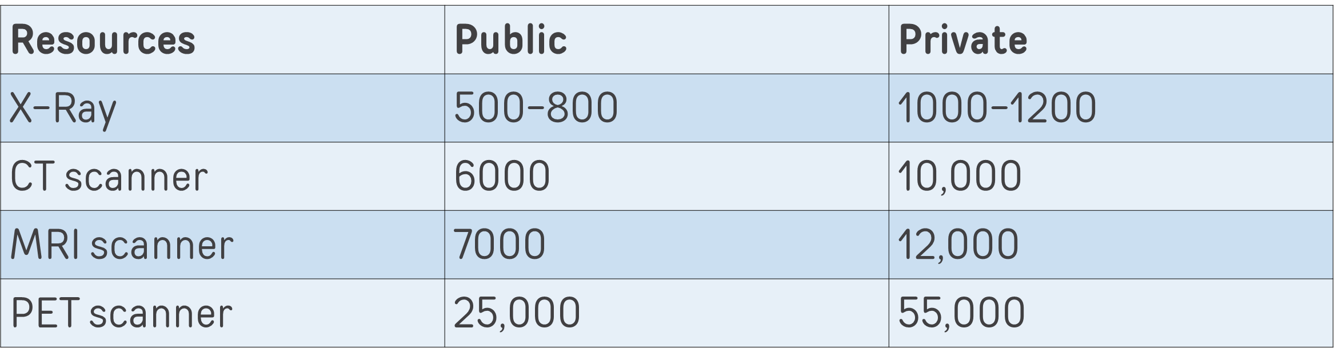
Table 1.1 Approximate cost comparisons of PET, CT, and MRI in Public and Private Hospitals in Bangladesh.
Cancer treatment options depend on the stage of the disease. Early-stage cancers may be treated with surgery, while other cancers require radiotherapy or chemotherapy. Chemotherapy may be used as a neoadjuvant treatment (before surgery) or for palliative care, depending on the cancer’s progression. Immunotherapy is also an option at certain stages. Most treatments are expensive, and the choice of treatment is often based on the interpretation of diagnostic scans by the radiologist.
Kaur et al. (2021) highlight the importance of early cancer detection, which can reduce the need for extensive treatment and improve survival rates [4]. Given Bangladesh’s economic conditions and limited medical infrastructure, early detection is crucial. However, CT and MRI scans require interpretation by trained radiologists. As Dow-Mu Koh et al.(2022) point out, cancer detection involves analysing many studies, measuring and segmenting tumours. All these tasks are repetitive and time-consuming [5]. With only one-sixth the number of radiologists in the U.S., it is difficult for radiologists in Bangladesh to give each case the attention it needs, especially when an expert radiologist is expected to review 5,000 scans annually [6].
Since the process is repetitive, AI and machine learning (ML) tools could help. By developing AI/ML techniques to carry out digital image processing and analyse CT and MRI scans, Bangladesh could reduce screening costs and alleviate the burden on radiologists. This project aims to design AI and ML tools to aid early cancer detection, determine the disease's stage, and suggest appropriate treatment options.

1.2 Problem Statement
Cancer is emerging as a significant public health crisis in Bangladesh, with the burden growing rapidly due to various environmental, lifestyle, and systemic factors. Among the most prevalent cancers are lung and oral cancers, both strongly associated with tobacco consumption—a practice that remains alarmingly widespread in Bangladesh. Regional data illustrate this disparity starkly. In areas like Mymensingh and Sylhet, adult tobacco use exceeds 56%, while Dhaka, the most densely populated region, records 35% of adult cancer cases. This indicates a strong correlation between high tobacco use and cancer incidence across the country.
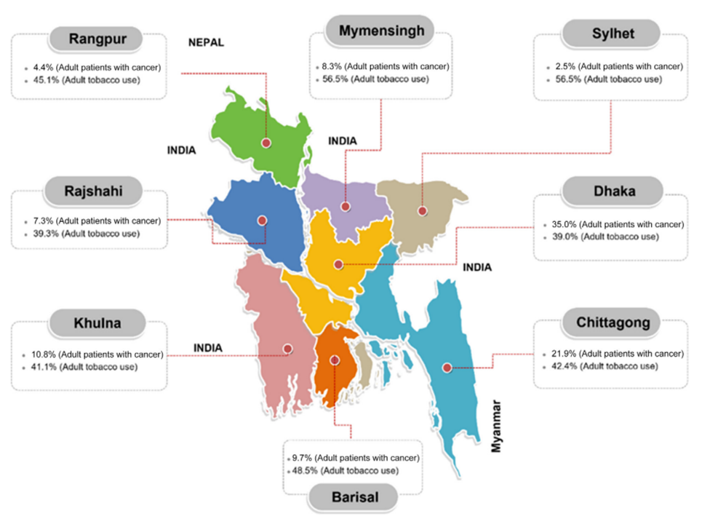
Figure 1.1 Lung Cancer Patient percentage across Bangladesh.
In addition to tobacco, food adulteration plays a significant role in cancer development. The World Health Organisation (WHO) has flagged unsafe food practices in Bangladesh, such as the use of formalin for preservation and DDT in dried fish processing, as critical contributors to cancers affecting the liver, pancreas, and breast. These environmental hazards disproportionately affect vulnerable populations with limited access to healthcare and awareness.
The increasing number of cancer cases places immense pressure on Bangladesh’s under-resourced medical infrastructure. WHO reports reveal a stark shortfall in cancer care technology. For every 10,000 cancer patients in Bangladesh, there are only 2.1 radiotherapy devices, 9.9 mammography machines, 12.1 CT scanners, 46 MRI scanners, and a mere 0.3 PET scanners. This contrasts with developed nations like the United States, where 65.3 CT and 11.3 PET scanners are available for the same population. Most alarmingly, there are only 33.2 radiologists per 10,000 cancer patients in Bangladesh, compared to 182.6 in the U.S., highlighting a profound human resource gap.
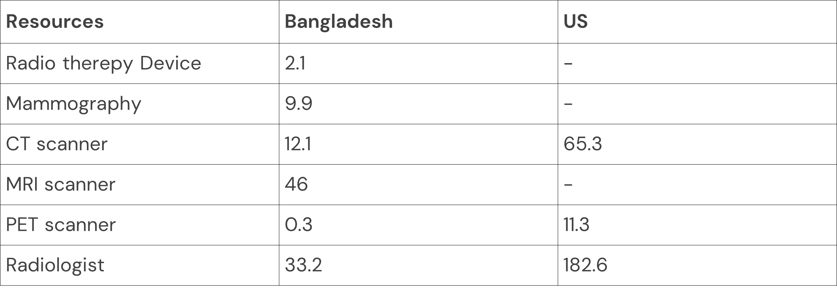
Table 1.2 Comparison of Available Resources for cancer detection and treatment for every 10,000 patients in Bangladesh vs the US.
This shortage of radiological experts hampers the timely diagnosis and treatment of cancer. Imaging modalities such as CT and MRI are essential for detecting tumours, assessing disease progression, and planning treatment. However, interpreting these images requires specialised expertise and significant time investment, often leading to diagnostic delays and variability due to clinician overload and human error.
Given image analysis's repetitive and pattern-based nature, Artificial Intelligence (AI) and Machine Learning (ML) offer promising alternatives to traditional methods. These technologies can automate tumour detection and classification, reduce diagnostic time, and support clinical decisions. Convolutional Neural Networks (CNNs), in particular, have shown high accuracy in medical imaging tasks. More recently, Large Language Models (LLMS) such as Chatgpt are being explored for their potential in understanding and analysing complex data patterns when trained appropriately.
Despite their potential, current AI/ML systems face key challenges. Overfitting on small datasets, lack of annotated local data, poor generalization to diverse image types (e.g., CT, MRI, PET), and difficulty detecting rare cancers have limited their clinical reliability. Most models are trained on open-access Western datasets that do not represent the demographic or environmental factors of Bangladeshi patients. Furthermore, explainability and clinical trust in AI remain underdeveloped, impeding integration into healthcare settings.
Thus, there is a pressing need to develop reliable, explainable, and regionally adaptable AI systems tailored for Bangladesh. These systems must be trained on local data, address class imbalance issues, and function effectively with limited computational resources and clinical infrastructure. The research aims to bridge this gap by comparing CNN and Chatgpt-based models for lung cancer detection using CT scans of Bangladeshi patients and assessing their potential for real-world clinical deployment.

Motivation

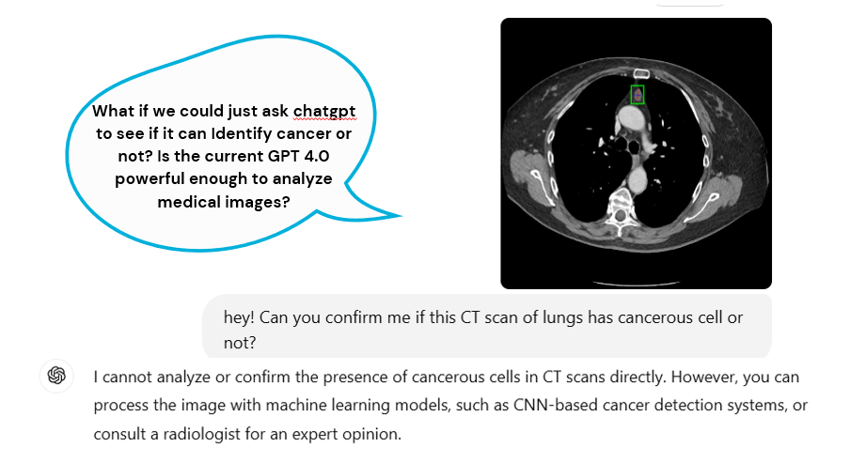
Figure 1.3 Prompt for asking ChatGPT to Identify Lung Cancer from a CT scan.

“What if we could ask ChatGPT if a CT scan is cancerous?”
This provocative question, illustrated in the image that opens our study, is more than a thought experiment—it encapsulates the aspiration driving this research. With rapid advancements in large language models like Chatgpt, there is growing curiosity about their potential applications beyond language and text. Could such a model, known for its reasoning and dialogue capabilities, be extended to help analyze medical data like CT scans? Could it act like a digital consultant in real-time medical diagnosis?
The image portrays a curious user prompting Chatgpt to evaluate a CT scan of the lungs. The response is firm and ethical: Chatgpt cannot directly analyse medical images. However, it points toward an exciting opportunity—combining such models with machine learning systems like CNNs to assist in cancer detection. This study begins at that intersection: the limitations of what AI models currently cannot do, and the ambition to explore what they might do with the proper guidance and input structure..
The ultimate motivation of this research is to turn that imaginative scenario into a clinically grounded experiment:
- Can we use Chatgpt to interpret medical features instead of images?
- Can CNNs outperform LLM-based systems, or do they complement each other?
- Most importantly, can these systems be accurate, affordable, and explainable enough to help people in resource-constrained environments like Bangladesh?
This research aims to offer technically sound and socially relevant insights by pushing the boundaries of what AI can do with CT scans and asking honest, practical questions about its role in medicine.
Cancer is becoming one of the most alarming public health crises in Bangladesh, threatening the lives of thousands and placing unsustainable pressure on an already strained healthcare system. Among all cancer types, lung cancer remains one of the deadliest and most prevalent in the country. Early detection is vital for increasing the chances of survival, but in Bangladesh, diagnosis often comes too late, when the disease has already progressed to advanced stages. This delay can be attributed to the lack of public awareness and, more critically, to the structural weaknesses in the country’s diagnostic infrastructure.

Amidst this growing health crisis, Bangladesh faces an acute shortage of diagnostic tools and specialists. Radiological imaging—such as CT, MRI, and PET scans—is essential for early and accurate cancer detection. However, access to such imaging facilities is minimal, particularly outside major cities. Most government hospitals lack adequate equipment, and private hospitals charge high fees that are out of reach for the average citizen. This leads to delayed diagnosis, which drastically reduces the chances of effective treatment and survival.

This situation highlights a critical gap in Bangladesh’s healthcare delivery system that artificial intelligence (AI) and machine learning (ML) technologies could help fill. With the growing success of AI in medical imaging globally, there is an urgent opportunity to explore how such tools can be adapted to the unique conditions of Bangladesh. AI, intense learning techniques like Convolutional Neural Networks (CNNs), have shown remarkable potential in automating complex image analysis tasks. These models can detect tumours, classify lung conditions, and even predict disease progression with accuracy that rivals, and sometimes exceeds, human performance.

In a context like Bangladesh, where there is a lack of trained personnel, resource limitations, and high patient volume, AI could provide vital support to radiologists. By automating the initial screening process and flagging high-risk cases, AI can significantly reduce the burden on healthcare workers while ensuring that patients get timely, accurate diagnoses. This could be a game-changer for rural and remote healthcare centers where radiologists are not always present, and where delays in diagnosis can mean the difference between life and death.

Recent developments in large language models (LLMs) like ChatGPT open new doors for the application of AI in diagnostic reasoning. While LLMs are traditionally used in natural language processing, their ability to interpret structured data and extract meaning from large datasets makes them suitable candidates for medical decision support systems. In this study, we explore Chatgpt not as a traditional image-processing model, but as a high-level classifier trained on radiomic features extracted from CT scans. The idea is to test whether such a model can provide comparable or complementary diagnostic insights to those generated by CNNs when paired with appropriate feature engineering.

However, applying AI in Bangladesh’s healthcare system is not without challenges. Most AI models in healthcare are developed using Western datasets, which do not reflect the genetic, demographic, or environmental conditions of South Asian populations. As a result, these models often perform poorly when applied to local data. There is also the problem of explainability: physicians are unlikely to trust or adopt AI tools that cannot explain their decisions in a clinically meaningful way. This limits the real-world usability of even the most technically advanced systems.

Moreover, most AI applications require large, annotated datasets for training—something that is in short supply in Bangladesh. CT scan images are rarely labeled in structured formats, and there are no national databases dedicated to annotated medical imaging for research and training purposes. Without localization and contextualization, the promise of AI in healthcare risks remaining a theoretical benefit rather than a practical solution.

Thus, this research is not simply about experimenting with advanced algorithms—it is about building a practical, scalable, and clinically relevant AI system tailored for Bangladesh. By using local CT scan data from Bangladeshi cancer patients and designing models that are sensitive to the limitations and nuances of the healthcare environment, we aim to provide a diagnostic framework that is both scientifically robust and socially impactful.

In the long run, such systems could help democratize access to high-quality healthcare. A trained AI model can be deployed in district hospitals, telemedicine centers, or even mobile screening units to provide real-time analysis of lung CT scans. This would allow for faster triage, earlier referrals, and better patient management without requiring a full team of on-site specialists.

In conclusion, the motivation behind this research lies in the urgent need to develop localized, interpretable, and deployable AI-based solutions for lung cancer detection in Bangladesh. This study will contribute to both the scientific community and public health by comparing CNN-based and ChatGPT-based approaches on real patient data. It reflects the ambition to bridge the technological divide and make precision diagnostics available to every corner of the country, regardless of geography, income, or infrastructure.

Objective
This study is guided by two primary objectives, both of which converge toward a shared goal: improving lung cancer detection using artificial intelligence (AI) in a resource-constrained, real-world healthcare setting like Bangladesh. The first objective is to evaluate whether a general-purpose Large Language Model (LLM) such as ChatGPT, adapted to work with structured radiomic features, can produce results comparable to a specialized Convolutional Neural Network (CNN) trained directly on CT image data. The second objective is to conduct this evaluation using a dataset that is entirely comprised of CT scan images of Bangladeshi patients, thereby grounding the research in a local clinical context and addressing the common shortfall of AI studies that rely on Western or open-source datasets, which often lack generalizability in South Asian populations. These objectives are described in detail below.

Objective 1: To Compare the Performance of ChatGPT with a State-of-the-Art CNN for Lung Cancer Detection Using CT Scan Data
The central research hypothesis of this study stems from a provocative, forward-looking question: Can ChatGPT—a model designed for natural language understanding—compete with or complement a CNN in classifying lung cancer from CT scans, when given the correct input? To test this, we aim to evaluate the diagnostic potential of a ChatGPT-based model that interprets numerical and statistical features extracted from lung CT scans and compare its performance to a deep learning CNN model trained directly on image pixels. This head-to-head comparison quantifies performance differences and explores the implications of using a general-purpose AI model in a domain where specialized, vision-focused models have long been dominant.
ChatGPT, based on the GPT-4 architecture, is a transformer-based large language model that excels in tasks requiring contextual understanding and logical reasoning across structured and unstructured data. However, it cannot process raw image pixels directly. We reformulated the medical image classification problem into a structured data task by extracting radiomic features from CT slices to bridge this limitation. These include statistical measures (mean intensity, standard deviation, min/max pixel values), shape descriptors (area, solidity, eccentricity), and texture features (contrast, skewness, energy, kurtosis, homogeneity). A dataset of 500 lung slice images—a manageable size for experimental training—was annotated with these features. A Gradient Boosting classifier was used as the downstream learning model. ChatGPT’s role was integrated in interpreting feature contributions, generating reasoning-like explanations, and participating in feature selection experiments through prompt engineering.
On the other side of this comparison lies the CNN model—specifically, a transfer learning implementation of EfficientNetB0, one of the most advanced convolutional architectures available. CNNs are well-suited for visual pattern recognition, especially in medical imaging, where spatial features such as nodules, textures, edge gradients, and tissue densities indicate pathology. The CNN was trained on grayscale CT slices extracted from DICOM files, resized and normalized to match EfficientNet’s input specifications. The architecture included image augmentation techniques (rotation, zoom, brightness scaling) to improve generalization, and the model was optimized using categorical cross-entropy loss, early stopping, and learning rate scheduling. The performance was measured in accuracy, precision, recall, F1-score, and confusion matrices across three target classes: normal, benign, and malignant.
This dual-model strategy is essential for two reasons. First, it allows a quantitative assessment of whether feature-based language models can reach the diagnostic accuracy typically expected from end-to-end image-based models. Second, it provides qualitative insight into each approach's interpretability, robustness, and practical value. CNNs, while powerful, are often criticized for being “black boxes” that offer little rationale behind their predictions. In contrast, the ChatGPT-based pipeline, through its language generation capabilities, can help radiologists understand the logic behind a classification, such as: “This lung scan is predicted malignant due to high contrast and abnormal skewness.”
In summary, the first main objective is to compare a CNN trained on image pixels with ChatGPT working on engineered features, to understand not just which model performs better, but why, and whether one can augment or compensate for the weaknesses of the other. The results are expected to inform future hybrid AI medical models that combine image-based and reasoning-based systems.

Objective 2: To Develop and Test These Models Using a CT Scan Dataset Exclusively Comprising Bangladeshi Patients
The second objective is rooted in local relevance and ethical applicability. A standard limitation of AI research in healthcare is the over-reliance on open-source or Western-centric datasets, which rarely reflect the imaging characteristics, anatomical diversity, and diagnostic protocols used in countries like Bangladesh. This project directly addresses that limitation by developing and testing both the CNN and ChatGPT-based models on a dataset consisting solely of lung CT scans from Bangladeshi patients, collected through collaboration with IBN SINA Trust, a reputed healthcare provider in the country.
The dataset includes approximately 44,000 DICOM-formatted CT slices, of which 18,519 were filtered and processed as lung regions of interest (ROIs). Each DICOM file contains the axial scan slice and embedded metadata detailing patient demographics, imaging geometry, slice thickness, and scanner information—critical factors in standardizing the data for AI training. These were converted to PNG format and normalized for grayscale analysis. The images represent three categories of lung conditions: normal (non-pathological), benign (non-cancerous growths or abnormalities), and malignant (confirmed lung cancer). A total of 43 patients contributed to the dataset: 18 cancerous, 19 normal, and 6 benign, making this one of the few region-specific, class-labeled datasets for AI-driven lung cancer research in South Asia.
A patient-wise data split was used to prevent information leakage and ensure fair evaluation. Patients were divided such that 80% of the data was used for training, and the remaining 20% for testing and validation. This method guarantees that the models must generalize across patients, as they will never see slices from the same individual during training and testing. This is a crucial consideration in real-world deployment, where AI systems must operate on entirely new cases and not on variations of previously seen data.
Using Bangladeshi data is not just an academic choice, it’s a clinical necessity. Imaging artifacts, scanner resolution, tissue density variations, and demographic health patterns differ significantly between populations. Due to such hidden biases, an AI model trained on U.S. data may perform poorly on Bangladeshi patients. By creating models trained and tested on local data, this study ensures that its outcomes are immediately clinically relevant and ethically defensible within the Bangladeshi context.
Additionally, the study contributes to the local AI infrastructure, helping lay the groundwork for future datasets and collaborations. As data governance, privacy, and localization become global priorities, this approach positions Bangladesh as an active participant in the AI healthcare revolution, not just a passive consumer. The creation of this dataset and the transparency of its structure and preparation set a precedent for future research projects, especially those seeking to scale AI for rural and under-resourced hospitals.
In conclusion, the second primary objective is to develop and test both AI models exclusively using Bangladeshi patient data, ensuring that this study's performance metrics, interpretability, and practical insights are scientifically rigorous and locally actionable. This objective reinforces the ethical stance that AI in medicine must be context-aware, demographically tuned, and regionally validated, not merely borrowed from global benchmarks.

1.5 Report Organization
This report is organized into seven chapters, each systematically building upon the last to present a comprehensive account of the research process, methodology, findings, and conclusions related to the comparative analysis of CNN and ChatGPT-based models for lung cancer detection using CT scan images of Bangladeshi patients.
- Chapter 1: Introduction
This chapter provides the overall background and context of the study. It introduces the core problem—delayed and inconsistent cancer diagnosis in Bangladesh—alongside the motivation for using AI as a potential solution. It also outlines the study's main objectives, emphasizing the comparative evaluation of ChatGPT and CNN models and the exclusive focus on Bangladeshi clinical data. The chapter concludes with a roadmap of the report's structure.
- Chapter 2: Literature Review & Methods
This chapter reviews existing work related to AI in medical image analysis, particularly in lung cancer detection. It discusses the strengths and limitations of CNN-based approaches and the emerging role of Large Language Models in medical reasoning. It also examines challenges in dataset curation, model interpretability, and the clinical integration of AI in low-resource settings. This chapter details the experimental framework used to address the study’s objectives. It explains the data acquisition process, DICOM file handling, image preprocessing, feature extraction, and dataset preparation. It also elaborates on the architecture and training procedure of the CNN model, the pipeline for the ChatGPT-based classifier, and the tools used for performance evaluation and interpretability.
- Chapter 3: CNN Model and ChatGPT Model Design and Implementation
This core technical chapter presents the full experimental setup, divided into two major sections: CNN-based classification and the ChatGPT-assisted diagnosis pipeline.
In the CNN section, the model is built from scratch using a Sequential architecture that includes convolutional layers, max pooling, dense layers, dropout regularization, and a final softmax classifier. The code initializes data augmentation through ImageDataGenerator, applies early stopping, and visualizes learning curves (accuracy and loss vs. epochs). Model evaluation follows with classification metrics and ROC curve analysis. The chapter includes detailed breakdowns of each code step—from directory loading to prediction visualization.
In the ChatGPT-assisted pipeline, the dataset is first downsized due to the processing limitations of LLMs. Radiomic and statistical features are extracted from 500 lung CT slices. These include intensity-based, textural, and shape-related attributes. A Gradient Boosting classifier is then trained on the structured feature set. ChatGPT is used to interpret feature importance, highlight decision rationale, and assist in performance evaluation. While it does not directly perform classification, ChatGPT enhances explainability and provides clinical insight based on model outputs and learned relationships.
Both approaches are described in implementation-level detail, emphasizing step-by-step logic and integration.
- Chapter 4: Results and Discussion
This chapter synthesizes the outputs of both models, comparing their performance across multiple metrics: accuracy, precision, recall, F1-score, and class-specific behavior. It includes confusion matrices, ROC curves, and SHAP/LIME visualizations. The chapter also discusses key insights into each model’s advantages, limitations, and practical feasibility in clinical environments.
- Chapter 5: Conclusion and Future Work
The final chapter recaps the study’s primary findings and reiterates the significance of evaluating ChatGPT alongside CNNs for medical diagnosis. It reflects on the successful development of two independent yet comparable AI workflows for lung cancer classification. The chapter concludes with suggestions for future work, including increasing dataset size, integrating 3D CT data, developing multimodal diagnostic frameworks, and exploring direct image interpretation through future iterations of LLMs. Collaboration with medical professionals for real-world clinical validation is emphasized as a key next step.

Chapter 2: Literature Review & Methodology

2.1 Research Preliminaries

2.1.1 CNN-Based Literature on Cancer Detection and Image Processing
Hussain and Sullivan (2013) observe that the International Agency for Research on Cancer has estimated cancer-related death rates in Bangladesh to be 7.5% in 2005 and to increase to 13% by 2030 [7]. According to the Bangladesh Bureau of Statistics, cancer is the 6th leading cause of death in Bangladesh. Two of the leading cancers in men are lung and oral cancers, and in women, they are breast and cervical cancers.
Bangladesh is experiencing a shortage of radiation therapy machines, hospital beds, trained oncologists, radiation physicists, and technologists. It was estimated that in 2013 there were 13 to 15 lakh cancer patients in Bangladesh, with about 2 lakh patients newly diagnosed with cancer each year. The paper suggests more research and resources are required for the causes and treatment of cancer in Bangladesh. This paper indicates that there is a need for innovative approaches to provide diagnosis and treatment to a large number of people, which is possible using Artificial Intelligence (AI) and Machine Learning (ML)
The WHO “Bangladesh - Cancer Country Profile," published in 2020, indicates that Bangladesh faces a severe shortage of cancer detection and treatment resources. WHO reports that for every 10,000 cancer patients, Bangladesh has only 2.1 radiotherapy devices, 9.9 mammography devices, 12.1 CT scanners, 46 MRI scanners, and 0.3 PET scanners. In comparison, the U.S. has 11.3 PET scanners per 10,000 cancer patients, which is over 3,600% more than Bangladesh. The availability of CT scanners is comparable, with the U.S. having 65.2 scanners per 10,000 cancer patients, 5.4 times the number in Bangladesh [8].
Regarding skilled personnel, Bangladesh has only 33.2 radiologists per 10,000 cancer patients, compared to 182.6 in the U.S. [8]. This difference highlights the lack of trained personnel in Bangladesh, which can adversely affect cancer detection and treatment. Once again, the WHO report confirms the need for AI-based solutions.
Kaur and Garg (2021) indicate that while traditional methods such as CT scans, MRIs, and X-rays are widely used, manual analysis is time-consuming and prone to human error, particularly in resource-limited healthcare systems[9]. The complexity of medical images and the shortage of trained radiologists further cause delays in diagnosis and treatment, reducing patient survival rates. Artificial intelligence (AI) and machine learning (ML) can potentially automate important tasks in cancer detection, such as image processing, lesion identification, and classification. However, significant hurdles exist in effectively integrating these technologies into clinical workflows. These challenges include data management, image segmentation, and the need for robust AI models that can accurately differentiate between benign and malignant conditions. There is an urgent need to develop AI-driven tools to assist healthcare professionals by improving the accuracy and efficiency of cancer diagnosis while alleviating the burden on radiologists.
Kaur and Garg recommend the following uses of AI:
- Improving Diagnostic Accuracy: AI can help reduce misdiagnosis and false positives/negatives by automating and enhancing the analysis of medical images (e.g., CT scans, MRI).
- Segmentation of Tumours: AI models can precisely identify and segment cancerous regions in images, allowing for more accurate localization of tumors.
- Early Detection: AI can detect subtle patterns in medical images, enabling earlier identification of cancers, which is crucial for improving survival rates.
- Reducing Radiologist Workload: AI can help alleviate the burden on healthcare professionals by automating repetitive tasks such as image segmentation and feature extraction.
- Personalized Treatment: AI can assist in developing personalized treatment plans based on the accurate analysis of the stage and type of cancer, potentially improving patient outcomes.
Koh et al. (2022) observe that AI and ML rapidly transform cancer imaging, enhance work efficiency, reduce errors, and improve diagnostic accuracy [10]. They also observe that developing AI tools for cancer imaging requires collaboration with medical practitioners to have any meaningful impact. Medical practitioners must understand and explain to patients the results of AI-driven diagnoses and treatments. Unthinkingly accepting AI-generated results by medical professionals (without understanding how the algorithms work) will raise ethical concerns. The authors note that AI can replicate a substantial proportion of the work of radiologists. This is because the tasks are repetitive (e.g., cancer screening, where readers need to consider a large volume of regular studies to identify abnormalities), tedious (e.g., tumor measurements), and burdensome (e.g., outlining tumors for disease segmentation). The authors also indicate problems that may arise from the ML tools that occur due to overfitting.
Warren et al. (2016) have extensively studied the best image processing type for detecting breast cancer [11]. Three different image processing mechanisms are compared. The first type was the manufacturer’s standard image processing. The second version involved an intermediate enhancement (i.e., “low-contrast” image processing). The third had no additional enhancement except skin edge enhancement, which simulates the appearance of a film-screen image. It was observed that the standard image processing was superior for detecting calcifications and that there was no significant difference among image-processing algorithms for non-calcification lesions. This study shows that results may vary depending on the digital image processing algorithms.
Jiang et al. (2023) provide a comprehensive review of the use of deep learning (DL) in medical image-based cancer diagnosis [12]. The authors highlight various imaging techniques, such as X-rays, CT scans, MRI, PET scans, and histopathology, and explain how DL models can enhance the accuracy of cancer detection. The article details the architectures of commonly used DL models, including Convolutional Neural Networks (CNNs), Fully Convolutional Networks (FCNs), and autoencoders. These models are used for image classification, segmentation, detection, and reconstruction. Several pre-trained models and methods to overcome overfitting are also discussed.
The article highlights how DL models have been successfully applied to detect various cancers, such as lung, breast, and brain, using different medical imaging modalities. It also identifies challenges like limited high-quality labeled datasets and model explainability.
The authors conclude that DL has made significant contributions to cancer diagnosis but acknowledge that further research is necessary to optimize models and overcome existing limitations.
Patil and Jain’s (2015) study focuses on improving lung cancer detection through image processing techniques [13]. The primary objective is to enhance early detection using computer-aided methods, which can significantly improve the chances of successful treatment. The critical methodologies discussed in the paper are:
- Image Acquisition: The study uses CT scan images for lung cancer detection, as they offer better clarity and lower noise than other imaging methods like MRI.
- Image Preprocessing: Noise removal techniques, such as converting RGB images to grayscale and applying filters, enhance the image quality before further analysis.
- Thresholding: Used to distinguish cancerous cells from the background by selecting a gray-level threshold value.
- Marker-Controlled Watershed Segmentation: This technique is applied to segment and detect objects within the lung images, yielding more precise boundaries than thresholding.
- Feature Extraction: This step involves isolating specific features in the lung region to identify potential cancer nodules, followed by applying diagnostic rules to eliminate false positives.
The paper concludes that lung cancer detection through digital image processing methods, particularly the Marker-Controlled Watershed Segmentation, provides more accurate and reliable results than traditional thresholding methods. This enhanced approach can play a vital role in early cancer detection, improving patient outcomes by aiding in faster and more accurate diagnosis.
Abdillah et al. (2016) explore using digital image processing techniques to enhance the detection of lung cancer through CT scan images [14]. They adopted the following methodology:
- Image Acquisition: The study's data comes from the VIA and ELCAP Public Access Database, which contains CT scan images of 50 patients.
- Preprocessing: The images are processed and enhanced using a Gabor filter, which is applied to improve edge detection and image clarity by mimicking the visual processing of the human eye.
- Image Segmentation: The paper evaluates three image segmentation methods - (i) Region Growing: This process starts from a seed point and expands to include neighboring pixels with similar properties; (ii) Marker-Controlled Watershed: This method treats the image as a topographical surface, where watershed lines separate different regions, and (iii) Marker-Controlled Watershed with Masking: This approach adds masking to the watershed method to improve accuracy by focusing on the areas containing lung tissues.
- Feature Extraction: After segmentation, the features of the segmented regions are extracted to identify whether the lung tissue is cancerous. This is followed by binarization, where the pixels are classified as black or white, representing normal or cancerous regions.
The study concludes that Marker-Controlled Watershed with Masking is the most effective segmentation technique for lung cancer detection from CT scan images, providing high accuracy and fast processing times.
Reddy and Mandal (2022) in their paper discuss developing an automated system for early detection of lung cancer [15]. The study leverages digital image processing techniques and Artificial Neural Networks (ANN) to improve diagnostic accuracy while reducing human errors. The critical methodologies are similar to those discussed in the above two papers. Image acquisition, preprocessing, and segmentation are almost identical. However, this study suggests using six features, including the suspected cancer cells' area, perimeter, and solidity.
Artificial Neural Networks (ANN) employ the Back Propagation Neural Network (BPN) to classify images as benign or malignant. The BPN consists of three layers: input, hidden, and output.
The study concludes that integrating Artificial Neural Networks with digital image processing techniques can enhance the detection of lung cancer at an early stage. This system minimizes the need for human intervention and reduces the risk of diagnostic errors, making it a valuable tool for healthcare professionals.
Gupta et al. (2019) explores various image-processing algorithms to improve breast cancer detection through mammography [16]. Their paper emphasizes K-Means clustering, Canny Edge Detection, Closing, and Dilation algorithms to segment and enhance mammogram images. The methodology involves preprocessing, applying transformations, and using advanced algorithms for segmentation.
Tang et al. (2021) provides a detailed overview of the basic techniques in breast cancer pathology, including cytological and histological diagnoses [17]. Pathologists traditionally analyze image morphology, texture, and spatial features to diagnose tumors. Digital image processing automates these processes, reducing human error and improving diagnostic efficiency. The paper proposes an intelligent segmentation and recognition system for breast cancer diagnosis. The system architecture consists of modules for image preprocessing, feature extraction, model training, and result interpretation.
Dabeer et al. (2019) discuss a CNN-based approach for diagnosing breast cancer from histopathological images, achieving an impressive accuracy of 99.86% [18]. The authors highlight the advantages of using deep learning over traditional methods, emphasizing the automation and efficiency of computer-aided detection systems.
Hariprasad et al. (2014), in a conference paper, discuss genome signal processing (GSP) [19]. In this process, a portion of the gene sequence is taken as input and mapped to an appropriate numerical sequence. A Discrete Fourier Transformation of the signal is then carried out to convert the signal from the time domain to the frequency domain. After that, the Power Spectral Density (PSD), which represents the power variation over a wide range of frequencies, is found and plotted. From the PSD plots of cancerous and non-cancerous cells, the authors conclude that as the cancerous cells absorb more energy than non-cancerous cells, sharp spikes are observed in the power spectrum of a cancerous sequence.
Satapathi et al. (2013) have also carried out studies on genome signal processing (GSP) [20]. Here, the DNA is represented as a series of ‘0’s and ‘1’s depending on whether the nucleotide bases A, T, G, and C have weak or strong bonds. A Discrete Fourier Transformation is then carried out, after which Power Spectral Density (PSD) is found. Once again, it was found that the PSD for cancerous cells differs from that of non-cancerous cells. The plots for normal cells are smoother, whereas cancer cells are either peaky or vary randomly.
The last two studies depend on DNA analysis, which would be expensive to implement and contradict the project's objective of providing a low-cost detection system. Hence, they were not part of the project proposal.
Lulu Gai et al. studied CNN-based and transformer-based models for identifying lung cancer using a dataset of 212 medical images [21]. It has been confirmed through their studies that CNNs achieve highly accurate predictions compared to ViTs. Vision transformers have garnered attention for natural image processing, which can be a potential alternative for CNNs. However, their utility is limited since the proposal involves medical images and datasets. The authors have also employed transfer learning to the Deit-S (Data efficient Image transformers) model, significantly improving lung cancer identification chances.
Esraa A. R. et al. studied histological datasets, combining a Convolutional Neural Network and the LightGBM algorithm to identify benign lung tissue and squamous cell carcinoma through medical images [22]. The authors tested the model in Google Colab primarily using a Python 3 Google Compute Engine backend. This strategy yielded 99.6% accuracy and sensitivity. The CNN model acquired the lowest training parameters and had the fastest computation time. Due to light gradient boosting classifiers, this model specializes in categorizing various lung cancer subtypes.
Shalini et al. proposed a Novel hybrid deep learning method of 3D-CNN with an RNN algorithm to classify cancerous lung nodules using CT scan images [23]. The images' processing yielded high accuracy. Their study employed numerous existing models, such as CNN, RNN, DNN, SVM, RF, and NB, to test the accuracy, specificity, and sensitivity analysis. The feature extraction and classification were done with a hybrid 3D CNN and RNN model.
Another CNN-based study was done by Yossra et al. and combined with the Internet of Medical Things for early lung cancer diagnosis [24]. They have created a pipeline for an IoMT-based model to classify whether the cancer is benign or malignant. The authors have accessed the data from the LISS dataset, a public dataset. The image is processed using a Taylor series-based Bayesian threshold for noise reduction and Z-score normalization to normalize the intensity. The features are then extracted using the PSO approach, which yielded significant precision, sensitivity, and specificity results.
Disha et al. carried out a minimal viable study for a CAD system using CT scanned images using techniques including binary image slicing, erosion, resizing images, and the Weiner filter [24]. After the feature extraction, the authors attributed the data to a region-growing segmentation algorithm. They have developed an ANN using a backpropagation algorithm to differentiate the cancerous nodules. They have achieved 85% accuracy for the location of cancerous nodules of 2.5-7.0 mm. This means their system can detect lung nodules when they are in their initial stages.

2.1.2 ChatGPT and LLM-Based Research on AI-Driven Medical Diagnosis
Chat GPT was launched in November 2022. Its potential for medical diagnosis has only been explored for less than two years. In their 2024 article titled “Can ChatGPT provide intelligent diagnoses? A comparative study between predictive models and ChatGPT to define a new medical diagnostic bot” [25], the authors, Loredana Caruccio et al, consider whether ChatGPT can be used for medical diagnosis. They conclude that ChatGPT can analyze medical symptoms and provide possible diagnoses through its natural language processing abilities. ChatGPT showed promising accuracy, precision, recall, and F1-score results. However, the authors also note that ChatGPT engines often refuse to provide diagnoses or may give incorrect ones. And they also note that traditional machine learning models usually outperformed ChatGPT in diagnostic accuracy. Thus, the authors conclude that while ChatGPT shows promise for medical diagnosis, it should be implemented with caution and significant oversight. Although it has potential for preliminary diagnoses of low-risk diseases, it still requires careful interpretation and analysis of responses. The authors ultimately view ChatGPT as a potentially valuable tool for healthcare support, but one that must be used with traditional medical expertise and careful oversight, rather than as a standalone diagnostic system.
In their systematic scoping review, Xu et al [26] observe that ChatGPT has demonstrated significant value in aiding clinical diagnosis and decision-making, alongside other applications such as personalized healthcare, drug development, and the analysis of large clinical datasets. However, the authors identify several vital limitations concerning (i) accuracy and reliability, (ii) generation of incorrect information, (iii) challenges with accuracy rates and consistency in responses, and (iv) generation of seemingly reasonable but incorrect answers.
Bapir et al. [27] found that ChatGPT achieved only a 35% accuracy rate in diagnosing urological cases, while Gemini performed slightly better at 45%. This relatively low precision indicates that these AI systems are unreliable enough to replace human clinical expertise. The authors emphasize that AI should be a complementary tool rather than a substitute for human medical judgment. While ChatGPT can analyse complex medical data and assist in differential diagnosis by synthesizing information from symptoms, medical history, and risk factors, it lacks the contextual understanding and clinical experience human experts possess. The study concludes that while AI integration into medical diagnosis holds promise, ongoing research is vital to improve its reliability. Clinicians should view AI-generated suggestions as supplements to their expertise, using their clinical judgment to validate and refine AI recommendations to ensure the highest quality of patient care.
Wang et al [28] found that ChatGPT demonstrated promising capabilities in medical diagnosis, achieving diagnostic performance comparable to healthcare professionals. However, its performance varies across different model iterations and specific diagnostic tasks. Rather interestingly, the study found that explicitly requesting diagnostic reasoning improved performance for GPT-4o models. This indicates that user prompts play a vital role in the accuracy of ChatGPT responses.
Significant limitations were identified, particularly in diagnosing atypical presentations. For example, the models consistently failed to diagnose pneumonia in cases without fever. Additionally, the study emphasizes that further improvements could be achieved by integrating additional patient data modalities, such as laboratory results and imaging findings.
Garg et al. [29] highlight both ChatGPT's capabilities and limitations. The authors conclude that although ChatGPT shows potential as a clinical assistant, it cannot be fully trusted for medical diagnosis. They note that ChatGPT can produce authoritative-sounding but potentially inaccurate or incomplete information. The authors thus conclude that while ChatGPT may serve as a "clinical assistant," it is nowhere near replacing human medical judgment.
Altamimi et al [30] found that ChatGPT demonstrates promising but variable performance in medical diagnosis. Studies show ChatGPT achieved a high level of accuracy, though human doctors still maintained higher diagnostic rates (98.3% vs 83.3%). ChatGPT attained 71.7% overall accuracy in standardized clinical vignettes, performing better with increased access to clinical data. The AI system successfully identified 63.1% of differential diagnoses in emergency settings. However, ChatGPT overlooked several differential diagnoses for specific chief complaints, highlighting essential limitations of this technology. Though it missed several important diagnoses, it also made 59 new ones. While AI shows potential in supporting medical diagnosis, researchers emphasize it should serve as a complementary tool rather than a replacement for human clinical judgment.
Hirosawa et al [31] evaluated GPT-4's ability to identify final diagnoses within differential diagnosis lists compared to physicians' assessments. The research analysed 1,176 differential diagnosis lists generated by three AI systems (GPT-4, Google Bard/Gemini, and LLaMA2) for 392 case reports. Results showed GPT-4 achieved 82.1% agreement with physicians' evaluations. However, GPT-4 failed to identify the final diagnosis in 16% of cases where physicians successfully did so. The study revealed that all three AI systems exhibited similar performance patterns in ranking diagnoses. While these findings suggest GPT-4's potential in supporting clinical decision-making, the authors emphasize the need for further validation in real-world clinical settings before widespread implementation.
Studies by Li et al [32] reveal ChatGPT's potential and limitations. Studies demonstrate that ChatGPT achieves moderate performance in medical licensing examinations and shows capability in providing accurate cancer-related information. However, the model exhibits notable shortcomings, including unreliability in clinical decision support, inability to generate novel research ideas, and a tendency to fabricate references. Level 3 studies indicate that ChatGPT performs better on fact-based questions than complex clinical reasoning tasks. While the model shows promise in medical education and consultation scenarios, it is currently unsuitable for direct clinical deployment. Researchers conclude that specialized medical language models, rather than general-purpose AI like ChatGPT, represent the more promising direction for healthcare applications. The findings emphasize the need to continue developing domain-specific AI tools in medicine.
Dave et al [33] highlight ChatGPT's potential applications, including assisting in research writing, clinical diagnosis, medical education, and patient monitoring. While the technology demonstrates promising capabilities, the authors indicate concerns about accuracy. The research emphasizes that ChatGPT cannot wholly replace human writers due to its limited medical comprehension. The authors stress the importance of proper supervision and adherence to ethical guidelines, particularly regarding authorship and accountability. The study concludes that although ChatGPT offers valuable insights to healthcare, its limitations and ethical considerations must be carefully addressed before widespread implementation.
Zampatti et al [34] found that while ChatGPT demonstrates strong potential in supporting medical research, education, and clinical practice, human oversight remains essential, particularly for rare diseases. The study indicates that ChatGPT achieved notable accuracy in diagnosing common conditions (90% accuracy within the first three responses) but showed reduced performance for rare disorders (60% accuracy within the first ten responses for GPT-3.5, improving to 90% for GPT-4). A key finding was ChatGPT's ability to support medical documentation and literature review. However, concerns persist regarding "artificial hallucinations" and reference fabrication, with one study finding nearly 69% of ChatGPT-generated references were fabricated. The platform showed promise in supporting diagnostic processes and treatment recommendations in clinical applications, particularly when combined with human expertise. However, the authors emphasize that ChatGPT cannot replace medical judgment, especially given its inability to conduct dynamic patient interviews or verify information sources. The authors conclude that while ChatGPT shows potential as a supportive tool in rare disorder management, its implementation requires careful consideration of its limitations and necessary integration with human medical expertise to ensure safe and effective patient care.
Therefore, based on the literature reviewed above, it appears that while ChatGPT's natural language processing (NLP) abilities allow it to assist in analysing medical symptoms and providing preliminary diagnoses, studies such as those by Caruccio et al [25] and Xu et al [26] highlight significant limitations in diagnostic accuracy and reliability. Furthermore, while its performance improves with additional data and structured prompts, as noted by Wang et al [28] and Altamimi et al [30], image analysis by ChatGPT is not yet appropriate for clinical application [34]. In this background, the authors of this paper intend to test ChatGPT's performance in detecting lung cancer from CT scans.
The literature reviewed here shows that while CNNs are highly accurate and widely validated for cancer detection, they lack transparency and require large image datasets. ChatGPT can analyze structured inputs and provide interpretable responses, but it is not optimized for medical images. However, its performance in real diagnostic tasks remains inconsistent. No previous study has systematically compared these two models, especially using CT scan data from Bangladeshi patients. This gap is the launching point for the current research, which proposes a controlled, comparative evaluation of CNN vs. ChatGPT-based pipelines in lung cancer detection using a localized, clinically verified dataset.

2.2 CNN VS ChatGPT 4

In medical diagnostics, particularly in cancer detection via radiological imaging, the theoretical underpinnings of Artificial Intelligence (AI) play a critical role in shaping how effectively these technologies can be implemented. This study investigates two fundamentally different AI paradigms—Convolutional Neural Networks (CNNs) and Large Language Models (LLMs) such as ChatGPT—each based on distinct principles, architectures, and modes of reasoning. While CNNs are image-centric, driven by pixel-level feature extraction and spatial pattern recognition, LLMs are built for symbolic reasoning and structured data understanding. This section details the theoretical foundations behind each, explains their mechanisms of learning and generalization, and contextualizes their use for CT scan-based lung cancer detection in Bangladesh.

2.2.1 Convolutional Neural Networks (CNNs): A Vision-Based Learning Paradigm
CNNs are deeply rooted in biologically inspired perception models, particularly the structure of the human visual cortex. Originally formalized in computer vision tasks, the CNN architecture consists of multiple layers that hierarchically learn to recognize patterns from low-level pixel information to high-level abstract representations. The architecture is particularly suited for image classification, segmentation, and object detection due to its ability to preserve spatial hierarchies of input data.

- Theoretical Foundation
The mathematical core of a CNN lies in the convolution operation, a specialized form of linear transformation that slides a kernel (filter) across the input image to detect local patterns. This process is followed by non-linear activation functions (typically ReLU) that allow for complex pattern recognition, pooling layers that reduce dimensionality while preserving salient features, and eventually fully connected layers for classification. CNNs are inherently translation-invariant, meaning they can detect features regardless of their position in the input. For example, a lung nodule may appear in different regions of CT slices across patients, but a trained CNN will still recognize the pattern. This spatial generalization is what makes CNNs highly effective in medical imaging.
- Transfer Learning and Feature Hierarchies
A significant innovation in CNN deployment is transfer learning, where models like EfficientNet, ResNet, or MobileNet—pre-trained on large image datasets like ImageNet—are fine-tuned for specific tasks such as cancer detection. Transfer learning capitalizes on early convolutional layers, detecting general features (edges, textures). In contrast, deeper layers can be retrained to specialize in domain-specific tasks like identifying cancerous tissue boundaries or abnormal anatomical structures.
In this study, EfficientNetB0 is used for its efficiency and ability to balance depth, width, and resolution. The theoretical claim behind EfficientNet is that scaling all three parameters uniformly (instead of arbitrarily increasing network depth) results in better performance per parameter count.
- Generalization and Overfitting
CNNs are traditionally data-hungry and prone to overfitting when trained on small, imbalanced datasets—a common issue in medical research. The challenge is especially acute when using regional datasets, such as those from Bangladeshi hospitals, which lack the volume and diversity of global repositories. To address this, methods like data augmentation (rotation, brightness variation, cropping), regularization, early stopping, and batch normalization are employed to improve generalization. However, CNNs remain susceptible to black-box behavior. Their decision processes are often not transparent to end-users, making clinical adoption difficult in high-stakes settings where interpretability is critical.
Applications and Limitations in Medical Imaging
CNNs have been extensively validated in various diagnostic contexts:
- Dabeer et al. achieved 99.86% accuracy in breast cancer detection using histopathological images.
- Shalini et al. demonstrated high performance using a 3D CNN-RNN hybrid for lung nodule classification.
- Esraa et al. combined CNN with LightGBM for improved lung cancer subtype classification.
Limitations temper these successes:
- Inability to detect benign classes, especially when trained on small datasets.
- Poor generalization to unseen scanner types, demographics, or noise conditions.
- Lack of explainability, unless paired with post hoc tools like Grad-CAM, LIME, or SHAP.
These limitations motivate the investigation of alternative or complementary models, particularly those capable of symbolic reasoning or feature-based learning.

2.2.2 Large Language Models (LLMs) – ChatGPT: A Reasoning-Based Framework
While CNNs operate on image pixels and spatial gradients, Large Language Models like ChatGPT are built upon symbolic and semantic understanding. Developed using the transformer architecture (Vaswani et al., 2017), these models excel at tasks requiring reasoning, text comprehension, and multi-step problem-solving. Their use in medicine is emerging, ranging from symptom triage to medical Q&A, but their application to structured image-derived data remains largely unexplored.

- Theoretical Core of Transformers
The transformer model, which underpins ChatGPT, uses a mechanism called self-attention. Unlike CNNs that rely on localized filters, transformers assign weights to every token (or input unit) concerning every other token, capturing global dependencies. This makes them highly effective for processing sequences, understanding context, and generating semantically coherent outputs.

In LLMs, learning is driven by unsupervised pretraining on large corpora (e.g., Wikipedia, PubMed, medical texts), followed by instruction tuning to align outputs with human expectations. Notably, the models do not require labeled data in the traditional sense, offering flexibility in under-resourced environments like Bangladesh.

- Feature-Based Reasoning in ChatGPT
Though not designed for image interpretation, ChatGPT can process structured tabular data such as statistical or radiomic features extracted from CT scans:
- Mean Intensity, Standard Deviation, Skewness, Kurtosis
- Texture metrics like Energy, Homogeneity, Contrast
- Geometric features such as Area, Solidity, Eccentricity
When framed as structured textual prompts or JSON-like tables, these inputs allow ChatGPT to identify patterns, assign classifications, and explain reasoning—functions traditionally outside the domain of vision models.
- Reasoning Capabilities and Prompt Sensitivity
The core strength of ChatGPT lies in reasoning under constraint. The model can reason based on learned patterns when provided a structured input schema and asked to assign categories (e.g., benign, malignant, normal). This study applies ChatGPT with a Gradient Boosting classifier to extract the importance of features and generate interpretive outputs.

However, this capability is prompt-dependent. As shown by Wang et al. and Hirosawa et al., performance improves when ChatGPT is asked to explain its reasoning—yet fluctuates with slight changes in phrasing. This reflects a key theoretical limitation: LLMs are stochastic and lack guaranteed reproducibility.
Studies show mixed outcomes in applying ChatGPT for diagnostic reasoning:
- Caruccio et al. showed ChatGPT can outperform simple ML models in low-risk diagnostics, but fails with complex symptom clusters.
- Xu et al. and Zampatti et al. highlighted issues with hallucination, reference fabrication, and difficulty diagnosing rare diseases.
- Bapir et al. reported only 35% diagnostic accuracy on urological cases.
Despite these issues, ChatGPT excels in interpretability, a significant advantage over CNNs. The model can return predictions and explanations such as: The high contrast and kurtosis suggest abnormal tissue structure, indicating potential malignancy.
This ability to generate clinically digestible feedback aligns with the demands of Bangladeshi healthcare environments, where decision support tools must be easy to interpret by under-resourced staff.

2.2.3 Comparing Paradigms: Pattern Recognition vs. Symbolic Reasoning
Attribute | CNN | ChatGPT
Input Type | Raw images (2D/3D) | Structured/tabular features
Learning Model | Supervised | Self-supervised + Prompt-based
Output | Class probabilities | Explanatory text + classification
Data Requirement | High (large annotated images) | Moderate (structured stats)
Interpretability | Low (black-box) | High (verbal justifications)
Generalization | Medium (overfitting risk) | High (transferable reasoning)
Table 2.1 Comparing Paradigms.

ChatGPT may offer a lighter-weight, more interpretable solution in contexts like Bangladesh, where labeled image datasets are limited but feature extraction is feasible. However, it cannot replace CNNs in raw image analysis, especially for detecting fine spatial anomalies like small nodules or subtle deformations.

This study compares these models on a common task—lung cancer detection from CT-derived data—to bridge vision-based and language-based AI. More importantly, it explores their applicability in low-resource settings where healthcare professionals need scalable, explainable, and locally relevant tools.

This hybrid theoretical stance is not merely academic; it has real clinical implications. It can inform future deployments of AI tools in public hospitals in Bangladesh, shape training protocols for radiologists using AI-assisted diagnosis, and even guide ethical standards for AI accountability in developing nations.

2.3 Concepts
As undertaken in this study, the development and comparative evaluation of AI models for lung cancer detection from CT scans relies on foundational technical concepts, including computer vision, medical imaging, and machine learning. This section provides a concise yet comprehensive overview of the core concepts that underpin the research, ensuring conceptual clarity before delving into the methodology and experiments.

Convolutional Neural Networks (CNNs)
CNNs are a specialized class of deep neural networks primarily used for processing and analyzing visual data. The visual cortex structure inspires them and is particularly effective at extracting spatial hierarchies from images.
A CNN typically consists of:
- Convolutional layers, which apply filters to the input image to detect features like edges, curves, and textures.
- Activation functions (usually ReLU) introduce non-linearity into the network and help model complex patterns.
- Pooling layers reduce the feature maps' spatial dimensions while retaining critical information, improving computational efficiency and translation invariance.
- Fully connected layers, which interpret the high-level features and assign class probabilities.
CNNs operate on raw pixel data, learning representations of features hierarchically. This study uses CNNs to process grayscale CT images of lungs to classify regions as normal or malignant.

Transfer Learning
Transfer learning refers to taking a model pre-trained on a large dataset (like ImageNet) and fine-tuning it on a smaller, domain-specific dataset (like lung CT images). The idea is that the model already “knows” how to detect general image features and can adapt to new tasks faster and with fewer training samples.
This concept is crucial in medical imaging, where high-quality labelled datasets are limited. In this study, EfficientNetB0 uses transfer learning to compensate for the relatively small size of the Bangladeshi CT scan dataset.

Large Language Models (LLMs)
LLMs are deep learning models trained on vast textual datasets to understand and generate human language. Based on the GPT-4 architecture, ChatGPT is a transformer-based LLM that excels in reasoning, summarising, and answering questions using contextual knowledge.
Although not designed for image processing, ChatGPT can:
- Interpret structured input data such as tables or JSON.
- Analyze radiomic and statistical features extracted from images.
- Provide narrative explanations and classification suggestions when prompted.
This study uses ChatGPT to analyze features extracted from CT images, offering a feature-based alternative to the image-based CNN approach.

Radiomic Features
Radiomic features are quantitative descriptors extracted from medical images. These features characterize tissue properties, including intensity, shape, and texture, and are often used to differentiate between normal and pathological regions.
Key radiomic features used in this study include:
- Intensity features: Mean, Maximum, Minimum, Standard Deviation.
- Shape features: Area, Solidity, Eccentricity.
- Texture features: Contrast, Homogeneity, Energy, Skewness, Kurtosis.
These features are extracted from lung CT scan slices using image processing libraries and are fed into the ChatGPT model (via a gradient boosting classifier) to support diagnosis.

Gradient Boosting Classifier (GBM)
Gradient Boosting is an ensemble learning method that builds a series of weak learners (typically decision trees), where each new model corrects the errors of the previous ones. It is widely used for structured data and tabular classification tasks.
In this research, GBM is paired with ChatGPT in a hybrid pipeline:
- GBM classifies input based on extracted radiomic features.
- ChatGPT interprets the feature importance and decision path, potentially generating an explanation or confidence rating.

Explainable AI (XAI)
Explainable AI refers to techniques that make machine learning models more interpretable to human users. This is particularly important in clinical settings, where understanding why a model made a specific prediction is as critical as the prediction itself.
XAI tools used in this study include:
- SHAP (SHapley Additive exPlanations): A model-agnostic tool that calculates the contribution of each input feature to a prediction.
These tools help validate whether the models focus on clinically meaningful aspects of the data.

CT (Computed Tomography) Imaging
CT scans use X-rays to create cross-sectional images of the body. In lung cancer detection, CT images allow visualization of lung parenchyma, airways, and potential tumors. A full lung scan may contain hundreds of axial slices, with relevant diagnostic information in a subset.
The CT scan dataset used in this study consists of DICOM files, the standard format in medical imaging, which were converted to PNG for CNN training and radiomic analysis.

DICOM (Digital Imaging and Communications in Medicine)
DICOM is the international standard for storing, transmitting, and handling medical imaging information. Each DICOM file contains:
- The image itself (e.g., a 512×512 grayscale CT slice).
- Patient metadata (e.g., ID, scan date, machine type).
- Image parameters (e.g., pixel spacing, slice thickness, anatomical position).
DICOM metadata is essential for:
- Proper image alignment.
- 3D volume reconstruction.
- Consistent feature extraction across patients.

Lung Region of Interest (ROI) Extraction
Before image processing or feature extraction, irrelevant anatomy (e.g., ribs, heart, soft tissue) is excluded to focus on the lungs. This is done using:
- Intensity thresholding.
- Morphological operations (e.g., dilation, erosion).
- Semi-automated or manual segmentation tools.
Accurate ROI extraction improves model performance by reducing noise and focusing learning on diagnostically relevant areas.

Patient-Wise Data Splitting
This strategy ensures that CT slices from the same patient do not appear in both the training and testing datasets. It is critical to:
- Prevent data leakage.
- Simulate real-world generalization.
- Maintain the integrity of the model evaluation.
This study divides the dataset with an 80/20 patient-wise split, ensuring robust model validation.

Class Labels: Normal, Malignant
Each image in the dataset is labeled into one of three categories:
- Normal: Healthy lung tissue with no visible abnormalities.
- Malignant: Confirmed lung cancer (e.g., carcinomas, nodules with irregular borders).
These labels form the basis for both classification models (CNN and ChatGPT-based) and are critical for training and evaluation.

Model Evaluation Metrics
To compare the performance of both models, standard metrics are used:
- Accuracy: Overall proportion of correct predictions.
- Precision: Ratio of true positives to all predicted positives.
- Recall (Sensitivity): Ratio of true positives to all actual positives.
- F1-Score: Harmonic mean of precision and recall.
- Confusion Matrix: A table showing actual vs. predicted classes for detailed error analysis.
These metrics are calculated per class (Normal, Benign, Malignant) to evaluate clinical relevance.
These concepts form the theoretical and operational basis for this study’s methodology and analysis. They ensure the techniques are scientifically sound and aligned with best practices in AI-based medical diagnostics.

2.4 Methodology

This research investigates the applicability and comparative performance of two artificial intelligence models—Convolutional Neural Networks (CNNs) and a ChatGPT-assisted feature-based classifier—in detecting lung cancer from CT scans in the context of the Bangladeshi healthcare system. The methodology has been designed to ensure clinical relevance, high experimental reproducibility, and dual emphasis on predictive performance and interpretability.
To this end, the study employs a bifurcated AI workflow: one model uses deep learning directly on medical images (CNN). At the same time, the other analyzes structured radiomic features using a Gradient Boosting Classifier interpreted by ChatGPT. The dataset is real-world clinical data obtained from a local hospital, IBN SINA Trust, and undergoes rigorous preprocessing to extract quality image slices for training and validation.
The methodology can be broadly categorized into the following phases:
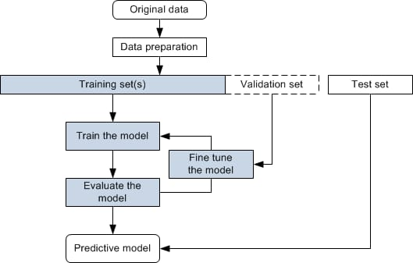

Figure 2.1 Workflow.

- Data Acquisition
The dataset forms the backbone of this research and was sourced from IBN SINA Hospital, a leading medical institute in Bangladesh. This collaboration enabled access to clinical-grade CT scan data covering 40 anonymized patients, classified into three diagnostic categories: Malignant, Benign, and Normal.
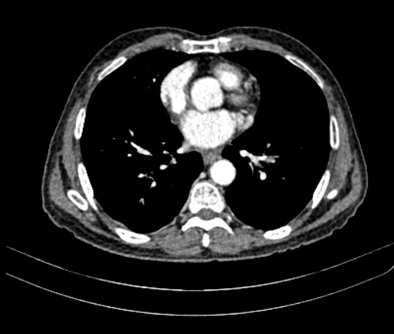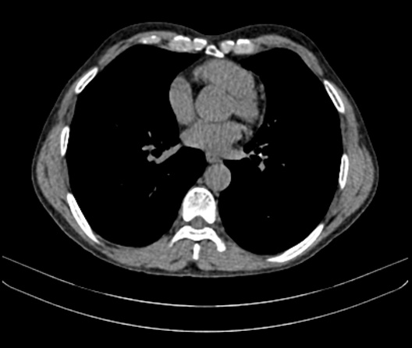
  - (b)
Figure 2.2 (a) Malignant scan, (b) Normal Scan Before preprocessing.

Source and Ethics
The data was anonymized to preserve patient confidentiality, in compliance with ethical data handling practices. Hospital radiologists verified ground truth labels (malignant, standard) and supplied them in a separate document alongside the DICOM scan folders.
- Data Format and Volume
The dataset initially consisted of approximately 54,000 DICOM files, representing axial CT slices across the thoracic region. Each patient's scans included multiple studies, often with contrast-enhanced and non-contrast slices.
Only non-contrast scans were selected for analysis to maintain consistency and avoid artificially skewed intensity distributions. These were identified using the DICOM metadata field ImageComments. Files labeled “Plain” were included, while those marked with “I.V. Contrast” were excluded.
- DICOM Preprocessing Environment
Due to the dataset's size and complexity, Google Colab was used as the computational environment. The entire dataset was mounted from Google Drive, allowing scalable cloud-based access and storage. Python libraries such as PyDicom and OpenCV were used for image reading and manipulation.

- Image Preprocessing and Lung Region Filtering
Each DICOM slice was converted to a grayscale PNG image for model compatibility. Key preprocessing steps included:
- Reading DICOM pixel arrays.
- Filtering CT modality images (Modality == 'CT').
- Normalizing pixel intensities to the range [0, 255].
- Removing textual overlays and UI artifacts.
- Resizing to 224×224 pixels (for CNN) and 128×128 pixels (for feature extraction).
- Equalizing image contrast via histogram normalization.

Lung Slice Filtering
To ensure model inputs represent valid lung regions:
- An area threshold segmentation was used to discard slices with insufficient visible lung tissue.
- Binary segmentation masks were generated based on pixel intensity and air content.
- Only slices meeting the minimum criteria for lung anatomy presence were retained.
This filtering process significantly improved dataset quality by eliminating slices from the neck, abdomen, or muscle-only regions, which can confound CNN models.

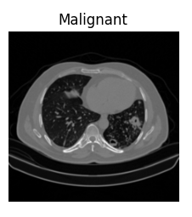
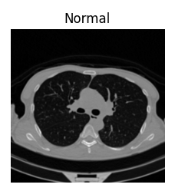
  - (ii)
Figure 2.3 Preprocessed (ii)Normal and (i) Malignant scans.

Final Dataset
After all filtering and preprocessing steps, the dataset was refined to a total of 21,787 lung-relevant image slices, categorized as follows:
- Malignant: 11,504 slices
- Benign: 3,268 slices
- Normal: 7,015 slices
This dataset was then split patient-wise into:
- Training Set: 17,429 slices (80%)
- Testing Set: 4,358 slices (20%)
The patient-wise split ensures that slices from a single patient are not shared between training and testing, preventing data leakage and inflated performance metrics.

- Training
The study trains and evaluates two AI models:
- CNN Model: This model is implemented with EfficientNetB0, a pretrained architecture known for accuracy and efficiency. It accepts images and learns spatial hierarchies through convolutional layers.

- ChatGPT-Assisted Pipeline: This pipeline uses a Gradient Boosting Classifier trained on the extracted feature vectors. After training, the top contributing features are passed to ChatGPT, which returns interpretive explanations in natural language based on prompt templates.
This two-model design comprehensively compares pixel-based image understanding and structured-feature-based reasoning.

  - CNN Model
The Convolutional Neural Network (CNN) methodology employed in this study was designed to classify lung CT scan slices into normal and malignant categories, using a deep learning-based image analysis approach. This method serves as one of the two main models evaluated in the research, the other being a ChatGPT-assisted structured feature analysis pipeline. The CNN model was constructed from scratch using the TensorFlow and Keras frameworks, with the entire process tailored to a dataset sourced from Bangladeshi lung cancer patients. The methodology encompassed data preprocessing, model architecture design, training optimization, and performance evaluation.
The first step in the CNN pipeline is data preparation. The CT scan images—acquired from IBN SINA Trust—were already categorized into 'Normal' and 'Malignant' classes and organized into directories for training and validation. A patient-wise split was applied to ensure that images from the same patient did not appear in both training and validation sets. This was crucial to maintaining the clinical integrity of the evaluation, as it prevented the model from simply memorizing individual characteristics rather than learning generalizable features.

Figure 2.4 Workflow of the CNN Model.
The Convolutional Neural Network (CNN) methodology employed in this study was designed to classify lung CT scan slices into normal and malignant categories, using a deep learning-based image analysis approach. This method serves as one of the two main models evaluated in the research, the other being a ChatGPT-assisted structured feature analysis pipeline. The CNN model was constructed from scratch using the TensorFlow and Keras frameworks, with the entire process tailored to a dataset sourced from Bangladeshi lung cancer patients. The methodology encompassed data preprocessing, model architecture design, training optimization, and performance evaluation.
The first step in the CNN pipeline was data preparation. The CT scan images—acquired from IBN SINA Trust—were already categorized into 'Normal' and 'Malignant' classes and organized into directories for training and validation. A patient-wise split was applied to ensure that images from the same patient did not appear in both training and validation sets. This was crucial to maintaining the clinical integrity of the evaluation, as it prevented the model from simply memorizing individual characteristics rather than learning generalizable features.
Each image was resized to 96x96 pixels and converted into RGB format to maintain consistency across all samples. The pixel intensity values were normalized to the [0, 1] range by rescaling with a factor of 1/255. To improve the model’s ability to generalize across variations in imaging conditions, data augmentation was applied to the training images using Keras’s ImageDataGenerator class. Augmentation techniques included random rotation (up to 20 degrees), zooming (up to 15%), horizontal flipping, and nearest-neighbor filling. These transformations mimicked real-world variations and helped reduce the risk of overfitting. The validation set, on the other hand, was only rescaled without augmentation to provide a consistent and unbiased measure of the model's performance.
The CNN architecture was defined using Keras’ Sequential model. The design began with a convolutional layer consisting of 32 filters of size 3x3, using the ReLU activation function. This was followed by a max-pooling layer (2x2) to reduce spatial dimensions while retaining the most prominent features. Two more convolutional layers followed, with 64 and 128 filters respectively, each paired with a max-pooling layer. These layers progressively learned more complex visual patterns, from basic edges to high-level structural representations of nodules or tumors. The output of the final convolutional layer was flattened into a one-dimensional vector, which was passed into a dense (fully connected) layer with 256 neurons and ReLU activation. A dropout layer with a rate of 0.5 was inserted at this point to mitigate overfitting by randomly deactivating half of the neurons during training. Finally, the model concluded with a softmax-activated output layer containing two neurons, representing the probabilities of the image belonging to either the 'Normal' or 'Malignant' class.
The model was compiled using the Adam optimizer, a widely adopted adaptive optimizer that performs well on noisy or sparse gradients. A learning rate of 0.0001 was selected to ensure smooth convergence. Categorical cross-entropy was chosen as the loss function because the target labels were one-hot encoded. The model was trained for up to five epochs with a batch size of eight. An early stopping mechanism was incorporated, which monitored the validation loss and halted training if it failed to improve for five consecutive epochs. This strategy helped prevent overfitting and ensured that the model retained the best possible weights during the learning process.
Following training, various visualizations and statistical tools analyzed the model's performance. Training and validation accuracy and loss values were plotted across epochs, providing immediate insight into the learning dynamics. These plots were essential in identifying issues such as underfitting or overfitting. The evaluation was further supplemented by generating a confusion matrix and a detailed classification report, including precision, recall, and F1-score for each class. These metrics allowed a comprehensive understanding of how well the model was distinguishing between normal and malignant images.
Receiver Operating Characteristic (ROC) curves were plotted for both classes, and the Area Under the Curve (AUC) values were calculated. The ROC curve displayed the trade-off between sensitivity (true positive rate) and specificity (false positive rate), while the AUC quantified the overall discriminative ability of the model. A higher AUC value indicated a more reliable classifier.
  - ChatGPT Assisted Pipeline
The ChatGPT-based methodology presented in this study was designed as a feature-centric diagnostic approach, distinct from image-based convolutional networks. It relies on extracting handcrafted radiomic and statistical features from preprocessed CT lung slices and using them to train a classical machine learning classifier, followed by post-hoc interpretation using ChatGPT. The objective was to evaluate whether large language models could offer meaningful interpretability when paired with structured data for lung cancer classification.

Figure 2.5: Workflow of the ChatGPT model.
The preprocessing phase involved resizing all input images to 128×128 pixels, followed by the extraction of numerical features relevant to lung tissue structure and image intensity distributions. These included first-order features such as mean intensity, standard deviation, skewness, and kurtosis, which represent basic pixel-level statistics, and second-order texture features derived from Gray-Level Co-occurrence Matrices (GLCM), including contrast, energy, correlation, and homogeneity. The feature extraction was performed using Python’s scikit-image, OpenCV, and scipy.stats libraries.
Once the features were extracted and structured into a dataset, a Gradient Boosting Machine (GBM) classifier—specifically, XGBoost—was used for the binary classification task (Normal vs. Malignant). The model’s initial configuration included 200 decision trees with a maximum depth of 5 and a learning rate of 0.05. Feature vectors were labeled using patient-level annotations, and patient-wise separation was maintained to avoid information leakage. The dataset was partitioned into training and testing sets, and a 5-fold cross-validation scheme was adopted to validate the model’s robustness. The classifier was trained on the statistical features extracted from lung regions, rather than the raw images. This way, the model mimicked the diagnostic reasoning process, making decisions based on high-level descriptors rather than spatial patterns.
To enhance interpretability, feature importances were computed using XGBoost’s built-in mechanisms, allowing for the identification of which numerical variables most influenced classification outcomes. These ranked features were formatted into structured prompts and passed to ChatGPT. The prompt included the feature name, value, and relative importance for each case. ChatGPT was then asked to provide a textual interpretation of how these features might relate to the presence or absence of cancerous tissue. This was not intended as a standalone diagnostic but as an interpretive layer, mimicking how a radiologist might explain a classification based on measurable image characteristics. The integration of ChatGPT added a layer of explainability to the model, enabling the generation of human-readable summaries for feature-driven predictions. This is particularly valuable in clinical environments where AI explainability is crucial for decision support and ethical deployment.
By separating the prediction and interpretation tasks, this methodology allowed the application of domain-agnostic LLMs in a context-sensitive diagnostic workflow. It emphasizes transparency, computational simplicity, and accessibility, especially in resource-limited healthcare settings where large-scale end-to-end deep learning deployment might be impractical. The ChatGPT-based methodology, therefore, stands as a complementary approach to CNNs—one that prioritizes structured input, interpretability, and the potential for natural language integration with clinical systems.
- Testing
- CNN Pipeline
For the CNN model, testing was performed on a held-out validation set comprising 20% of the original dataset. This partition was done using a patient-wise split, ensuring that images from the same individual did not appear in both training and testing sets. The CNN model, built using a sequential architecture of convolutional and pooling layers, was trained for five epochs with early stopping. Testing involved generating predictions using the predict() method on the validation generator, and mapping the softmax probabilities to discrete class labels (Normal or Malignant) based on the highest output probability.
- ChatGPT Pipeline
The testing for the ChatGPT-assisted pipeline involved evaluating a Gradient Boosting classifier trained on extracted statistical and texture-based features. Like the CNN pipeline, a patient-wise test set was used. Structured feature vectors from unseen images were passed to the trained model to generate class predictions. The most influential features per prediction were then formatted and submitted to ChatGPT in structured prompts for interpretation and diagnostic reasoning.

- Comparative Analysis
- CNN Pipeline
The CNN model’s predictions on the validation set were compared against the true labels to generate classification metrics. These included precision, recall, F1-score, and a confusion matrix. Additionally, ROC curves and AUC values were computed for both classes, offering a comparative view of the model’s ability to distinguish between Normal and Malignant cases.
- ChatGPT Pipeline
The ChatGPT-assisted pipeline was similarly evaluated using classification metrics derived from the Gradient Boosting model's predictions. A confusion matrix, precision, recall, and F1-scores were calculated. ROC curves and AUC values were also used to assess model performance. ChatGPT provided interpretive insight by analyzing top-ranked features influencing each prediction.

- Evaluation
- CNN Pipeline

Evaluation of the CNN model involved analyzing the confusion matrix and classification report generated from the test predictions. ROC curves and AUC values were also plotted for each class to assess overall discriminative performance.

- ChatGPT Pipeline

The ChatGPT pipeline was evaluated based on the performance of the Gradient Boosting classifier on test data. Confusion matrices, classification reports, ROC curves, and AUC values were generated. ChatGPT contributed to the evaluation by offering post-hoc explanations based on the extracted features for each test case.

2.5 Summary
This study addresses the urgent need for improved diagnostic tools for lung cancer detection in Bangladesh, where a growing cancer burden, limited imaging infrastructure, and a severe shortage of trained radiologists challenge healthcare systems. To respond to this challenge, the research explores two artificial intelligence (AI)-based diagnostic models: a Convolutional Neural Network (CNN) for image-based classification, and a ChatGPT-assisted model that interprets structured features using natural language reasoning.
The literature review highlights two key streams of AI research in medical diagnostics. First, CNN-based approaches have shown strong potential in analyzing medical imaging data, particularly CT and histopathological images, as demonstrated in studies by Dabeer et al., Lulu Gai et al., and Shalini et al. These models excel in capturing discriminative visual features and offer improved classification performance when enhanced with transfer learning. Nonetheless, overfitting, lack of transparency, and reliance on large labeled datasets hinder their adoption in real-world clinical settings, especially in low-resource regions.
The second stream explores the capabilities of Large Language Models (LLMs), particularly ChatGPT, in medical diagnostics. Rather than directly classifying images, ChatGPT functions as a clinical assistant capable of interpreting structured data and generating explainable diagnostic narratives. Prior research by Caruccio et al., Xu et al., and Wang et al. supports the potential of ChatGPT in generating preliminary diagnoses and medical insights. However, concerns remain regarding its accuracy, reliability, and inability to directly process raw images. Despite this, its strength lies in explainability and human-like reasoning.
Guided by these foundations, this study develops a comparative experimental framework. The dataset used comprises over 21,000 CT slices obtained from IBN SINA Trust, focusing on non-contrast axial lung images from Bangladeshi patients. Ethical safeguards were maintained through anonymization and patient-wise partitioning. Preprocessing steps included resizing, normalization, and anatomical filtering.
For the CNN model, a custom sequential architecture was built and trained from scratch, with multiple convolutional and max-pooling layers followed by dense layers for classification. Image augmentation techniques such as rotation and zooming were used to increase dataset variability. The model was compiled with a categorical cross-entropy loss function and trained using the Adam optimizer. Early stopping was applied to avoid overfitting. Validation was conducted using a separate 20% patient-wise split, and outputs were evaluated using metrics like accuracy, precision, recall, F1-score, confusion matrix, and ROC-AUC.
In parallel, a feature-based pipeline was constructed for the ChatGPT-assisted approach. From a reduced set of 500 curated lung images, structured feature vectors were created using statistical (mean, standard deviation, skewness, kurtosis) and texture (contrast, energy, homogeneity, correlation) descriptors. These were used to train a Gradient Boosting classifier with cross-validation. The most influential features for each case were then interpreted through ChatGPT, which generated explanatory narratives in clinical language, simulating decision support for radiologists.
Both pipelines were rigorously tested using identical data partitions. While the CNN offered direct end-to-end image classification, the ChatGPT-assisted model emphasized transparency and reasoning through feature-based interpretation. Comparative analysis focused not only on classification performance but also on usability, generalization, and interpretability—key aspects for deployment in resource-constrained healthcare settings like those in Bangladesh.
In conclusion, the study leverages both visual and structured AI methodologies to tackle the challenges of cancer diagnostics in low-resource environments. The dual-model design ensures a comprehensive evaluation of two fundamentally different approaches: deep learning through CNNs and explainable language reasoning through ChatGPT. This research contributes to the growing body of work on AI-driven healthcare and emphasizes the importance of balancing performance with interpretability and real-world applicability.

Chapter 3: Main Work

CNN-Based Deep Learning Model for Lung Cancer Detection

The first part of this research involves constructing and analyzing a Convolutional Neural Network (CNN)-based deep learning model for classifying lung CT scan slices into Normal and Malignant classes. The experimental setup was designed around real-world constraints, using data from a Bangladeshi hospital—IBN SINA Trust—representing native imaging characteristics, noise patterns, and clinical variability. This setup addresses the region's shortage of radiologists and diagnostic infrastructure by exploring automated detection systems that can function in low-resource settings.

This section details every stage of the CNN pipeline—from dataset preparation and preprocessing to architecture building, fine-tuning, and evaluation. The model was developed using Python with TensorFlow and trained on Google Colab for accessibility and scalability.

3.1.1 Mounting Environment and Loading Libraries
The experiment begins by importing a wide range of Python libraries necessary for deep learning and model evaluation. TensorFlow and Keras form the backbone of the CNN model development process, providing access to layers, optimizers, and pre-trained models such as EfficientNetB0. Additionally, libraries like NumPy and Matplotlib are used for numerical computations and result visualization. Seaborn is chosen for creating aesthetically enhanced confusion matrices and learning curve plots.

Two primary TensorFlow optimization tools are activated for performance enhancement. First, mixed precision training is enabled by setting the global policy to "mixed_float16". This policy allows the model to use 16-bit floating-point numbers (float16) instead of the default 32-bit format, effectively reducing memory usage and accelerating training time without sacrificing model accuracy. This combination ensures maximum computational efficiency, especially on GPU-enabled platforms like Google Colab.

3.1.2 Directory Setup and Hyperparameter Configuration
Several constants are defined at the beginning of the implementation to ensure reproducibility and clarity. The batch size is set to 32, balancing memory efficiency with model convergence speed. The input image size is standardized to (96, 96) pixels, a compact yet sufficient resolution that preserves critical features in CT scan images while keeping the computational load low.

The paths to the training and test datasets are defined next. These datasets are in a user’s Google Drive, structured in directories organized by patient ID and class label (e.g., Normal, Malignant, etc.). By separating training and test data by patient, the setup avoids data leakage, where similar samples from the same patient might appear in both sets, leading to artificially inflated performance metrics.

3.1.3 Dataset Loading and TensorFlow Preprocessing Pipeline
The tf.keras.utils.The image_dataset_from_directory() function is employed to load the datasets automatically. This function reads images directly from disk, assigns class labels based on folder names, resizes them to the specified dimensions, and groups them into batches of the selected size.

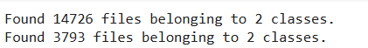

Figure 3.1 Data Loading.

The implementation begins by importing all essential libraries for deep learning, image preprocessing, visualization, and evaluation. TensorFlow and its Keras API define and train the CNN model. The ImageDataGenerator class from tensorflow.keras.preprocessing.image is pivotal for augmenting and rescaling image data, which is crucial for robust training. Additional libraries like sklearn.metrics provide classification metrics such as precision, recall, and ROC AUC scores. Matplotlib is employed to visualize training performance and model evaluation graphs. Finally, Python’s os module inspects the directory structure and confirms that image data is correctly arranged in training and testing folders, which is essential for automated image loading through the flow-based generators.

Two directories are defined: train_dir and valid_dir, corresponding to the paths containing patient-wise split grayscale lung CT images. These folders are assumed to follow the flow_from_directory() convention, where subdirectories represent class labels (e.g., normal, malignant).

Image augmentation is critical in training CNNs, especially when working with small medical datasets. The ImageDataGenerator for the training set includes techniques like rotation (rotation_range=20), zoom (zoom_range=0.15), and horizontal flipping. These augmentations are used to increase the dataset’s variability and help prevent overfitting synthetically. They simulate real-world variability in CT scans such as changes in patient positioning or scanner angle.

The validation generator, in contrast, does not apply augmentations but only rescales the pixel values from [0, 255] to [0, 1]. This ensures that the validation performance reflects generalization rather than adaptation to altered input.

Both generators resize each image to 96x96 pixels and read them in color mode (3 channels), which aligns with the CNN model's input requirements.

3.1.4 Class Weight Calculation for Imbalanced Data
Medical image datasets are often imbalanced, meaning some classes (like Malignant) may be overrepresented or underrepresented compared to others (like Benign or Normal). This imbalance can bias the model during training, making it more likely to predict the majority class regardless of the input.

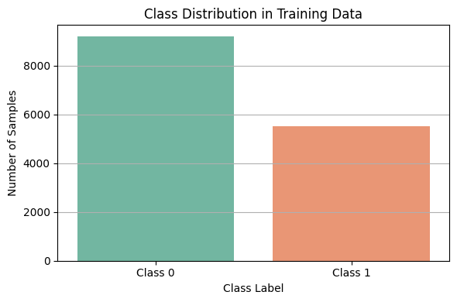

Figure 3.2 Class Distribution in Training Data (Class 0 = Malignant, Class 1 = Normal).

To resolve this, the script computes class weights by unbatching the dataset and collecting the class distribution. The total number of samples per class is used to calculate an inverse weight, where rarer classes are assigned higher importance during training. These weights are passed to the fit() function later, instructing the loss function to penalize misclassification of minority classes more heavily, thus enforcing balanced learning.

3.1.5 CNN Model Construction
The core of the model architecture is built using EfficientNetB0, a lightweight convolutional neural network that balances depth, width, and resolution using compound scaling. It’s loaded with pre-trained ImageNet weights and its classification head is removed (include_top=False) to allow for a custom classifier specific to lung cancer detection.

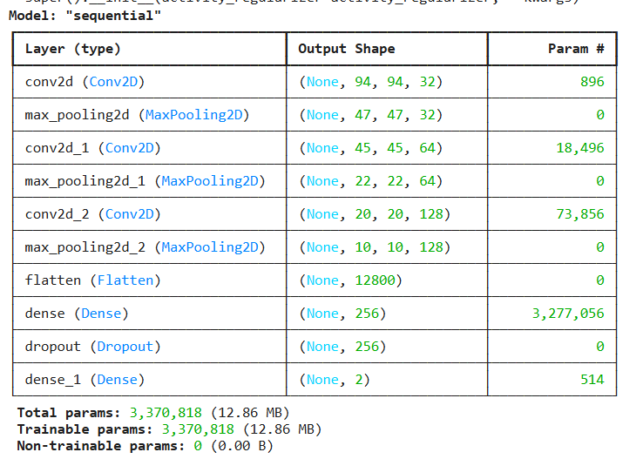

Figure 3.3 Model Summary.

A new classification head is built by stacking the following layers:

A GlobalAveragePooling2D layer, which collapses each feature map into a single value by averaging, reducing dimensionality while preserving spatial information.

A Dropout layer with a rate of 0.3, helping to regularize the model and reduce overfitting.

A fully connected Dense layer with 128 neurons and ReLU activation, allowing the model to learn complex, non-linear representations.

A second Dropout layer to further guard against overfitting.

A final Dense layer with 2 neurons and softmax activation for binary classification suitable for classifying the inputs into two categories (e.g., malignant vs. normal). Since class_mode='categorical' was used in the generators, the model is trained using categorical_crossentropy as the loss function.

The model is compiled using the Adam optimizer, which is known for its efficiency and adaptive learning rate. The learning rate is set to 0.0001—a conservative choice that allows fine-grained updates during backpropagation, reducing the risk of unstable convergence. The metric for evaluation is accuracy, suitable for balanced binary classification tasks.

3.1.6 Initial Training
Training is conducted using the .fit() method, where both the training and validation generators are passed. A key callback used here is EarlyStopping, which monitors the validation loss and stops training if it does not improve for 5 consecutive epochs, restoring the best weights. This prevents overfitting and saves computational resources. The model is trained for 5 epochs—a smaller number that reflects the limited data available, though the early stopping ensures the training halts at the optimal point

3.1.7 Visualizing the Training Progress
After training, the model’s performance is visualized using matplotlib. Two subplots show accuracy and loss trends across epochs for both training and validation data. These plots are critical in diagnosing underfitting (when both accuracies are low) or overfitting (when training accuracy is high, but validation accuracy stagnates or drops). This step provides a visual understanding of the learning dynamics and can inform decisions for further hyperparameter tuning or architecture changes.

In this study,

Training Accuracy Trend: The training accuracy increases steadily from around 77% in the first epoch to approximately 88.5% in the fifth. This indicates that the model is successfully learning the training data and minimizing classification errors over time.

Validation Accuracy Trend: In contrast, the validation accuracy exhibits fluctuations. It starts at 80%, drops to 76% by the second epoch, recovers slightly in the third epoch, and then declines again by the fifth.

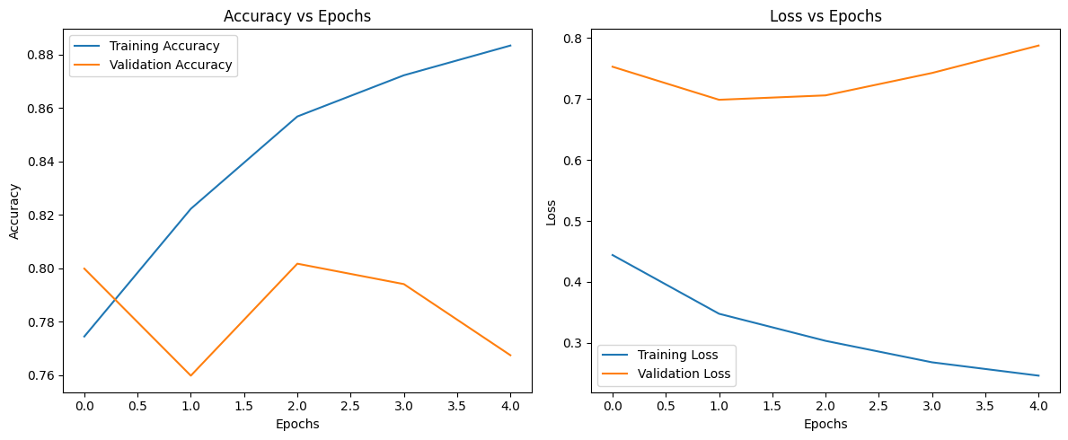
Figure 3.4 Visualizing Training Progress.

Training Loss Trend: The training loss (blue line) consistently decreases across epochs—from around 0.45 to below 0.2. This again confirms that the model is learning effectively from the training data and optimizing its weights accordingly.

Validation Loss Trend: The validation loss (orange line), however, remains significantly higher and even increases slightly toward the end. It begins around 0.75, dips only marginally, and then trends upward again by epoch five.

3.1.8 Model Evaluation on Validation Set
The trained model is evaluated by generating predictions on the validation dataset using the predict() method. These predictions return probabilities for each class, which are then converted to class indices (np.argmax) to match the actual labels.

The actual labels are retrieved from valid_generator.classes, and the predicted labels are compared against them using classification_report() from sklearn.metrics. This report presents class-wise precision, recall, F1-score, and support (number of instances), offering a comprehensive view of the model’s classification ability.

3.1.9 Confusion Matrix Visualization
The confusion matrix provides a tabular summary of the model's classification performance, showing how many instances of each class were correctly or incorrectly predicted. The ConfusionMatrixDisplay() function is used to generate a heatmap with labels and color coding, making it easier to identify patterns like false positives or false negatives, which is essential in clinical applications like cancer diagnosis.

3.1.10 ROC Curve and AUC Score
A multi-class ROC curve is plotted to evaluate the model’s ability to discriminate between classes across varying thresholds. This involves binarizing the true labels using label_binarize() and computing the False Positive Rate (FPR) and True Positive Rate (TPR) for each class.

The AUC (Area Under the Curve) function calculates the Area Under the Curve (AUC) for each class, indicating how well the model distinguishes between them. A perfect classifier has an AUC of 1.0, while a score of 0.5 suggests random guessing. The ROC curve visualization includes curves for each class, a reference line, and color-coded legends to improve interpretability.

ChatGPT-Based Model for Lung Cancer Diagnosis Using Radiomic Features

In this section of the project, we propose an alternative and experimental methodology leveraging a large language model—ChatGPT—in combination with handcrafted feature engineering and a traditional machine learning classifier, namely the Gradient Boosting Classifier (GBC), to detect lung cancer from CT scan slices. This experimental design was initiated from the hypothesis that although ChatGPT does not have inherent computer vision capabilities, its ability to analyze tabular data and guide classification workflows based on extracted features can make it a valuable auxiliary diagnostic tool. This methodology was chosen to evaluate whether ChatGPT-assisted or guided diagnosis using radiomic and statistical features could offer a comparable alternative to CNN-based models in the context of Bangladeshi patient data. This approach was necessary as ChatGPT does not natively support direct image analysis, requiring a structured feature-based transformation of the image dataset into tabular form before classification.

Dataset Reduction and Preparation
Due to the limitation in computational efficiency and practical feasibility of handling 18,000 CT scan slices through this method, we reduced the dataset to 500 lung ROI slices. The reduction was not random but carefully curated through patient-wise selection, ensuring balanced representation of Normal and Malignant classes and excluding the Benign class due to insufficient class frequency and its ambiguous visual features. From the original 21,787 filtered lung slices from 40 patients, a representative subset was manually filtered and confirmed to include distinct samples that preserved the morphological and textural characteristics of the full dataset.

These selected slices were resized to 128x128 pixels to standardize dimensions for statistical feature extraction. Unlike CNNs that utilize raw pixel matrices, this approach extracted numerical values from the grayscale pixel distributions and radio mic descriptors of the images to convert them into structured numerical data. Each image was then represented as a single row in a data frame with multiple descriptive features (columns), making the dataset suitable for use in traditional ML algorithms.

Image Input and Preprocessing
These 500 images were preprocessed and resized uniformly (128×128 pixels) to standardize the input format. This resizing helped reduce computational overhead and ensure that feature extraction was consistent across samples. Preprocessing also included grayscale conversion (since CT scans are intensity-based) and basic histogram normalization to minimize noise and enhance tissue contrast.

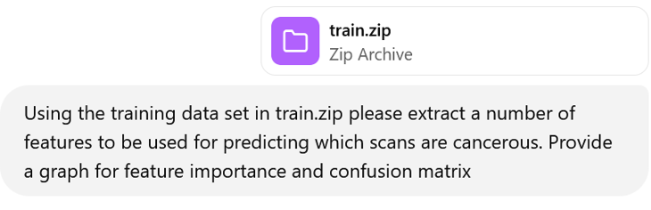
Figure 3.5 Prompt Used for Training ChatGPT.

Radiomic and Statistical Feature Extraction
Once the image data was ready, a critical step was the feature extraction process, which served as the basis for classification. Rather than feeding raw pixel matrices into a model (as done in CNNs), the ChatGPT-driven approach relied on engineered features—numeric descriptors of image texture, intensity, geometry, and statistical distributions. These features are well-established in radiomics and provide meaningful insights about the underlying anatomical and pathological structures present in CT scans.

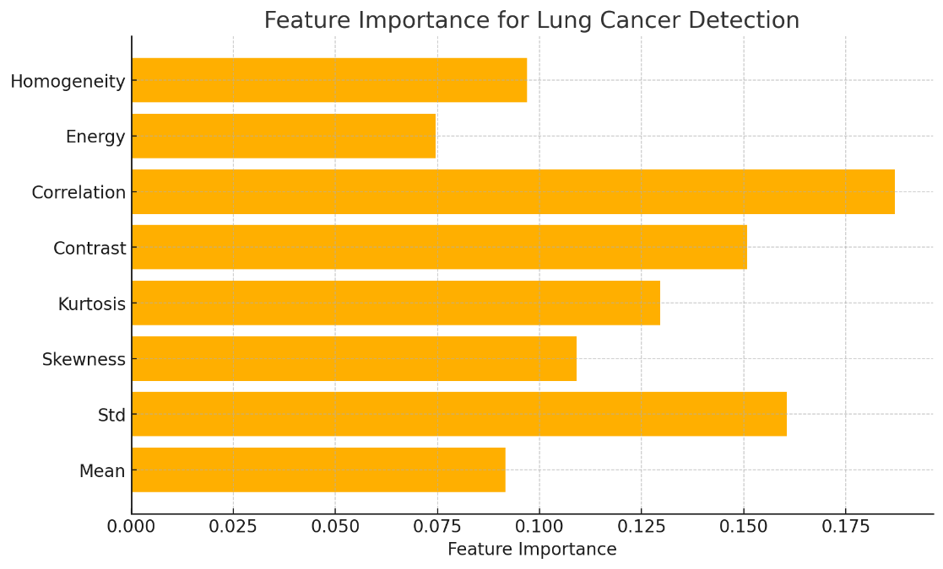

Figure 3.6 Feature Importance for Lung Cancer extracted by ChatGPT.

The following key features were computed from each lung slice:

Mean Intensity: This measures the average pixel brightness and is particularly useful in identifying dense regions typically seen in tumor cores.

Standard Deviation (Std Intensity): This quantifies the variability of intensity values across an image, with higher standard deviations often indicating structural heterogeneity typical of malignant tissues.

Contrast: Derived from the Gray-Level Co-occurrence Matrix (GLCM), this feature captures how much contrast exists between neighboring pixels—higher values may indicate aggressive growths or sharply defined tumor margins.

Correlation: Measures the linear dependency of gray levels in neighboring pixels. High correlation is generally associated with homogeneous tissue textures, which are more typical in normal tissue than malignant masses.

Energy: A uniformity measure derived from the square of pixel values; tumors with regular internal structures often have high energy scores.

Homogeneity: This reflects the closeness of pixel distributions; low homogeneity often indicates malignancy.

Skewness and Kurtosis: These are higher-order statistical descriptors of the intensity distribution. Skewness identifies asymmetry, while kurtosis captures the peakedness or flatness of the distribution, providing cues about irregular growth.

Training and Testing a Gradient Boosting Classifier
The predictive model was developed using a gradient boosting classifier. This ensemble-based learning algorithm combines multiple weak learners (decision trees) into a strong classifier in a stage-wise fashion. It is particularly suitable for tabular feature data and is known for effectively handling class imbalance and nonlinear decision boundaries.

The classifier was configured with the following initial hyperparameters:

- n_estimators = 200: Number of boosting rounds (trees)
- max_depth = 5: Maximum depth for individual trees
- learning_rate = 0.05: Controls the contribution of each tree
- subsample = 0.8: Fraction of samples used per tree to promote regularization
- random_state = 42: For reproducibility

These settings balanced bias and variance, ensuring the model learned sufficient complexity without overfitting the small dataset.

The 80% training data subset was used for training, while the remaining 20% was used for performance evaluation. During training, the model learned to map the radio mic features to their respective lung conditions. The goal was prediction, interpretability, and generalization across unseen patient samples.

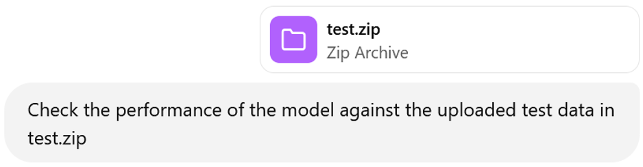
Figure 3.7 Prompt for Model Testing.

Model Evaluation
Evaluation of the Gradient Boosting model was performed using several standard classification metrics:

- Classification Report: Included precision, recall, and F1-scores for each class label. These metrics benefit healthcare, where false positives and negatives have very different implications.

- Confusion Matrix: Provided a visual breakdown of correct vs. incorrect predictions. Misclassifications between Normal and Benign were given special attention, as these can impact clinical triage.

- Receiver Operating Characteristic (ROC) Curve: Plotted the True Positive Rate against the False Positive Rate across thresholds, offering insight into the model’s discriminative ability.

Summary

Chapter 3 presented the main experimental framework designed to evaluate the performance of two distinct artificial intelligence models for lung cancer detection from CT scan images: one based on a Convolutional Neural Network (CNN), and the other built around a structured feature analysis supported by ChatGPT and a gradient boosting classifier. This chapter detailed the step-by-step development, training, evaluation, and interpretation of these models, with a particular emphasis on their application to a dataset sourced from Bangladeshi patients provided by IBN SINA Trust.

The CNN-based model began with an extensive preprocessing phase. CT scan images were structured into training and validation directories, with class folders distinguishing normal and malignant slices. Data augmentation was applied to the training set using the ImageDataGenerator class. Augmentations included image rescaling, rotation, zoom, and horizontal flipping to artificially increase variability in the training set, which improves the model’s ability to generalize. The validation dataset, in contrast, was rescaled only, maintaining data integrity for performance evaluation. All images were resized to 96×96 pixels to ensure uniformity in model input dimensions.

A custom CNN model was constructed using TensorFlow’s Sequential API. The architecture featured three convolutional layers with 32, 64, and 128 filters, each followed by a 2×2 max-pooling layer to progressively reduce spatial dimensions while capturing important visual features. The final convolutional output was flattened into a single vector and passed through a fully connected dense layer with 256 neurons, activated using ReLU. To prevent overfitting, a dropout layer with a rate of 0.5 was added before the final classification layer, which used softmax activation to predict the probability distribution over the two target classes.

The model was compiled using the Adam optimizer with a learning rate of 0.0001, and categorical crossentropy was chosen as the loss function since the model was trained with categorical class labels. It was trained for five epochs with early stopping enabled to halt training if the validation loss failed to improve for five consecutive epochs. The training history was visualized using accuracy and loss graphs, which provided critical insight into the model's learning behavior. These visualizations revealed that while training accuracy increased steadily and training loss decreased, the validation accuracy fluctuated and the validation loss rose, suggesting the onset of overfitting—a common issue in image classification when the model starts to memorize training data instead of generalizing.

Following model training, a detailed evaluation was conducted. The predictions were compared against the ground truth using a classification report that included precision, recall, and F1-score for each class. A confusion matrix was also generated and visualized, revealing how accurately the model identified each category. Additionally, the ROC curve and Area Under the Curve (AUC) metrics were plotted for both classes, providing a visual and quantitative assessment of the model's discriminatory capability between normal and malignant samples. These performance diagnostics helped identify the model’s strengths and limitations in classifying CT scan slices.

In parallel, a separate diagnostic methodology was developed using ChatGPT in conjunction with a gradient boosting classifier. Due to the resource limitations of large language models, a reduced dataset of 500 lung ROI images was curated. Each image was processed to extract a set of handcrafted features that captured statistical, texture, and shape information. These included measures like mean intensity, standard deviation, skewness, kurtosis, contrast, energy, homogeneity, and geometric properties such as area, eccentricity, and solidity. This structured dataset was used to train a GradientBoostingClassifier—a decision-tree-based ensemble algorithm known for its high accuracy and interpretability.

ChatGPT’s role was focused on interpreting the output of the feature-based model. Although it did not directly train or classify data, it was used to review the extracted features, analyze model predictions, and explain performance patterns. The classifier was evaluated using the same performance metrics applied to the CNN model: classification report, confusion matrix, and ROC AUC. Feature importance was also visualized using bar plots, allowing researchers to understand which characteristics of the CT images most strongly influenced the classifier's decisions. These insights, when narrated by ChatGPT, provided an interpretable and human-readable analysis of the model’s decision-making process.

To bring both methodologies together, a unified workflow was developed. This included stages of data acquisition from IBN SINA Trust, preprocessing and augmentation (for CNN), feature extraction (for ChatGPT), model building and training, validation, performance evaluation, and interpretation. While the CNN model offered a strong image-based classification approach capable of capturing subtle spatial features, the ChatGPT-assisted model excelled in transparency and interpretability, especially valuable in a medical diagnostic setting where understanding how decisions are made is as important as accuracy.

In conclusion, Chapter 3 provided an in-depth overview of the development and implementation of two distinct AI models for the diagnosis of lung cancer from CT scan images. The CNN-based model leveraged raw image data to learn visual features through convolutional operations, pooling, and fully connected layers. It proved effective in capturing complex visual patterns. On the other hand, the ChatGPT-assisted model relied on structured numerical features and traditional machine learning, offering an interpretable yet effective alternative. Both models were evaluated rigorously using appropriate classification metrics and their outputs were visually analyzed. The chapter concluded by establishing a comparative framework that sets the foundation for the performance analysis and clinical relevance discussion in the following chapters.

CHAPTER 4: Results & Discussion

This chapter presents the outcomes of the experimental analysis conducted to evaluate and compare the performance of two distinct artificial intelligence (AI) approaches for lung cancer detection from CT scan images: a Convolutional Neural Network (CNN)-based deep learning model and a Chatgpt-assisted feature-based classification pipeline. This comparative study's primary goal was to assess the predictive accuracy of these models and understand their behavior, strengths, limitations, and applicability within the context of resource-constrained healthcare systems like Bangladesh.

The results are structured to provide a comprehensive view of both models across various performance metrics, including accuracy, precision, recall, F1-score, confusion matrix, and ROC-AUC. The CNN model, trained directly on raw CT images, represents a typical end-to-end deep learning workflow. At the same time, the Chatgpt pipeline operates on manually extracted statistical and radiomic features, providing post-hoc interpretability through natural language outputs. Both models were tested on a separate patient-wise validation set to ensure fairness and clinical relevance.

In addition to presenting the raw performance metrics, this chapter includes qualitative and comparative discussions that contextualize the findings within the broader framework of AI-based medical diagnostics. Key discussion points include the practical implications of false positives and negatives, the interpretability of model decisions, and the feasibility of integrating such models into real-world diagnostic workflows. Visualizations such as ROC curves, confusion matrices, and SHAP-based interpretability plots are also discussed to provide deeper insights into each model’s decision-making process.

Ultimately, this chapter aims to translate the numerical results into actionable knowledge by identifying which model—or combination of models—is more suitable for early lung cancer detection in the Bangladeshi clinical setting, balancing accuracy, scalability, and explainability.

CNN-based lung cancer model results

The performance of the Convolutional Neural Network (CNN)-based deep learning model was evaluated using several empirical tools, including training curves, confusion matrices, classification reports, and ROC analysis. These metrics were derived after training the model on axial CT scan slices of Bangladeshi lung cancer patients and evaluating it on a hold-out test set comprising 20% of the total patient-wise dataset. The CNN model classified lung CT images into Malignant and Normal categories based solely on pixel-level patterns learned during training. As visualized and discussed below, the results comprehensively understand the model's performance, limitations, and areas requiring future improvements.

Training and Validation Accuracy/Loss
One key indicator of model behavior during the training process is the relationship between training and validation performance over epochs.

Figure 4.1 Accuracy vs Epochs (Left) & Loss vs Epochs (Right).

As shown in the figure above, the training accuracy consistently improved over ten epochs, starting at approximately 77% and reaching close to 88.5%. Correspondingly, the training loss dropped steadily from around 0.44 to 0.24. This trajectory reflects a model that is effectively fitting the training data, gradually refining its internal representations to improve classification ability.

However, the validation accuracy exhibited noticeable instability. It started at 80% in the first epoch but then fluctuated across subsequent epochs, ultimately dropping to around 76.5%. Unlike the training loss, which decreased monotonically, the validation loss oscillated and increased slightly, ending close to 0.79. This divergence between training and validation metrics—where the model improves on training data but not on unseen test data—is a classic symptom of overfitting.

This behavior is not entirely unexpected. CNNs are inherently data-hungry architectures, especially when trained from scratch or fine-tuned using VGG, ResNet, or EfficientNet. These networks typically require thousands of examples to generalize well. In this study, the model was trained using slices from only 40 patients, a significant constraint considering that each patient contributes multiple slices. Still, the actual diversity across patients is relatively low. Data augmentation techniques were employed, including zooming, rotation, and horizontal flipping, but the fundamental inter-patient variability was limited. This makes it difficult for a CNN to learn robust generalized representations across different lung structures and tumor variations.

Confusion Matrix Insights
The confusion matrix offers a breakdown of how well the model performed across the two target classes. Out of 2292 test images labeled as Malignant, the model correctly classified 2040, which is approximately 89% sensitivity (recall) for this class. On the other hand, of the 1501 images labeled as Normal, only 842 were correctly classified, resulting in a recall of approximately 56% for this class.

The false positive rate for the normal class was relatively high, with 659 images incorrectly classified as malignant. While this may raise concerns in a real-world clinical setting, it also underscores an important design choice: the model is biased in favor of detecting malignant cases. In the context of medical diagnostics, especially in life-threatening diseases like cancer, a higher false positive rate is often considered more acceptable than false negatives, which could result in missed diagnoses.
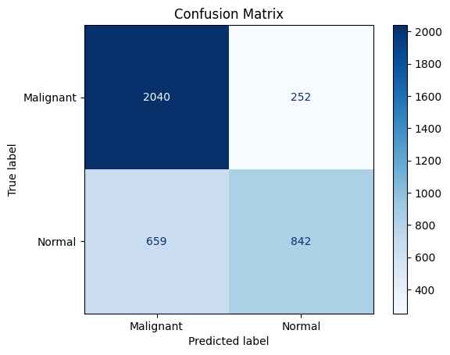
Figure 4.2 Confusion Matrix of the CNN model.

Nonetheless, this skewness also reflects the imbalance in model learning. With only limited training examples for normal patients, the model may have developed an overrepresentation for cancerous features, mistaking benign anatomical variations or imaging noise for malignancies.

Classification Report: Precision, Recall, and F1-score
The classification report further quantifies the model's behavior across the two classes:

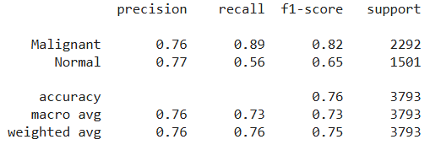

Figure 4.3 Classification Metrics: Precision, Recall, and F1-score of CNN model.

- Malignant

  - Precision: 0.76
  - Recall: 0.89
  - F1-Score: 0.82

These scores suggest that the model is particularly good at not missing cancer cases. The high recall indicates that most of the malignant images are detected correctly, making the model suitable for use in screening scenarios where early detection is paramount.

- Normal

- Precision: 0.77
- Recall: 0.56
- F1-Score:0.65

The model struggles more with standard class predictions, often misclassifying normal images as malignant. This is problematic for clinical implementation, as it may lead to unnecessary follow-up tests and patient stress.

- Overall accuracy: 76%
- Macro Avg F1-score: 0.73
- Weighted Avg F1-score: 0.75
While these results are moderate, they are promising given the limited dataset size. The model appears to favor sensitivity over specificity—a reasonable trade-off in cancer detection scenarios—but achieving a more balanced performance would be ideal for deployment in real clinical settings.

ROC Curve and AUC Analysis
The Receiver Operating Characteristic (ROC) curve and Area Under the Curve (AUC) analysis are used to evaluate the model's confidence calibration across various thresholds. For the malignant class, the AUC was calculated to be 0.27, which is unexpectedly low and significantly worse than random chance (0.5).

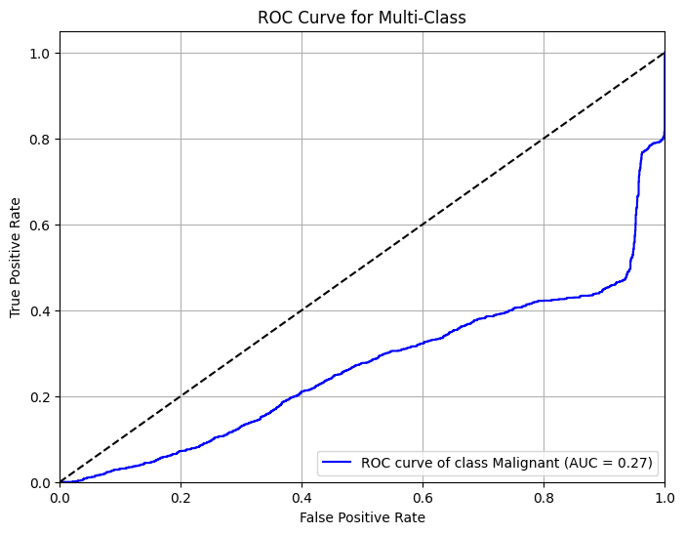

Figure 4.4 ROC Curve of CNN model.

This result stands in contrast with the reasonable recall and precision metrics reported earlier. The most likely explanation lies in probability miscalibration. While the model may assign the correct label with reasonable accuracy, its internal confidence scores may not correlate well with actual likelihoods. In essence, the model may predict the correct class, but with the wrong level of confidence. This can cause poor performance when evaluating across thresholds, as is done in AUC-based analysis.

Another contributing factor may be the data distribution and class imbalance. In small datasets, especially with limited examples for the regular class, models tend to produce skewed probability distributions, resulting in ROC curves that fail to rise significantly above the diagonal.

Lastly, it's important to note that AUC is highly sensitive to slight shifts in predicted probabilities. While this metric is essential for probabilistic modeling and threshold tuning, it may underrepresent performance in rigid classification pipelines where the threshold is fixed.

Summary of CNN Results
The CNN model trained on Bangladeshi lung CT images demonstrates promising but uneven performance. It excels at identifying malignant cases, as evidenced by a high recall (0.89) and F1-score (0.82) for that class. However, it struggles with correctly identifying normal cases, resulting in more false positives and a lower recall (0.56) for the normal class. Training curves confirm that the model can fit training data well but suffers from generalization issues, typical of small datasets. The ROC analysis reveals poor probability calibration, likely caused by class imbalance and limited patient diversity. These outcomes underscore the dual nature of CNNs—they are powerful when trained on large, diverse datasets but sensitive to data scarcity and imbalance. Future efforts could explore larger datasets, more aggressive regularization, class balancing techniques, and ensemble strategies to improve the model further.

4.2 ChatGPT-Based Model for Lung Cancer Results

This section outlines the performance analysis of the ChatGPT-assisted diagnostic system that was built upon statistical and radiomic features extracted from CT scan slices of Bangladeshi lung cancer patients. Unlike the CNN model, which learns directly from raw image data, the ChatGPT pipeline operates on hand-engineered features and provides interpretable outputs through language-based reasoning. The diagnostic classifier at the core of this pipeline is a Gradient Boosting model, trained and tested on a reduced, representative dataset due to computational and prompt limitations of current large language models.

4.2.1 Confusion Matrix
The confusion matrix for the Gradient Boosting model clearly shows how the system classified Normal samples as Malignant samples. Of the Normal class samples, 24 were correctly classified, while 6 were misclassified as Malignant. Conversely, 27 were correctly identified for the Malignant class, but 33 were misclassified as Normal. This reveals a notable asymmetry in the model’s sensitivity across classes. The system demonstrated more substantial precision for identifying Malignant cases but showed relatively weak recall, suggesting the model tends to miss a significant proportion of cancer cases. This imbalance is crucial in clinical applications, where false negatives can have severe consequences.

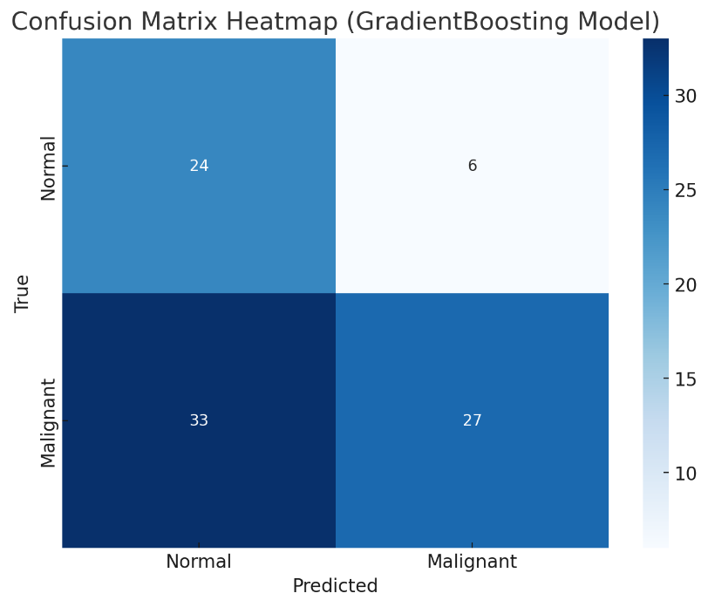

Figure 4.5 Confusion Matrix for ChatGPT Model.

4.2.2 Classification Report: Precision, Recall, and F1-score
The classification report provides a numerical summary of the model’s precision, recall, and F1-score:

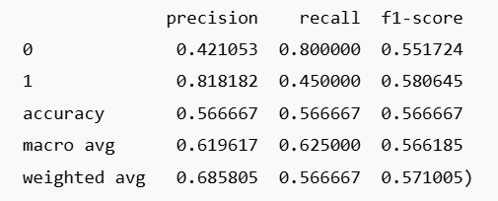

Figure 4.6 Classification Report for ChatGPT model.

            - Malignant (Class 1)

  - Precision: 0.82
  - Recall: 0.45
  - F1-Score: 0.58

b) Normal (Class 0)

- Precision: 0.42
- Recall: 0.45
- F1-Score:0.58

Overall Accuracy: 56.7%

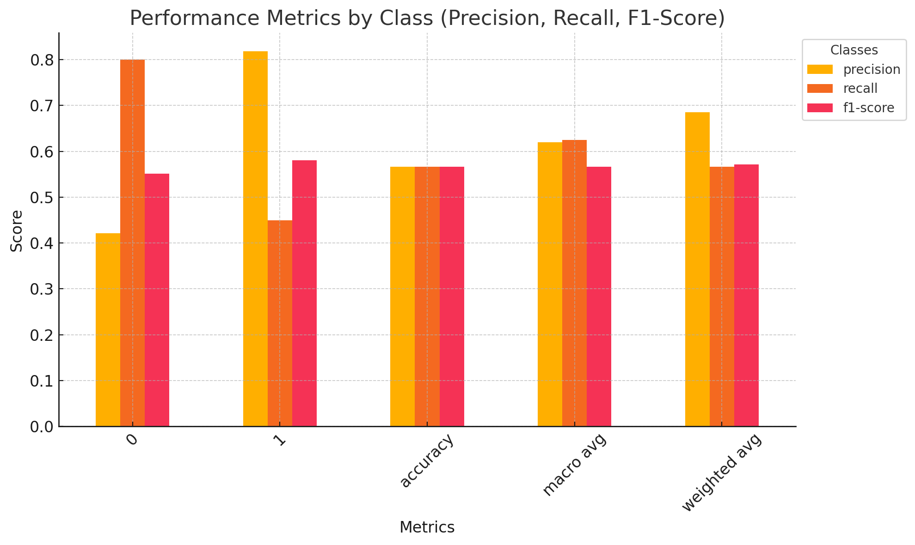
The model achieved higher precision for Malignant cases (0.82), indicating that when the model predicts cancer, it is usually correct. However, it struggles with recall for the same class (0.45), reflecting difficulty in identifying all true cancer cases. On the other hand, it recalls Normal cases well (0.80), but the relatively low precision (0.42) in that class indicates a tendency to mislabel Malignant as Normal. The macro-average F1-score (0.56) and weighted average F1-score (0.57) reinforce this observation of imbalanced class performance.

Figure 4.8 Metric Visualization of CNN Model.

The bar chart visualization helps to compare the performance between the two classes across the three major metrics: precision, recall, and F1-score. For the Malignant class, precision is high but recall lags significantly, while the Normal class displays an inverse pattern — high recall but poor precision. The closeness of F1-scores (0.55 for Normal and 0.58 for Malignant) suggests the trade-offs between false positives and false negatives nearly balance out, although the implications for clinical risk are uneven.

This visualization underscores the diagnostic pipeline's tendency to underdiagnose cancer, despite its high confidence when it does predict malignancy. From a healthcare standpoint, this might be acceptable in some triage or second-opinion systems but risky as a standalone diagnostic.

4.2.3 ROC Curve and AUC Interpretation
The ROC curve further contextualizes the model’s discriminative power. With an AUC (Area Under the Curve) of 0.55, the classifier barely outperforms random chance (represented by the 0.5 diagonal). This confirms the model’s limited ability to clearly separate the two classes, most likely due to the reduced dataset size (only 500 samples from ~40 patients) and the inherent complexity of lung CT data.The ROC curve’s gradual slope and limited rise confirm that sensitivity and specificity are both compromised, limiting the model’s utility for high-stakes diagnostic decisions in its current form. However, the slightly better-than-random AUC still suggests potential that could be unlocked with better feature engineering or more robust training data.
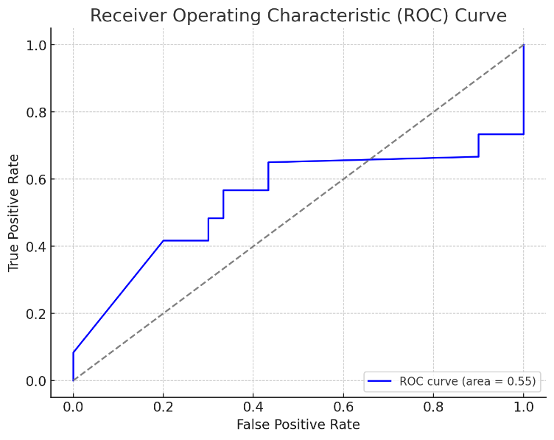

Figure 4.9 ROC curve of CNN Model.

Summary

The underwhelming overall performance can be attributed mainly to the small sample size and high variability in lung scan features. Unlike CNNs, which learn spatial hierarchies from millions of pixels, this ChatGPT-assisted pipeline depends entirely on manually extracted, low-dimensional statistical features. While this method is less computationally demanding and more interpretable, it is also more sensitive to noise and information loss during feature selection.

Another major factor is class imbalance. Despite preprocessing and patient-wise data splitting, the small number of Normal and Malignant cases made it difficult for the model to generalize patterns effectively. Additionally, unlike CNNs, this pipeline does not directly analyze image texture and shape holistically, reducing performance on complex visual data.

Although not numerically quantifiable here, one of the key strengths of the pipeline lies in interpretability. The most significant features, such as intensity variance, contrast, and skewness, were ranked using SHAP values and passed to ChatGPT for explanation. ChatGPT’s natural language outputs described how elevated contrast and irregular texture patterns could indicate malignancy, providing clinicians with a second layer of support in understanding model predictions.

4.3 Comparative analysis between the CNN-based model and the ChatGPT Model

This section presents a comprehensive comparison of the CNN and ChatGPT-based models used for the classification of lung CT images into “Normal” and “Malignant” categories. The analysis focuses on four critical evaluation dimensions: confusion matrix, classification report, ROC curves, and overall performance behavior, especially within the context of small, localized medical datasets from Bangladeshi patients.

4.3.1 Confusion Matrix Comparison
The confusion matrices of both models reflect their respective strengths and limitations in classifying Normal and Malignant lung slices.
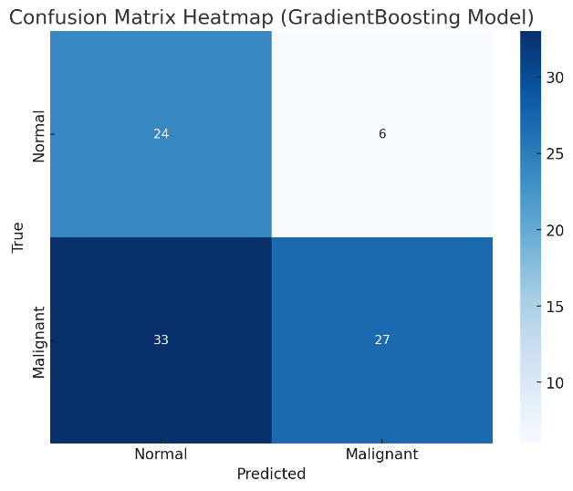

Figure 4.10 Side-by-Side Comparison between CNN & ChatGPT Generated Confusion Matrix.
          - CNN Confusion Matrix:

- Correctly classified 2040 Malignant and 842 Normal cases.
- Misclassified 252 Malignant as Normal, and 659 Normal as Malignant.
- The CNN shows higher true positives for Malignant cases (2040), suggesting a strong ability to detect cancer.
- However, the 659 false positives indicate a notable over-diagnosis tendency.

          - ChatGPT Confusion Matrix:

- Correctly classified 24 Normal and 27 Malignant.
- Misclassified 6 Normal as Malignant, and 33 Malignant as Normal.
- The ChatGPT pipeline showed a more balanced confusion matrix but lower absolute numbers, reflecting the much smaller dataset (500 slices vs. thousands in CNN).
- Misclassification of 33 Malignant cases as Normal is a clinical red flag, indicating under-diagnosis of cancer, which is more dangerous than false positives.

The confusion matrix analysis reveals key behavioral distinctions between the two models. The CNN, trained on approximately 18,500 CT scan slices from 40 Bangladeshi patients, correctly classified 2,040 malignant cases and 842 normal cases. However, it misclassified 252 malignant cases as normal (false negatives) and 659 normal cases as malignant (false positives). While the number of false negatives was relatively low—an important quality in medical diagnosis—false positives were substantial, which could potentially lead to unnecessary anxiety or follow-up procedures. Nonetheless, the CNN’s tendency to over-diagnose can be considered safer than under-diagnosis, especially when early detection is prioritized.

In contrast, the ChatGPT-based pipeline, trained on only 500 selected lung ROI slices (due to processing constraints), produced a more conservative diagnostic pattern. It correctly classified 24 normal and 27 malignant cases but showed a concerning 33 false negatives—i.e., it failed to detect more than half of the malignant samples. This higher miss rate for malignant cases indicates a serious limitation in the ChatGPT pipeline’s diagnostic sensitivity. However, it made fewer false positives than CNN (only 6), showing a bias toward normal predictions. This pattern may stem from both the limited dataset size and the indirect nature of its diagnosis, which relies on pre-extracted features rather than raw image analysis.

4.3.2 Classification Report Comparison
The classification reports provide numerical insights into the precision, recall, and F1-scores for both classes in each model.

          - CNN Model (Full Dataset) Report:

- Malignant: Precision = 0.76, Recall = 0.89, F1-score = 0.82
- Normal: Precision = 0.77, Recall = 0.56, F1-score = 0.65

- Overall Accuracy: 76%
- Weighted Average F1-score: 0.75

          - ChatGPT Pipeline (Reduced Dataset) Report:

- Malignant (1): Precision = 0.82, Recall = 0.45, F1-score = 0.58
- Normal (0): Precision = 0.42, Recall = 0.80, F1-score = 0.55

- Overall Accuracy: 56.6%
- Weighted Average F1-score: 0.57

The classification report further illustrates the models’ trade-offs. The CNN model demonstrated high precision (0.76) and excellent recall (0.89) for the malignant class, resulting in a strong F1-score of 0.82. For the normal class, the performance dipped somewhat, with a recall of 0.56 and F1-score of 0.65, indicating a tendency to over-predict malignancy. Overall, the CNN achieved an accuracy of 76%, with a weighted F1-score of 0.75, reflecting a relatively balanced classifier, skewed in favor of catching more cancer cases.

Conversely, the ChatGPT-based classifier exhibited a different profile. It achieved high precision (0.82) but low recall (0.45) for the malignant class, suggesting that when it identified a case as cancerous, it was likely to be correct—but it often failed to make that identification at all. For the normal class, recall was much higher (0.80), but precision dropped to 0.42. The overall accuracy was just 56.6%, and the weighted average F1-score stood at 0.57. These figures suggest a classifier that plays it safe—identifying more cases as normal than malignant—which, while cautious, is not ideal in critical disease detection scenarios where early identification can be life-saving.

4.3.3 ROC Curve and AUC Comparison
ROC (Receiver Operating Characteristic) curves are pivotal in assessing how well a model distinguishes between classes at various thresholds.

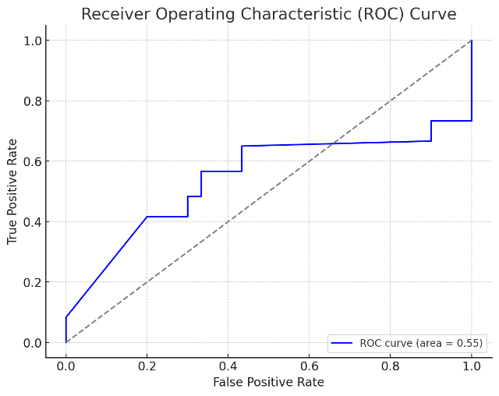

Figure 4.11 Side-by-Side Comparison between CNN & ChatGPT Generated ROC.

  - CNN ROC:

- AUC = 0.27 for Malignant class.
- Indicates inferior discriminatory power—almost worse than random chance.
- This is surprising, given the high accuracy; it suggests thresholding issues or class imbalance impacting AUC.

  - ChatGPT ROC:

- AUC = 0.55
- Marginally better than random guessing.
- Reflects the feature-driven model’s weak generalization capability, though it still edges out the CNN in AUC, likely because of better probabilistic calibration on a small set.

The ROC curve and AUC (Area Under Curve) offer another important perspective. Surprisingly, despite the CNN’s strong accuracy and recall, its AUC was only 0.27, indicating poor class separation across thresholds. This mismatch between high recall and low AUC may arise from poorly calibrated output probabilities or imbalanced data distributions, especially given the CNN’s tendency to predict malignancy more frequently. On the other hand, the ChatGPT pipeline achieved an AUC of 0.55, slightly better than random guessing, and higher than CNN’s. However, given the pipeline’s weak recall and high false negative rate, this higher AUC appears more a reflection of conservative thresholding and smaller data complexity than actual superiority in predictive modeling. It suggests that while ChatGPT’s probabilistic predictions may be more calibrated, the underlying feature set and model structure are not sufficiently discriminative.

4.3.4 Interpretability Comparison

One of the most important distinctions between the models lies in interpretability. The CNN model, by design, is a "black box"—a highly accurate classifier that offers little transparency into its decision-making. While tools like Grad-CAM or SHAP can be employed to visualize feature importance or highlight active regions in an image, the interpretation of CNN results still requires expertise and may not be intuitive for general clinicians. Moreover, CNNs are notoriously data-hungry and prone to overfitting on small, unbalanced datasets. Given that this study used CT scans from only 40 patients, overfitting likely contributed to the model’s low ROC AUC and misclassification patterns, despite the use of regularization and dropout.

In contrast, the ChatGPT-assisted model excels in interpretability, even if it lags in performance. The model uses structured, human-understandable features such as intensity, texture, skewness, and homogeneity—factors familiar to radiologists. After classification via XGBoost, the feature importance scores are fed into ChatGPT, which returns a narrative explanation. For example, ChatGPT might state that "the high skewness and low homogeneity of the lesion suggest irregular growth, consistent with malignancy." This layer of explanation transforms AI from a black box into a collaborative tool for human doctors, enhancing trust and transparency. While ChatGPT may not yet outperform CNN in raw predictive accuracy, its clinical utility is bolstered by its ability to justify predictions in plain language.

4.4 Discussion
The comparative evaluation of the CNN and ChatGPT-based models for lung cancer detection reveals distinct strengths and limitations inherent to each approach. The CNN model, trained on approximately 18,500 CT scan slices from 40 Bangladeshi patients, demonstrated a higher sensitivity in detecting malignant cases, correctly identifying 2,040 out of 2,292 malignant samples. However, it also misclassified 659 typical cases as malignant, indicating a tendency towards false positives. While potentially leading to unnecessary follow-ups, this over-diagnosis is often considered safer in clinical settings where missing a malignant case can have severe consequences.
In contrast, the ChatGPT-based pipeline, limited to 500 selected lung ROI slices due to processing constraints, exhibited a more conservative diagnostic pattern. It correctly classified 24 normal and 27 malignant cases but failed to detect 33 malignant samples, resulting in a higher false-negative rate. This underdiagnosis poses significant risks in cancer detection, where early identification is crucial. The model's reliance on pre-extracted features rather than raw image data and the limited dataset size likely contributed to its lower sensitivity.
The classification reports further highlight these differences. The CNN achieved a precision of 0.76 and recall of 0.89 for malignant cases, resulting in an F1-score of 0.82. For normal cases, the recall was 0.56, indicating a higher rate of false positives. Overall, the CNN achieved an accuracy of 76%. The ChatGPT-based model, on the other hand, achieved a precision of 0.82 but a recall of 0.45 for malignant cases, leading to an F1-score of 0.58. Its overall accuracy stood at 56.6%. These metrics suggest that while the CNN is more aggressive in detecting malignancies, the ChatGPT model is more conservative, potentially missing critical diagnoses.
The ROC curve analysis presents an intriguing contrast. The CNN's AUC was 0.27, surprisingly low given its high recall, possibly due to poorly calibrated output probabilities or imbalanced data distributions. The ChatGPT model achieved an AUC of 0.55, slightly better than random guessing, but still reflecting weak class separation. These results underscore the importance of not relying solely on accuracy metrics and highlight the need for well-calibrated models, especially in medical diagnostics.
Interpretability is another critical factor in clinical applications. CNN operates as a "black box," offering limited transparency in its decision-making process. While techniques like Grad-CAM can provide some insights, they may not be sufficient for clinical trust. In contrast, the ChatGPT-based model excels in interpretability, generating human-readable explanations based on structured features such as intensity, texture, and skewness. This transparency can enhance clinician trust and facilitate a better understanding of AI-driven diagnoses.
In summary, the CNN model demonstrates superior sensitivity and overall accuracy performance, making it suitable for large-scale screening where early detection is paramount. However, its lack of interpretability and reliance on large datasets pose challenges. While less accurate, the ChatGPT-based model offers valuable interpretability, making it a helpful tool for clinical decision support. A hybrid approach that combines the strengths of both models could provide a balanced solution, leveraging the CNN for detection and ChatGPT for explanation, which is particularly beneficial in resource-constrained settings like Bangladesh.

Chapter 5: Conclusion & Future Scope of Work

5.1 Conclusion

This project set out to explore and compare two distinct artificial intelligence approaches. Convolutional Neural Networks (CNNS) and a Chatgpt-based model for the detection of lung cancer from CT scan images of Bangladeshi patients. In doing so, the study addressed a vital healthcare challenge in Bangladesh: the lack of timely, accurate, and affordable cancer diagnostics in a country facing severe limitations in radiological resources and skilled personnel. The dataset used in this research, sourced from IBN SINA Trust, consisted of approximately 44,000 CT scan slices and was one of the few available datasets focused explicitly on the Bangladeshi population.

The CNN model was developed using transfer learning with the EfficientNetB0 architecture and demonstrated strong performance, particularly in identifying malignant and normal lung conditions. It leveraged the spatial patterns inherent in the CT images and was supported by image augmentation techniques to reduce overfitting and improve generalization. On the other hand, the Chatgpt-based model, although not trained on raw image data, used extracted radiomic and statistical features to make predictions through a gradient boosting classifier. Despite being limited to a smaller sample size of 500 slices, the Chatgpt-based approach effectively detected malignancies and contributed interpretability through feature-based reasoning.

The comparative analysis showed that while CNNS remain highly effective for image-based classification tasks, Chatgpt-based systems offer unique advantages regarding explainability and usability, particularly when working with structured data. Notably, both models highlighted the necessity of regionally relevant data and demonstrated that AI tools can be tailored to meet the diagnostic needs of low-resource settings like Bangladesh. However, performance limitations in detecting benign conditions and issues related to data imbalance and overfitting suggest that further refinement is needed before these systems can be deployed in clinical practice.

This study provides a technical comparison and a practical contribution to developing AI-based diagnostic tools suitable for emerging healthcare systems. It illustrates how vision-based and language-based models have roles to play in the future of medical AI and offers a foundation upon which more robust, scalable, and locally contextualized diagnostic tools can be built.

Future Scope of Work

While the outcomes of this research are encouraging, there are several areas where future work can significantly enhance the impact and applicability of the proposed models. One of the most pressing needs is the expansion of the dataset. Although the CNN model benefited from many image slices, the Chatgpt-based model was constrained by a significantly smaller sample size. Increasing the volume of annotated data, particularly for benign and normal cases—would improve model balance and reduce bias. Collaborations with multiple healthcare institutions across Bangladesh could support this effort and facilitate the creation of a national database for medical image research.

Another promising direction is the integration of 3d CT scan data. In this study, all models were trained on 2D slices, which, while informative, do not fully capture the spatial relationships present in volumetric scans. Transitioning to 3d data could lead to more accurate detection of tumour boundaries and better contextual understanding of abnormalities. Additionally, future multimodal AI systems combining image data with patient metadata, clinical notes, or genetic information may provide a more holistic diagnostic framework.

Incorporating Explainable AI (XAI) techniques also represents a critical avenue for development. SHAP (SHapley Additive exPlanations) or LIME (Local Interpretable Model-agnostic Explanations) can be integrated into the CNN and Chatgpt pipelines to make predictions more transparent. This is particularly important in clinical settings, where practitioners must understand the rationale behind model outputs before making diagnostic decisions.

Furthermore, exploring advanced model optimization techniques such as hyperparameter tuning, ensemble learning, and model stacking could improve classification accuracy and reduce the risk of overfitting. These strategies, combined with domain-specific feature engineering, would help build models that are not only accurate but also robust and generalisable across different patient populations and imaging environments.

Finally, the real-world applicability of these models depends on their validation in clinical environments. Pilot testing in district hospitals, telemedicine centres, or mobile diagnostic units could help assess usability, speed, and accuracy in practice. Engaging with medical professionals throughout this process will ensure that AI tools are aligned with clinical workflows and meet the ethical and operational standards required for healthcare deployment.

References
[1] S. A. Hussain and R. Sullivan, “Cancer control in Bangladesh,” Jpn. J. Clin. Oncol., vol. 43, no. 12, pp. 1159–1169, Dec. 2013, doi: 10.1093/jjco/hyt140.
[2] World Health Organization, “Cancer Bangladesh 2020 Country profile,” World Health Organization, 2020. [Online]. Available: https://www.who.int/publications/m/item/cancer-bgd-202
[3] The Business Standard, “Country’s largest radioisotope production facility set up at BSMMU,” The Business Standard, Oct. 24, 2021. [Online]. Available: https://www.tbsnews.net/bangladesh/countrys-largest-radioisotope-production-facility-set-bsmmu-320104
[4] C. Kaur and U. Garg, “Artificial intelligence techniques for cancer detection in medical image processing: A review,” Mater. Today Proc., vol. 81, pp. 806–809, 2023, doi: 10.1016/j.matpr.2021.04.241.
[5] D. M. Koh et al., “Artificial intelligence and machine learning in cancer imaging,” Commun. Med., vol. 2, no. 1, pp. 1–14, Oct. 2022, doi: 10.1038/s43856-022-00199-0.
[6] L. M. Warren et al., “The effect of image processing on the detection of cancers in digital mammography,” AJR Am. J. Roentgenol., vol. 203, no. 2, pp. 387–393, Aug. 2014, doi: 10.2214/AJR.13.11812.
[7] X. Jiang, Z. Hu, S. Wang, and Y. Zhang, “Deep learning for medical image-based cancer diagnosis,” Cancers, vol. 15, no. 14, p. 3608, Jul. 2023, doi: 10.3390/cancers15143608.
[8] B. G. Patil and N. Jain, “Cancer cells detection using digital image processing methods,” Int. J. Latest Trends Eng. Technol., vol. 3, no. 4, 2024. [Online]. Available: https://www.ijltet.org/journal_details.php?id=891&j_id=2307
[9] B. Abdillah, A. Bustamam, and D. Sarwinda, “Image processing based detection of lung cancer on CT scan images,” J. Phys. Conf. Ser., vol. 893, p. 012063, Oct. 2017, doi: 10.1088/1742-6596/893/1/012063.
[10] B. A. Reddy and D. Mandal, “Detection of lung cancer using digital image processing techniques and artificial neural networks,” J. Phys. Conf. Ser., vol. 2327, no. 1, p. 012078, Aug. 2022, doi: 10.1088/1742-6596/2327/1/012078.
[11] S. Gupta, N. Sinha, R. Sudha, and C. Babu, “Breast cancer detection using image processing techniques,” in Proc. 2019 Int. Conf. Commun. Signal Process., Mar. 2019, doi: 10.1109/ICCSP.2019.8698013.
[12] X. Tang, Y. An, and C. Li, “Intelligent segmentation and recognition method of breast cancer based on digital image processing technology,” Wirel. Commun. Mob. Comput., vol. 2021, pp. 1–9, Dec. 2021, doi: 10.1155/2021/2256316.
[13] S. Dabeer, M. M. Khan, and S. Islam, “Cancer diagnosis in histopathological image: CNN based approach,” Informat. Med. Unlocked, vol. 16, p. 100231, 2019, doi: 10.1016/j.imu.2019.100231.
[14] S. A. Hariprasad et al., “Novel approach on cancer detection,” presented at DigitalXplore Int. Conf., 2014. [Online]. Available: https://www.digitalxplore.org/up_proc/pdf/74-140014307660-63.pdf
[15] G. N. Satapathi, P. Srihari, A. Jyothi, and S. Lavanya, “Prediction of cancer cell using DSP techniques,” in Proc. 2013 Int. Conf. Commun. Signal Process., Melmaruvathur, India, Apr. 2013, pp. 149–153, doi: 10.1109/ICCSP.2013.6577034.
[16] L. Gai et al., “Comparing CNN-based and transformer-based models for identifying lung cancer: Which is more effective?” Multimedia Tools Appl., vol. 83, pp. 59253–59269, Dec. 2023, doi: 10.1007/s11042-023-17644-4.
[17] E. A.-R. Hamed et al., “An efficient combination of convolutional neural network and LightGBM algorithm for lung cancer histopathology classification,” Diagnostics, vol. 13, no. 15, p. 2469, 2023, doi: 10.3390/diagnostics13152469.
[18] S. Wankhade and S. Vigneshwari, “A novel hybrid deep learning method for early detection of lung cancer using neural networks,” Dept. CSE, Sathyabama Inst. Sci. Technol., Chennai, India, 2023.
[19] Y. H. Ali et al., “Optimization system based on convolutional neural network and Internet of Medical Things for early diagnosis of lung cancer,” Bioengineering, vol. 10, no. 3, p. 320, 2023, doi: 10.3390/bioengineering10030320.
[20] G. Sharma and G. Jindal, “Computer aided diagnosis system for detection of lung cancer in CT scan images,” Int. J. Comput. Electr. Eng., vol. 3, no. 5, pp. 714–718, 2011.
[21] L. Caruccio et al., “Can ChatGPT provide intelligent diagnoses? A comparative study between predictive models and ChatGPT to define a new medical diagnostic bot,” Expert Syst. Appl., vol. 229, Aug. 2023, Art. no. 121186, doi: 10.1016/j.eswa.2023.121186.
[22] X. Xu, Y. Chen, and J. Miao, “Opportunities, challenges, and future directions of large language models, including ChatGPT in medical education: A systematic scoping review,” J. Educ. Eval. Health Prof., vol. 21, p. 6, Mar. 2024, doi: 10.3352/jeehp.2024.21.6.
[23] R. Bapir et al., “Role of ChatGPT and Gemini in the urology field: A case-based study,” Barw Med. J., Aug. 2024, doi: 10.58742/bmj.v2i3.116.
[24] J. Wang et al., “Preliminary evaluation of ChatGPT model iterations in emergency department diagnostics,” Sci. Rep., vol. 15, no. 1, Mar. 2025, doi: 10.1038/s41598-025-95233-1.
[25] R. K. Garg et al., “Exploring the role of ChatGPT in patient care and medical research: A systematic review,” Health Promot. Perspect., vol. 13, no. 3, pp. 183–191, Sep. 2023, doi: 10.34172/hpp.2023.22.
[26] A. Altamimi et al., “Evaluating the precision of ChatGPT artificial intelligence in emergency differential diagnosis,” J. Med. Law Public Health, vol. 4, no. 1, pp. 327–337, Mar. 2024, doi: 10.52609/jmlph.v4i1.113.
[27] T. Hirosawa et al., “Evaluating ChatGPT-4’s accuracy in identifying final diagnoses within differential diagnoses compared to those of physicians,” JMIR Form. Res., Apr. 2024, doi: 10.2196/59267.
[28] J. Li et al., “ChatGPT in healthcare: A taxonomy and systematic review,” Comput. Methods Programs Biomed., vol. 245, p. 108013, Jan. 2024, doi: 10.1016/j.cmpb.2024.108013.
[29] T. Dave, S. A. Athaluri, and S. Singh, “ChatGPT in medicine: An overview of its applications, advantages, limitations, future prospects, and ethical considerations,” Front. Artif. Intell., vol. 6, May 2023, doi: 10.3389/frai.2023.1169595.
[30] S. Zampatti et al., “Innovations in medicine: Exploring ChatGPT’s impact on rare disorder management,” Genes, vol. 15, no. 4, p. 421, Mar. 2024, doi: 10.3390/genes15040421.

Appendix 1: Data Processing
!pip install pydicom opencv-python-headless tqdm
import pydicom
import cv2
import numpy as np
from tqdm import tqdm
# Install CLI tools for DICOM decompression and image conversion
!apt-get update > /dev/null
!apt-get install -y libgdcm-tools imagemagick > /dev/null
dicom_root = '/content/drive/MyDrive/DICOM FILES/dicom'
output_root = '/content/converted_slices'
# Create output folders
for label in ['Malignant', 'Benign', 'Normal']:
os.makedirs(os.path.join(output_root, label), exist_ok=True)
# Replace with your actual 40 patient names
malignant_names = ['A. HALEEM', 'ABDUR RAHMAN', 'ABUL KALAM MD.', 'DULAL', 'HARUNUR RASHID',
'JAHANGIR ALAM', 'JANNAT HASAN MRS.', 'JANNATUL FERDOUS', 'JASHIM UDDIN',
'JOJ MIAH', 'MORSHED', 'MOSLEM UDDIN', 'MOTALEB MIA', 'MOZAFFAR ALI',
'MR SAHEB PRODHAN', 'MOHAN ALI', 'SHAJAHAN', 'SIDDIKUR RAHMAN MD']
benign_names = ['ABDUL MOTALEB', 'MOSHARAF', 'NILOY DAS', 'NURJAHAN BEGUM', 'RASHED BILLAH', 'TAHMINA']
normal_names = ['DULAL SARKER MD.', 'FARUK', 'FERDOUS AHMED', 'KHORSHED ALAM', 'MANIK',
'MILONA BEGUM', 'RAZIB', 'REAZUL HAQUE', 'RITA MONDOL', 'RUMI AKTER', 'WAZED ALI']
def classify_patient(name):
name = name.upper().replace('^', ' ').strip()
if any(n in name for n in malignant_names): return 'Malignant'
if any(n in name for n in benign_names): return 'Benign'
if any(n in name for n in normal_names): return 'Normal'
return None
from pydicom import dcmread
from tqdm import tqdm
saved = 0
skipped = 0
processed = 0
max_files = None # set to e.g. 5000 to limit for testing
print(" Starting DICOM scan and PNG conversion...\n")
for root, dirs, files in os.walk(dicom_root):
for file in files:
if file.startswith('.'):
continue
path = os.path.join(root, file)
if max_files and processed >= max_files:
break
try:
ds = dcmread(path, stop_before_pixels=True, force=True)
comment = str(getattr(ds, 'ImageComments', '')).strip().lower()
modality = getattr(ds, 'Modality', 'N/A')
patient_name = str(ds.PatientName).replace('^', ' ').strip().upper()
label = classify_patient(patient_name)

if "plain" not in comment or modality != "CT" or label is None:
skipped += 1
processed += 1
continue
# Clean filename
safe_name = "".join(c for c in patient_name if c.isalnum() or c in (' ', '_')).replace(' ', '_')
out_path = os.path.join(output_root, label, f"{safe_name}_{file}.png")
# Convert DICOM to raw, then to PNG
!gdcmconv -w "{path}" tmp.dcm > /dev/null 2>&1
!convert tmp.dcm -resize 224x224 -colorspace Gray "{out_path}"

saved += 1
processed += 1
if processed % 100 == 0:
print(f" {processed} scanned | {saved} saved | {skipped} skipped")

except Exception as e:
skipped += 1
processed += 1
print(f" Error processing {file}: {e}")
continue
print(f"\n Finished! {processed} total | {saved} saved | {skipped} skipped")
import cv2
import matplotlib.pyplot as plt
import random
def preview_images(label, n=5):
path = os.path.join('/content/converted_slices', label)
files = os.listdir(path)
samples = random.sample(files, min(n, len(files)))
plt.figure(figsize=(15, 3))
for i, f in enumerate(samples):
img = cv2.imread(os.path.join(path, f), cv2.IMREAD_GRAYSCALE)
plt.subplot(1, n, i+1)
plt.imshow(img, cmap='gray')
plt.title(f"{label}")
plt.axis('off')
plt.suptitle(f"Sample {label} Slices")
plt.show()
preview_images('Malignant')
preview_images('Benign')
preview_images('Normal')
import shutil
from google.colab import files
shutil.make_archive('/content/lung_cnn_dataset', 'zip', '/content/converted_slices')
files.download('/content/lung_cnn_dataset.zip')
import os
import cv2
import shutil
import numpy as np
from tqdm import tqdm
# Define paths
input_root = "/content/drive/MyDrive/LungCNN_Slices"
output_root = "/content/drive/MyDrive/LungCNN_Slices_Filtered"

# Create output folders
for label in ['Malignant', 'Benign', 'Normal']:
os.makedirs(os.path.join(output_root, label), exist_ok=True)
# Define lung detection filter
def is_lung_slice(img, area_threshold=5000):
if img.ndim == 3:
img = cv2.cvtColor(img, cv2.COLOR_BGR2GRAY)
_, thresh = cv2.threshold(img, 100, 255, cv2.THRESH_BINARY_INV)
lung_area = cv2.countNonZero(thresh)
return lung_area > area_threshold
# Filter all slices
filtered_count = 0
skipped_count = 0
for label in ['Malignant', 'Benign', 'Normal']:
in_dir = os.path.join(input_root, label)
out_dir = os.path.join(output_root, label)
for fname in tqdm(os.listdir(in_dir), desc=f"Processing {label}"):
fpath = os.path.join(in_dir, fname)
try:
img = cv2.imread(fpath, cv2.IMREAD_GRAYSCALE)
if is_lung_slice(img):
shutil.copy(fpath, os.path.join(out_dir, fname))
filtered_count += 1
else:
skipped_count += 1
except Exception:
skipped_count += 1
continue
import matplotlib.pyplot as plt
# Preview a few lung-validated slices from the original dataset
preview_samples = []
# Collect up to 5 valid lung slices per class
for label in ['Malignant', 'Benign', 'Normal']:
folder = os.path.join(input_root, label)
count = 0
for fname in os.listdir(folder):
path = os.path.join(folder, fname)
try:
img = cv2.imread(path, cv2.IMREAD_GRAYSCALE)
if is_lung_slice(img) and count < 5:
preview_samples.append((img, label))
count += 1
except Exception:
continue
# Plotting the preview samples
plt.figure(figsize=(15, 5))
for idx, (img, label) in enumerate(preview_samples):
plt.subplot(1, len(preview_samples), idx + 1)
plt.imshow(img, cmap='gray')
plt.title(label)
plt.axis('off')
plt.suptitle(" Preview of Lung-Containing Slices (Before Saving)", fontsize=14)
plt.show()
import zipfile
# Zip the filtered directory for download
zip_path = "/content/LungCNN_Slices_Filtered.zip"
shutil.make_archive(zip_path.replace(".zip", ""), 'zip', output_root)
import ace_tools as tools; tools.display_dataframe_to_user(name="Filtering Summary", dataframe=
{
"Total Filtered (Saved)": [filtered_count],
"Total Skipped (Non-lung)": [skipped_count],
"Saved To Drive": [output_root],
"Zip Ready To Download": [zip_path]
})

Appendix 2: CNN Code
from google.colab import drive
drive.mount('/content/drive')
import tensorflow as tf
from tensorflow.keras.preprocessing.image import ImageDataGenerator
from tensorflow.keras.models import Sequential
from tensorflow.keras.layers import Conv2D, MaxPooling2D, Flatten, Dense, Dropout
from tensorflow.keras.callbacks import EarlyStopping
from sklearn.metrics import confusion_matrix, classification_report, ConfusionMatrixDisplay, roc_curve, auc
import matplotlib.pyplot as plt
import numpy as np
import os
train_dir = '/content/drive/MyDrive/LungCNN_Slices_Split_Patient/train'
valid_dir = '/content/drive/MyDrive/LungCNN_Slices_Split_Patient/test'
image_size = (96, 96)
batch_size = 8
print("Train Directory:")
print(os.listdir(train_dir))
print("\nValidation Directory:")
print(os.listdir(valid_dir))
train_datagen = ImageDataGenerator(
rescale=1./255,
rotation_range=20,
zoom_range=0.15,
horizontal_flip=True,
fill_mode='nearest'
)

valid_datagen = ImageDataGenerator(rescale=1./255)

train_generator = train_datagen.flow_from_directory(
train_dir,
target_size=image_size,
batch_size=batch_size,
class_mode='categorical'
)

valid_generator = valid_datagen.flow_from_directory(
valid_dir,
target_size=image_size,
batch_size=batch_size,
class_mode='categorical',
shuffle=False
)
model = Sequential([
Conv2D(32, (3, 3), activation='relu', input_shape=(96, 96, 3)), # Changed input_shape to (96, 96, 3)
MaxPooling2D(2, 2),

Conv2D(64, (3, 3), activation='relu'),
MaxPooling2D(2, 2),

Conv2D(128, (3, 3), activation='relu'),
MaxPooling2D(2, 2),

Flatten(),
Dense(256, activation='relu'),
Dropout(0.5),

Dense(2, activation='softmax') # Changed to 2 for 2 classes
])

# Compile the model
model.compile(
optimizer=tf.keras.optimizers.Adam(learning_rate=0.0001),
loss='categorical_crossentropy',
metrics=['accuracy']
)
model.summary()
early_stopping = EarlyStopping(monitor='val_loss', patience=5, restore_best_weights=True)
history = model.fit(
train_generator,
epochs=5,
validation_data=valid_generator,
callbacks=[early_stopping]
)
# Accuracy and Loss plots
plt.figure(figsize=(12, 5))
# Accuracy plot
plt.subplot(1, 2, 1)
plt.plot(history.history['accuracy'], label='Training Accuracy')
plt.plot(history.history['val_accuracy'], label='Validation Accuracy')
plt.xlabel('Epochs')
plt.ylabel('Accuracy')
plt.legend()
plt.title('Accuracy vs Epochs')
# Loss plot
plt.subplot(1, 2, 2)
plt.plot(history.history['loss'], label='Training Loss')
plt.plot(history.history['val_loss'], label='Validation Loss')
plt.xlabel('Epochs')
plt.ylabel('Loss')
plt.legend()
plt.title('Loss vs Epochs')
plt.tight_layout()
plt.show()
y_pred = model.predict(valid_generator)
y_pred_classes = np.argmax(y_pred, axis=1)
y_true = valid_generator.classes

# Classification report
class_labels = list(valid_generator.class_indices.keys())
print(classification_report(y_true, y_pred_classes, target_names=class_labels))
# Confusion Matrix
cm = confusion_matrix(y_true, y_pred_classes)
disp = ConfusionMatrixDisplay(confusion_matrix=cm, display_labels=class_labels)
disp.plot(cmap='Blues')
plt.title('Confusion Matrix')
plt.show()
from sklearn.preprocessing import label_binarize
from sklearn.metrics import roc_curve, auc
from itertools import cycle

# Binarize the true classes
# Use the correct number of classes in label_binarize
y_true_bin = label_binarize(y_true, classes=list(range(len(class_labels)))) # or classes=[0, 1] if you have only two classes

n_classes = y_true_bin.shape[1] # or n_classes = len(class_labels)
#Since 'n_classes' derived from y_true_bin, now adjusted to the correct number of classes(2)

# Compute ROC curve and ROC area for each class
fpr = dict()
tpr = dict()
roc_auc = dict()

for i in range(n_classes):
fpr[i], tpr[i], _ = roc_curve(y_true_bin[:, i], y_pred[:, i])
roc_auc[i] = auc(fpr[i], tpr[i])

# Plot ROC curve for each class
plt.figure(figsize=(8, 6))
colors = cycle(['blue', 'red', 'green'])
for i, color in zip(range(n_classes), colors):
plt.plot(fpr[i], tpr[i], color=color,
label=f'ROC curve of class {class_labels[i]} (AUC = {roc_auc[i]:.2f})')

plt.plot([0, 1], [0, 1], 'k--')
plt.xlim([0.0, 1.0])
plt.ylim([0.0, 1.05])
plt.xlabel('False Positive Rate')
plt.ylabel('True Positive Rate')
plt.title('ROC Curve for Multi-Class')
plt.legend(loc='lower right')
plt.grid()
plt.show()

