Parents'/Guardian's Preference of English Medium Coaching Centers: The Effect of Teacher Reputation and Word-of-Mouth Marketing

Prepared by
Name: Kaniz Fatima Eve
ID: 211011010

Supervised by
Faisal Mohammad Shahriar
Assistant Professor
School of Business

Submitted in Partial Fulfilment of the Requirements for the Degree
Bachelor of Business Administration.



19 April 2026


Internship Report Approval Form

Student Name: Kaniz Fatima Eve ID No. 211011010

Major: Marketing Year: 2026

Local Phone: +88 01977430130 Email: kaniz.fatima.bba@ulab.edu.bd

------------------------------------------------------------------------------------------------------------------------------------------

INTERNSHIP/PROJECT INFORMATION

Internship/Project: Internship

Internship Report Topic: Parents'/Guardian's Preference of English Medium Coaching Centers: The Effect of Teacher Reputation and Word-of-Mouth Marketing
Term (Tick one) : ✔ Spring 2026 □ Summer 2026 □ Fall 2026

------------------------------------------------------------------------------------------------------------------------------------------

SUPERVISOR APPROVAL (Please place a Tick)

√ Approved □ Not Approved □ Partial Re-write □ Full Re-write

Remarks (If Not Approved/Pretrial/Full Rewrite): Not Applicable


Signature: _____________________________ Date: 19 April 2026

Name: Faisal Mohammad Shahriar Title: Assistant Professor

E-mail: faisal.shahriar@ulab.edu.bd Phone: +8801673600800

Letter of Transmittal

19 April 2026.

Mr. Faisal Mohammad Shahriar
Internship Supervisor (Academic) & Assistant Professor, School of Business
University of Liberal Arts Bangladesh, Dhaka.

Subject: Submission of Internship Report.

Dear Sir,
Due to respect, I state that I have prepared my internship report on the topic of ‘Parents'/Guardian's Preference of English Medium Coaching Centers: The Effect of Teacher Reputation and Word-of-Mouth Marketing’. I hereby submit this internship report which I prepared based on my 12 weeks experience in the firm as an intern.

I have tried my best to follow your instructions and make the report as perfect as possible with a meaningful outcome within the targeted time. I have also tried my best to follow appropriate methods for the topic which I have found the most relevant and practical for my internship report. I would be glad to provide any clarifications, if required. I therefore submit it and hope that you would excuse the minor errors.

Sincerely Yours


Kaniz Fatima Eve
ID: 211011010
BBA Program
ULAB School of Business

Plagiarism Declaration

- I know that plagiarism means taking and using the ideas, writings, works or inventions of another as if they were one’s own. I know that plagiarism not only includes verbatim copying, but also the extensive use of another person’s ideas without proper acknowledgement (which includes the proper use of quotation marks). I know that plagiarism covers this sort of use of material found in textual sources and from the Internet.

- I acknowledge and understand that plagiarism is wrong.

- I understand that my research must be accurately referenced.

- This assignment is my own work, or my group’s own unique group assignment. I acknowledge that copying someone else’s assignment, or part of it, is wrong, and that submitting identical work to others constitutes a form of plagiarism.

- I have not allowed, nor will I in the future allow, anyone to copy my work with the intention of passing it off as their own work.

Name: KANIZ FATIMA EVE Signature: _________________
ULAB ID # 211011010 Date: 19 April 2026

Table of Contents

Chapter One: Internship Preparation 6
1.1 Motivation and expected learning from the internship. 6
1.2 Internship search process. 6
1.3 Internship interview experience. 7
1.4 An overview of the internship organization 7
Chapter Two: About the Internship 9
2.1 Activities of the department/office 9
2.2 Work environment 9
2.3 Duties and responsibilities as an intern 9
Chapter Three: Self Reflection 10
3.1 Highlights the likings and dislikings during internship 10
3.2 How could the internship experience be improved 11
3.3 Suggestions for the organization and future plans 12
Chapter Four: Personal Development Plan 12
4.1 Plans for further learning and career 12
4.2 Technical and interpersonal skills to develop to secure employment/career. 13
Part B 13
Chapter One: Introduction 14
1.1 Research title 14
1.2 Research objective 14
1.3 Background of the study 14
1.4 Research questions 15
Chapter Two: Methodology 15
2.1 Type of research 15
2.2 Research design 15
2.3 Study design 16
Chapter Three: Findings and Discussion 17
Chapter Four: Recommendations 25
Chapter Five: Conclusion 26
Reference 26
Appendix:
CS003 28
Part A

Chapter One: Internship Preparation

1.1 Motivation and expected learning from the internship.

To fulfill my Marketing major, I was motivated to participate in an internship to witness how the principles of marketing are realistically applied in a service-oriented environment. Because of the intense competition among educational institutions providing English-language instruction for international examinations, institutions rely heavily on their reputation, reliability, and word of mouth to attract new students; therefore, as a current teacher at Cephalon International School, I felt it would be an excellent opportunity to apply what I am learning in my classes to my job experience.

From my perspective, one of my primary motivators for participating in this internship was to learn how parents/guardians select a coaching centre for their children. I also want to know how the reputation of the teacher affects the school/centre that is chosen, and the role informal recommendations play in attracting additional students to a centre. Additionally, my goal for developing my professional skill set through this experience is to enhance my ability to communicate with parents/guardians, understanding consumer behaviours, displaying an attitude of professionalism, and conducting qualitative research. Therefore, I expect to have the opportunity to observe how marketing concepts are implemented in the educational sector and to witness how those concepts influence actual decisions made by consumers.

1.2 Internship search process.
The first step in the internship search process was determining whether my current workplace could fulfill the academic requirements for my internship course. I am currently employed at Cephalon International School as a teacher, so I considered if it would be possible to fulfill my internship requirements at my current workplace. Cephalon International School operates in a very competitive English-medium education market and provides tutoring and international exam registration services, both of which relate to several marketing concepts including positioning, reputation building, and word-of-mouth influence. Thus, I concluded that it would be appropriate to conduct my internship at Cephalon International School.
After discussing the internship requirements with the Principal (Mr. Naved Mohammed Khan), I formally requested his permission to complete my internship with him as my direct supervisor. During this discussion, we were able to discuss what my duties as an employee at Cephalon International School would be and how these duties would fit in line with my duties as a marketing intern and how they related to my research topic. Recognizing that an official offer letter from Cephalon International School confirming my internship was important in creating a formal structure for my internship and for my internship to be considered by the academic institution that I was registering my internship with (i.e. The International School of Marketing). Therefore, it was important to me that I continued being paid as a teacher for the time that I was working as a marketing intern.

1.3 Internship interview experience.
As I was already part of the organization, the interview took place in a professional yet familiar environment. The conversation centered on how I would manage my roles as a teacher and how I would be able to perform my research tasks as well. I mentioned my research interest in the subject of understanding the preferences of parents and the significance of teacher reputation and word-of-mouth marketing.

The interview process also covered professional conduct, ethical behavior, and confidentiality during the course of gathering information from parents and guardians. I learned here that it’s not just about the learning process, it’s also about being responsible and professional. I mentally prepared myself for conducting research activities in a structured and disciplined manner.

1.4 An overview of the internship organization
1.4.1 An overview of Cephalon International School :

History: Cephalon International School is an English medium educational institution located in Dhanmondi, Dhaka, Bangladesh. It offers internationally recognized and standardized educational qualifications, including major foreign examination programs. Over time, the institution’s academic activities have mainly focused on the Edexcel-Pearson system and the registration of international examination programs for its students. Cephalon International School has gained competitive strength in the English medium educational sector by recruiting highly skilled and well-qualified teachers and implementing well-structured and well-planned educational activities.

Vision: The vision of Cephalon International School is to achieve the highest standard of international educational quality so that its students can access local and global social and economic opportunities. It aims to ensure the educational needs of its students with strong academic support for international programs of study.

Mission: The mission of Cephalon International School is to ensure the educational activities of the institution are based on well-structured and conceptually sound methodologies with the involvement of highly qualified and highly experienced teachers. It also aims to ensure proper guidance for its students regarding Edexcel international examination programs, including IGCSE, O Level, and International A Level, etc.

Objectives: The major objectives of Cephalon International School are:
- Academic excellence in international curricula.
- Proper guidance in international examination registration.
- Building effective relations with parents and guardians.
- Building trust and credibility in the English medium educational sector.

Goals: The long-term goal of Cephalon International School is to ensure the establishment and maintenance of its trust and credibility in the English medium educational sector in the Dhanmondi area, with the highest quality and professionalism in its academic activities.

1.6.2 Products and Services of Cephalon International School:
The academic services provided in the Cephalon International School are junior classes up to O Level and A Level. The organization also provides coaching services to the students who appear in the IGCSE, O Level, and A Level exams.

One of the most important services provided by the organization is the registration of international exams under the Edexcel Pearson board. The organization also provides academic counseling services to the students and prepares the students to appear in the board exams. These services help the organization establish itself in the English medium educational sector.

1.6.3 Key people of Cephalon International School:
The Principal of the Cephalon International School is Mr. Naved Mohammed Khan, who also acted as my supervisor in the organization during the internship program. He is an experienced teacher in the Physics department for IGCSE and IAL students. The vice-principal of the Cephalon International School is MD. Rashedul Islam, who is also the coordinator of Axis Education. He is also an experienced teacher in the Mathematics department for Pre O Levels students. The organization also has experienced teachers in various subjects like Mathematics, Science, English, and Business.

Chapter Two: About the Internship

2.1 Activities of the department/office
The activities of the institution are primarily academic and administrative in nature. The academic department is responsible for the academic process, designing the course syllabi, preparing examinations, and evaluating the students. On the contrary, the administrative office is responsible for documentation, examination registration, and maintaining a professional relationship with the parents or guardians of the students. During the internship period, I got a glimpse of the academic and administrative activities of the institution. I got to see how the institution responds to the parents' queries and maintains a professional attitude while dealing with the parents and guardians of the students.

2.2 Work environment
The work environment of Cephalon International School is highly disciplined, and the academic process is given a high priority. The staff of the academic department are punctual and strictly adhere to the academic process. There is a high degree of mutual respect among the staff of the institution. The communication between the management and the staff is highly professional. The interaction with the staff of the institution helped me understand the need to maintain a professional attitude in academic and administrative activities.

2.3 Duties and responsibilities as an intern
I continued to function in my capacity as an instructor for students in Class 6 to Pre-O Level. I assisted students in examination-related activities and in overall communication related to examination registration. In addition, I observed the overall interaction between parents and the school regarding queries and examination-related registrations. From a marketing perspective, I observed how parents rate teachers and how recommendations from people impact their opinions, thus impacting the study.

2.4 Learnings and acquired skills from the internship
The internship helped me to enhance my skills in communicating with people, especially with students and guardians. The internship also helped me to enhance my skills in managing classes and being professional in different situations. Furthermore, I was able to enhance my skills in observing and analyzing people, especially parents. It helped me to understand how different concepts of marketing, such as word-of-mouth, quality, and reputation, affect various sectors, such as education. It also helped me to gain confidence in applying my academic learnings.

2.5 How learnings from internship enhanced academic learnings
The internship helped me to understand the practical implications of various concepts of marketing. I gained knowledge about consumer behavior, service marketing, and reputation management through observing parents’ decision-making behavior regarding which coaching centers to select for their children. I realized that concepts of marketing are not limited to only those sectors that are related to products, but they are equally applicable to sectors such as education.

Chapter Three: Self Reflection

3.1 Highlights the likings and dislikings during internship

Likings:
- I appreciated the opportunity to operate within a professional academic environment.
- I appreciated the opportunity to interact with students at different levels in their academics, especially O Level and A Level students.
- I found it informative and interesting to observe how parents interact with the institution prior to the enrollment process.
- I perceived that the teacher’s reputation contributes greatly to gaining the trust of parents.
- I gained knowledge on the procedures that are followed in the registration process for examinations with the Edexcel Pearson board.
- I appreciated the guidance and supervision offered by the Principal and the teachers in the institution.
- I appreciated the opportunity to link the theories of marketing with the realities in the application of the theories in the field of marketing.

Dislikings:
- There were moments that were difficult in balancing the responsibility of the teacher with that of the research assignment.
- There was a lack of information regarding the feedback from parents, which made the research process difficult.
- The workload was slightly higher during the examination registration period.
- Time management was at times stressful.

3.2 How could the internship experience be improved
Although the overall experience of the internship has been positive and educational, there are certain areas in which improvement can be made. A potential improvement would be to have a more organized system in place to document and store the feedback provided by parents. The feedback is currently documented manually. A more organized system, such as a computerized system, would be more efficient and would help in the research process in the future as well.

Another potential improvement would be to have a more organized research activity process. As I had to attend to my teaching duties as well, at times it became quite challenging to manage the two tasks simultaneously. A more organized system would have helped in the efficient completion of the research task, and the entire process would have been less stressful.

Furthermore, holding more frequent internal meetings to discuss the trends in research and the feedback provided by parents could also be an improvement in the marketing planning process. These would not only be advantageous for the interns but would also result in an improvement in the overall management system of the institution.

3.3 Suggestions for the organization and future plans
After gaining experience from the internship, I feel that the organization could further strengthen its marketing strategies by implementing a more organized system of parent satisfaction surveys. These would help in the identification of the areas in which parents are satisfied and the areas in need of improvement as well.

Another potential improvement could be in the institution's online communication system. Parents often seek references from others and check the online presence of the institution as well. A more organized online communication system would be advantageous in this case as well.

Furthermore, the institution could also maintain a data bank of success stories from its former students, as this would have a more positive impact on the overall marketing process through word-of-mouth as well. The achievements of the students would reflect positively on the institution as well, and this would result in more new admissions as well.

From a personal point of view, I would like to continue in the education sector, and in the future, I would like to apply marketing concepts more effectively.

Chapter Four: Personal Development Plan

4.1 Plans for further learning and career
The entire internship process has helped me understand and realize the importance of integrating academic knowledge with practical experience. In the upcoming years, I would like to further focus on and specialize in the marketing research field, especially in the qualitative research methods sector, including interview and content analysis techniques.

In addition, I would like to have the opportunity of gaining more in-depth knowledge about service marketing and consumer behavior in the educational sector. In order to boost my chances in the corporate world, I would like to attend various professional marketing analytics and digital marketing techniques based workshops, training programs, and certification courses.

My long-term career aspiration is to have a professional career in the field of marketing, especially in the service sector, and in the educational sector, as reputation management and relationship marketing are very important in this sector.

4.2 Technical and interpersonal skills to develop to secure employment/career.
In order to have more chances in the corporate world in the coming years, I need to further develop technical and interpersonal skills. From a technical point of view, I would like to further develop my research analysis, report writing, and data interpretation skills. In addition, I would like to learn more about digital marketing tools and basic marketing analytics software to remain competitive in the coming years.

In terms of interpersonal skills, I would like to further develop my leadership, teamwork, and communication skills. In the field of marketing, I would have to interact with clients on a regular basis, and hence, I would like to further develop my negotiation and presentation skills to boost my chances in the corporate world in the coming years.

Part B

Chapter One: Introduction

1.1 Research title
Parents'/Guardian's Preference of English Medium Coaching Centers: The Effect of Teacher Reputation and Word-of-Mouth Marketing

1.2 Research objective
The objective of the study are as follows:
- To explore how parents/guardians find and choose English Medium coaching centers for their children.
- To examine how the reputation of the coaching center affects parents'/guardians' selection process.
- To examine how word-of-mouth marketing affects the parents'/guardians' selection process.

1.3 Background of the study
Over the past few years, there has been an immense growth in the requirement of English Medium coaching centres in Bangladesh. A huge number of students are preparing for international exams like IGCSE O Levels and A level, raising the demand and in the long run the number of English Medium coaching centres, resulting in highly competitive environments in the education sector.

Parents/Guardians are the main decision makers for selecting the best Coaching Centre for their children. Since the education sector is a service based sector, parents/guardians are not able to assess the quality of education until they get their respective children enrolled in the respective coaching centre. Therefore, they have to rely on various factors such as teacher’s reputation, student’s performance at the respective coaching centre, reputation of the coaching centre and recommendations.

One of the most important factors that influence the decisions of parents/guardians in choosing the best coaching centre is the teacher’s reputation. Parents/Guardians want to enroll their children in a coaching centre where the teachers are highly experienced. The parents/ guardians feel that teachers with higher qualifications can have a positive influence on their children’s academic performance.
Moreover, word-of-mouth marketing is also one of the most significant factors that influence the decisions of parents/guardians in choosing the best coaching centre for their children in the English Medium coaching centre sector. The recommendations from friends, relatives, other parents/guardians, and other students provide the parents/guardians with the level of trust and certainty they need, in order to make a decision. Informal ways of communication with each other tend to have a greater influence on each other's decisions than formal ways of advertising/promoting.

As a result, a study needs to be conducted to understand the measures taken by the parents/guardians when choosing a coaching centre for their children having all the factors taken into account. This research will provide a quantitative analysis of these factors.

1.4 Research questions
- How do parents/guardians find and choose English Medium coaching centres and how do these coaching centres’ reputation affect the process?
- How do word-of-mouth marketing affect the parents'/guardians' selection process of English Medium coaching centres for O Level and A Level students?

Chapter Two: Methodology

2.1 Type of research
The research is qualitative in nature. The study is based on the perception, preferences and decision-making process of the parents/guardians when choosing the best English Medium Coaching centres for their children. The research is appropriate for qualitative research because being the researcher, I am able to understand the opinions, experiences, and beliefs of the parents/guardians of the children. The findings of the research are also descriptive in nature based on the interpretations of the feedback taken from the parents/guardians.

2.2 Research design
The research is based on the descriptive research design. The main purpose of this research is not to test the hypothesis but it is based on the exploration of the behavior of the parents/guardians when it comes to selecting the best English Medium coaching centres for their children and the influence of teacher reputation and word-of-mouth marketing.

The research is conducted within the context of Axis Education, the after school academic services under the coaching initiative of Cephalon International school, where the parents/guardians of the children who are appearing for the IGCSE O Level and A Level observed and their response collected via Google form. The research design allows the collection of detailed responses from the participants and helps identify the common grounds related to English Medium coaching centre preference.

2.3 Study design
2.3.1 Sampling technique: The population of this research will include parents/guardians of International Examination candidates, i.e., IGCSE and O/A Level students of Axis Education. The sampling technique for this research is purposive sampling. The parents/guardians who are directly involved in the enrollment and registration process were selected as they are relevant for this research purpose. Only those parents/guardians who have experience in selecting a coaching center were considered as appropriate for this research.

2.3.2 Data collection technique: The data for this research was collected using a structured Google Form, mainly for parents/guardians of IGCSE and O/A Level candidates. The Google Form was sent to the parents/guardians who are directly involved in the enrollment and registration process with the organization. The questions were related to how parents got to know about the coaching center and what factors influenced their decision in selecting the particular coaching center. The questions will also be related to factors such as teacher reputation, recommendations, credibility of the organization, and overall perception of the particular coaching center. Along with the Google Form, the feedback records of the organization will also be considered for the purpose of this research.

2.3.3 Data analysis technique: The data was analyzed using qualitative content analysis. The responses were carefully evaluated and categorized under headings such as teacher reputation, influence of other people, trust, and credibility of the organization.

Similar responses are classified in respective sections in order to extract the core idea behind the choice of the parents/guardian’s preference and is written in a descriptive format. The research result is written in descriptive format due to the research being qualitative and not quantitative. This is because a descriptive format will help to achieve the purpose of the research which is to understand why and how parents/guardians prefer a particular coaching center despite having many options available.

Chapter Three: Findings and Discussion
Given below is the discussion based on the outcomes and evaluations of the information gathered from parents/guardians of IGCSE O level and A level students. The platform chosen and used in order to collect the information was Google Form.

1. Relationship with the Student
Most of the responses were received from parents whereas fewer were received from guardians. This shows that when it comes to choosing the best coaching centers for their respective children, parents are the main decision makers.
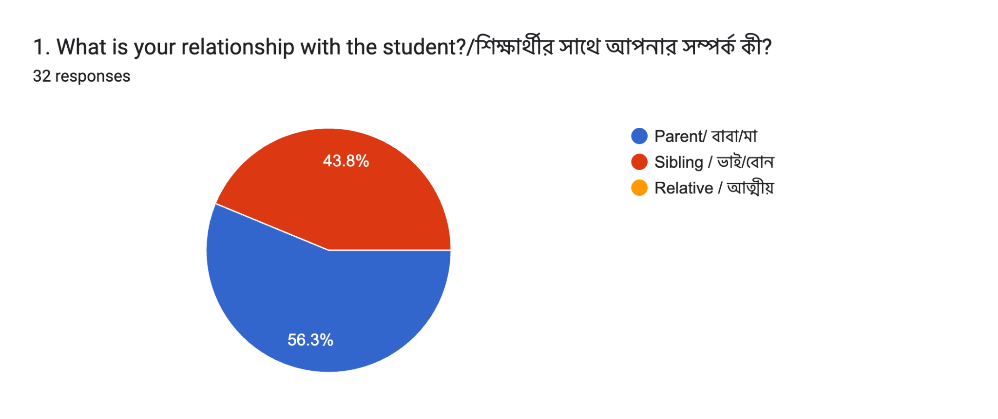

2. Role in getting student enrolled
The majority of the parents who responded, have children studying for IGCSE O Level, whereas a much smaller portion of parents have their children studying for A Level.

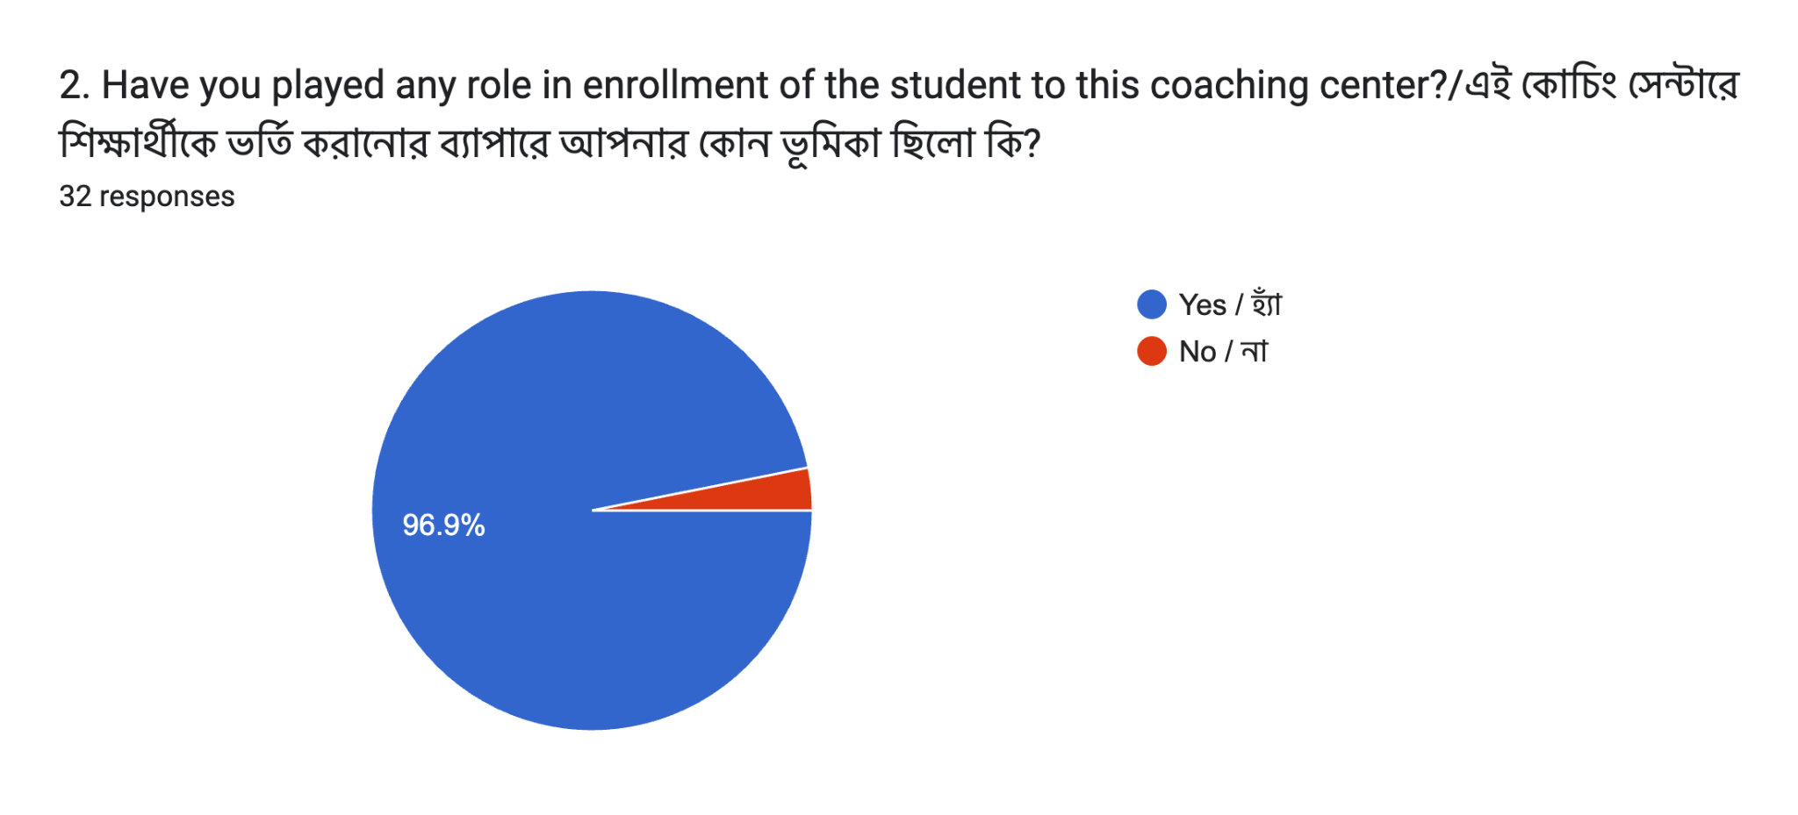

3. Enrollment Period
The enrollment period is varied according to the responses. Some students have been enrolled for a long time while others have been enrolled for a shorter period.
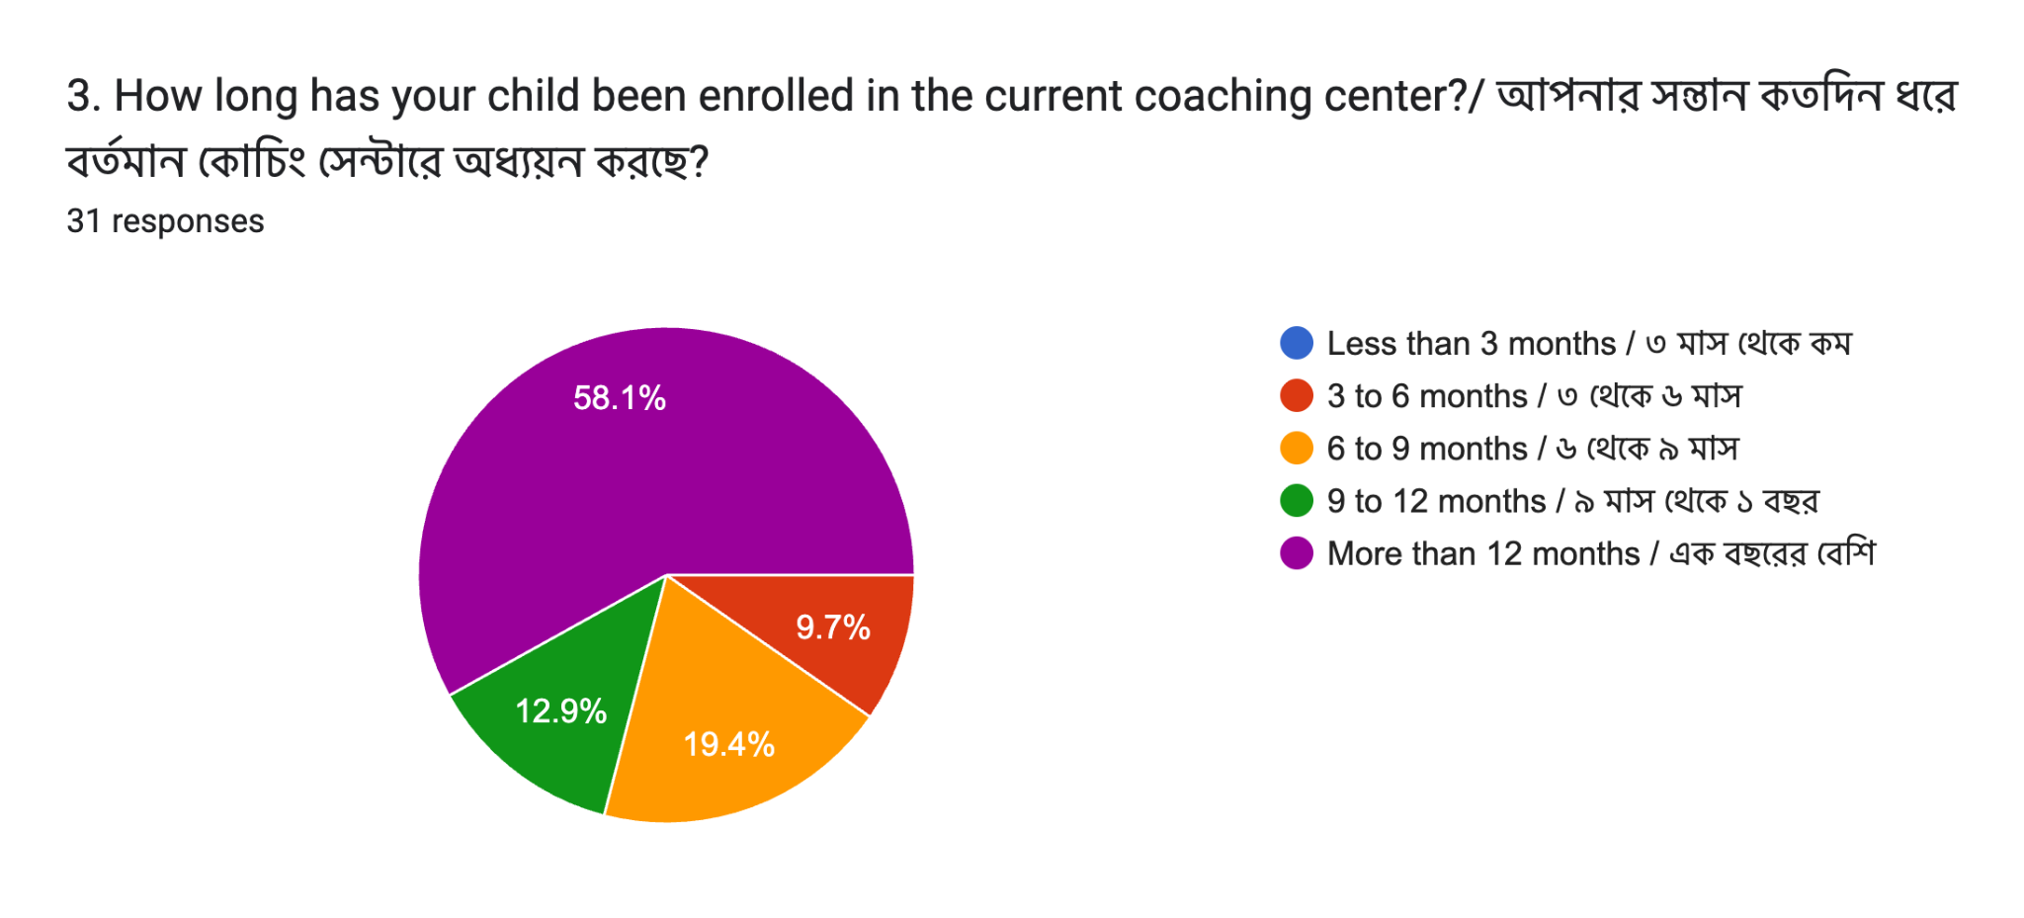

4. Information Source
Most of the parents and guardians responded by stating that they got to know about the coaching center through their friends and fellow parents. A few of them also responded by stating their familiarity with the teacher. This indicates that awareness about the coaching center is greatly facilitated by word of mouth.
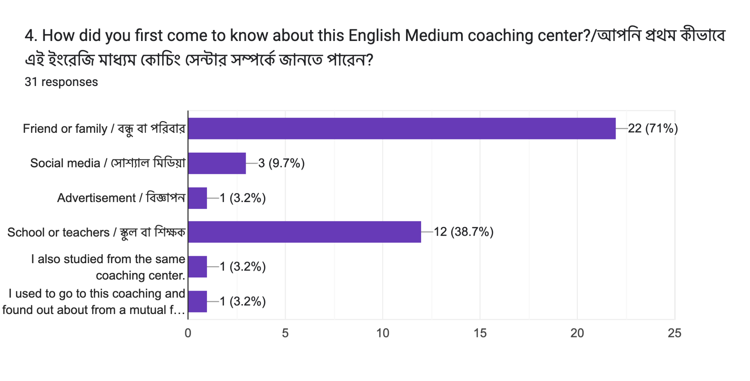

5. Justifications for Thinking About the Coaching Center
From the results, it is evident that the most important factor for parents to think about was the reputation of the teacher. This was also echoed by a number of respondents. This indicates that academic reputation is of utmost importance to parents.
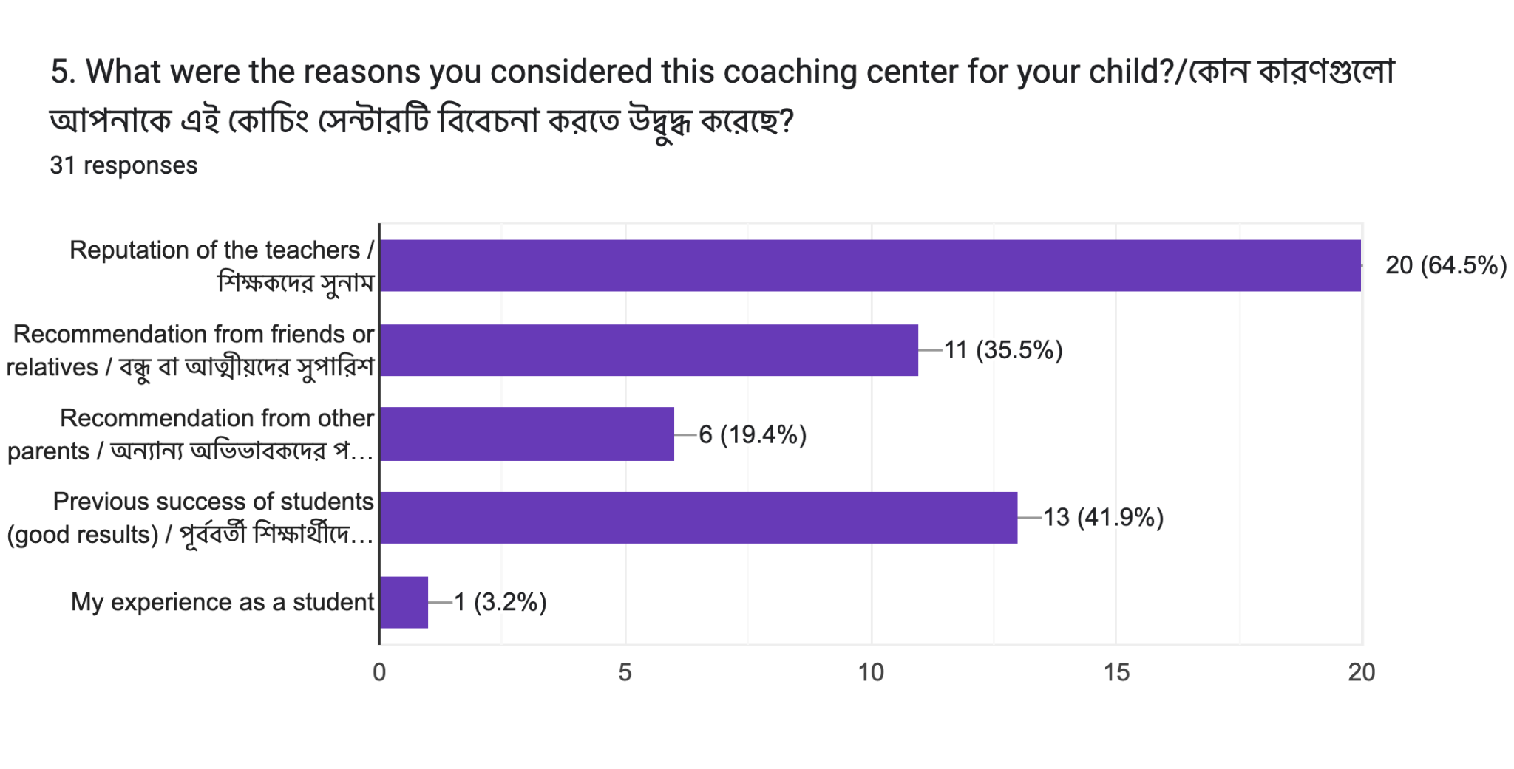

6. Elements Affecting the Ultimate Choice
A number of factors affected the choice of parents to select the coaching center over others. Apart from recommendations by reliable sources and academic performance, the reputation of the teacher was an important factor for parents. Another factor was convenience. This indicates that parents do not base their decisions on a single factor.
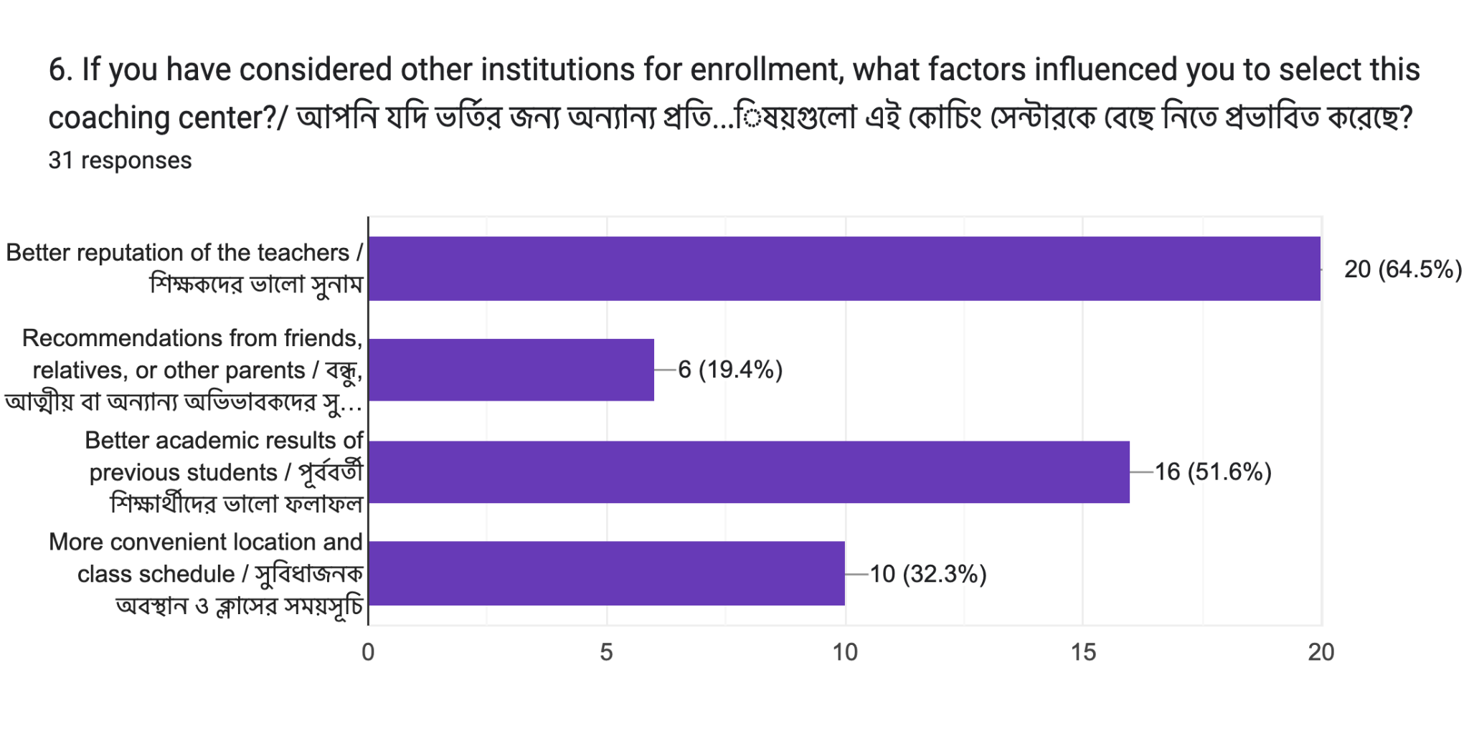

7. The value of teacher’s reputation
The majority of the respondents agreed to the point that while selecting a coaching center, the teacher's reputation is crucial. Parents/guardians believe that well-known and experienced teachers can enhance academic achievements and offer great supervision to their respective children. This shows how important a teacher’s reputation is when making decisions.
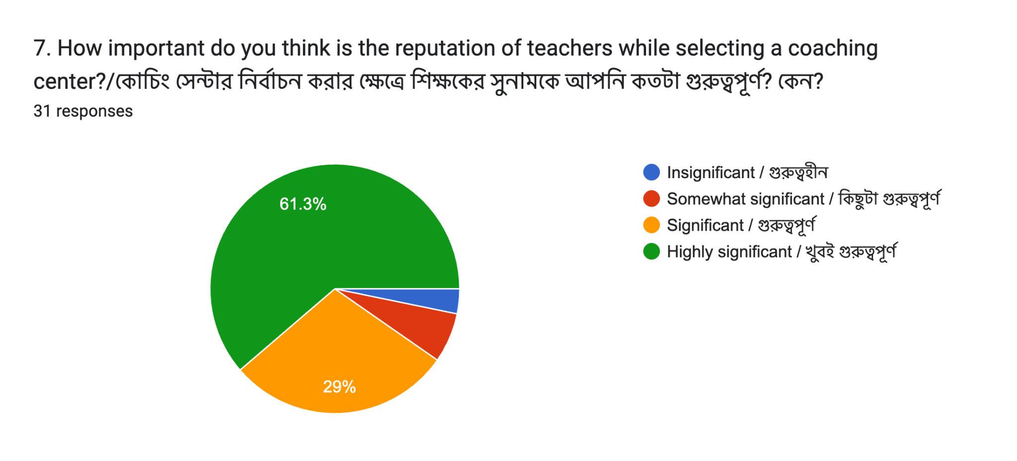

8. Influence of specific teachers
Several parents/guardians have agreed that their choice was directly influenced by the reputation of specific teachers. In a few cases, the respondents stated that they have selected the institution because of particular teachers. This shows that individual teacher reputation has an impact on drawing students in.
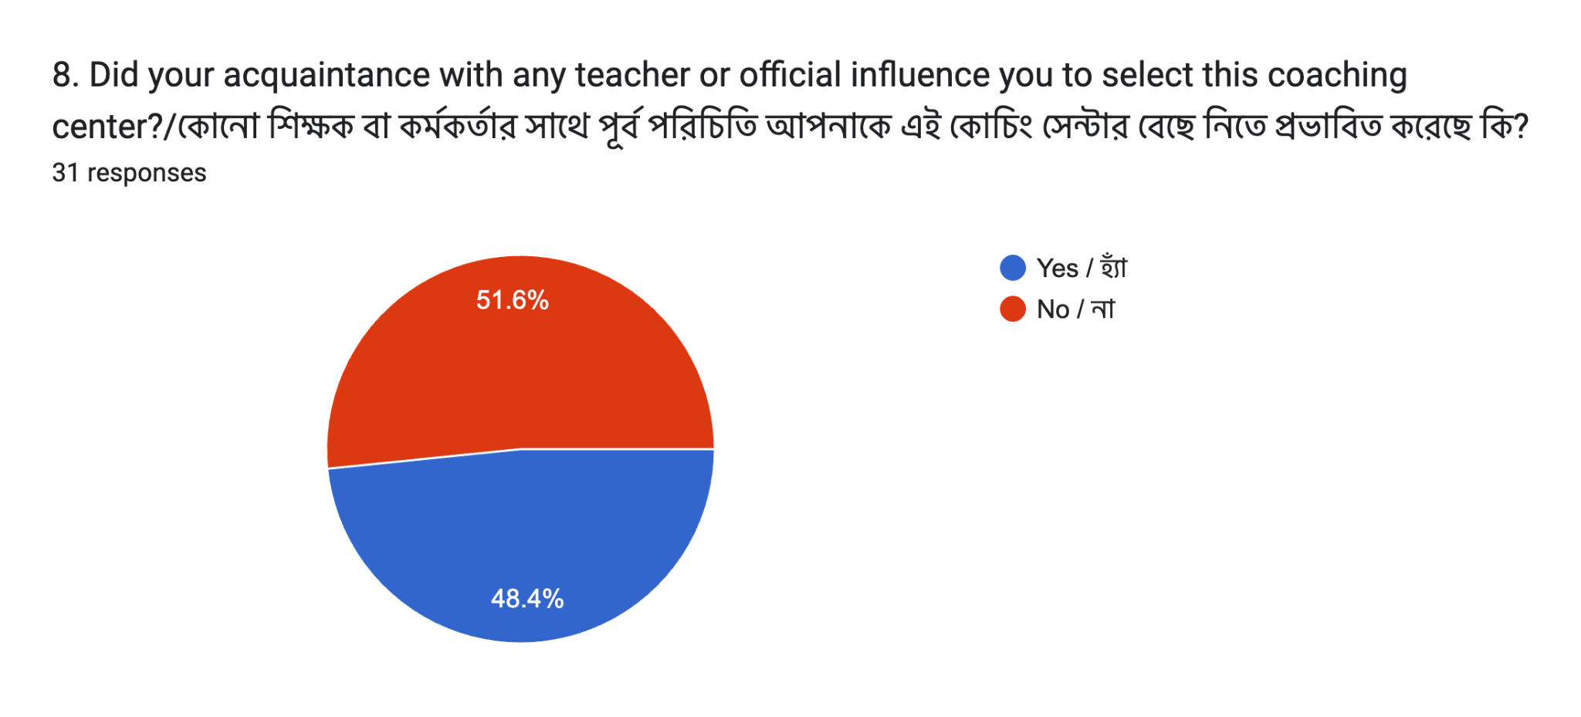

9. teacher qualities affecting reputation
Strong topic knowledge, clear explanations, positive student results, and a supportive attitude are few of the several qualities identified by the parents that contribute to the teacher's reputation. This shows how both teaching skill and student performance contribute to the teacher's reputation.

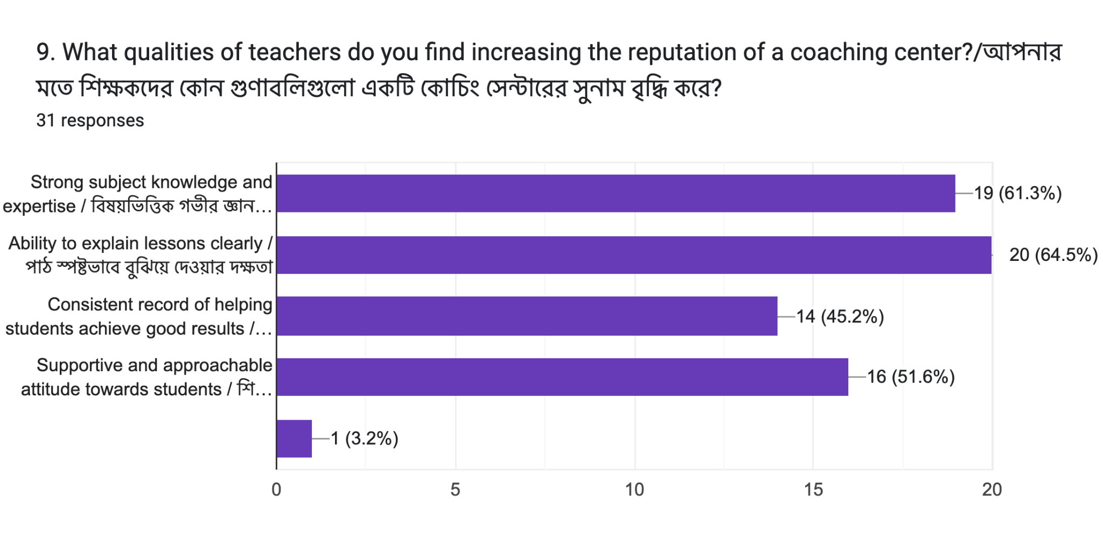

10. role of recommendations
The majority of the respondents acknowledged that they got referrals from friends, family, or other parents before choosing the coaching centre. This shows that word-of-mouth communication plays a significant role in the process of forming decisions.

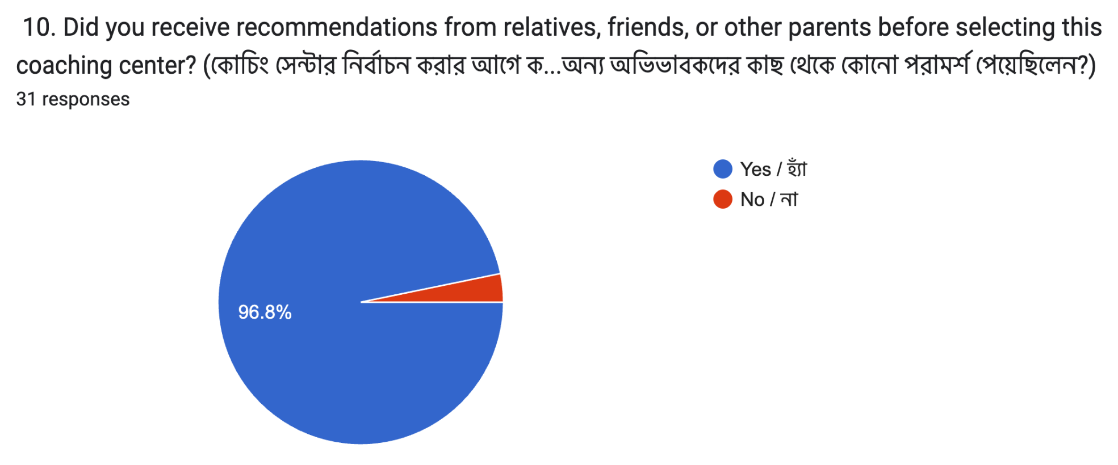
11. level of influence of recommendations
The majority of the respondents agreed that recommendations had a significant or moderate impact on their choice. This shows how prevalent and powerful word-of-mouth is.
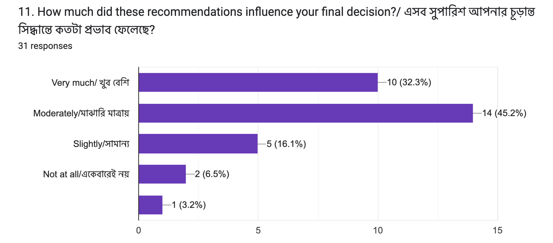

12. reliance on other’s opinion
The majority of the parents said that while selecting educational institutions, they usually relied on the opinions of others. Their answers suggest that recommendations eliminate uncertainty and boosts confidence throughout the process of decision-making.

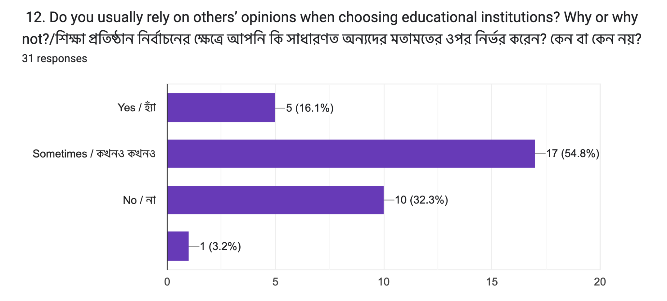
13. crucial factors in the selection process
The answers to this question hints towards the fact that parents, very commonly, take into account factors such as structured syllabus coverage, proper student evaluations frequently done by teachers, positive learning environment, and individual attention along with reputation and recommendations.
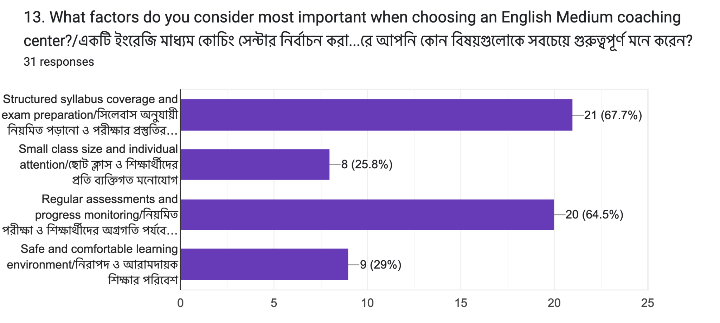

14. Trust factors in the selection process
The answers to this question suggests that parents strongly believe that when a coaching center maintains strong and transparent communication, employs qualified and trained teachers, and follows a strict, structured academic system, it thus becomes trustworthy enough for them to trust the institution with their respective children. This shows how both internal and external perception plays a strong role in building trust.
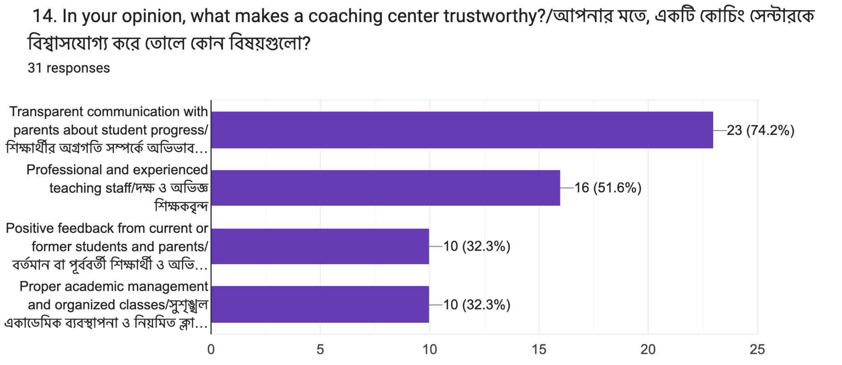
15. Recommendations to others
Most of the answers to this question stated that the parents would recommend the coaching center to others. This indicates a higher level of satisfaction and a strong word-of-mouth marketing taking place among the parents/guardians.

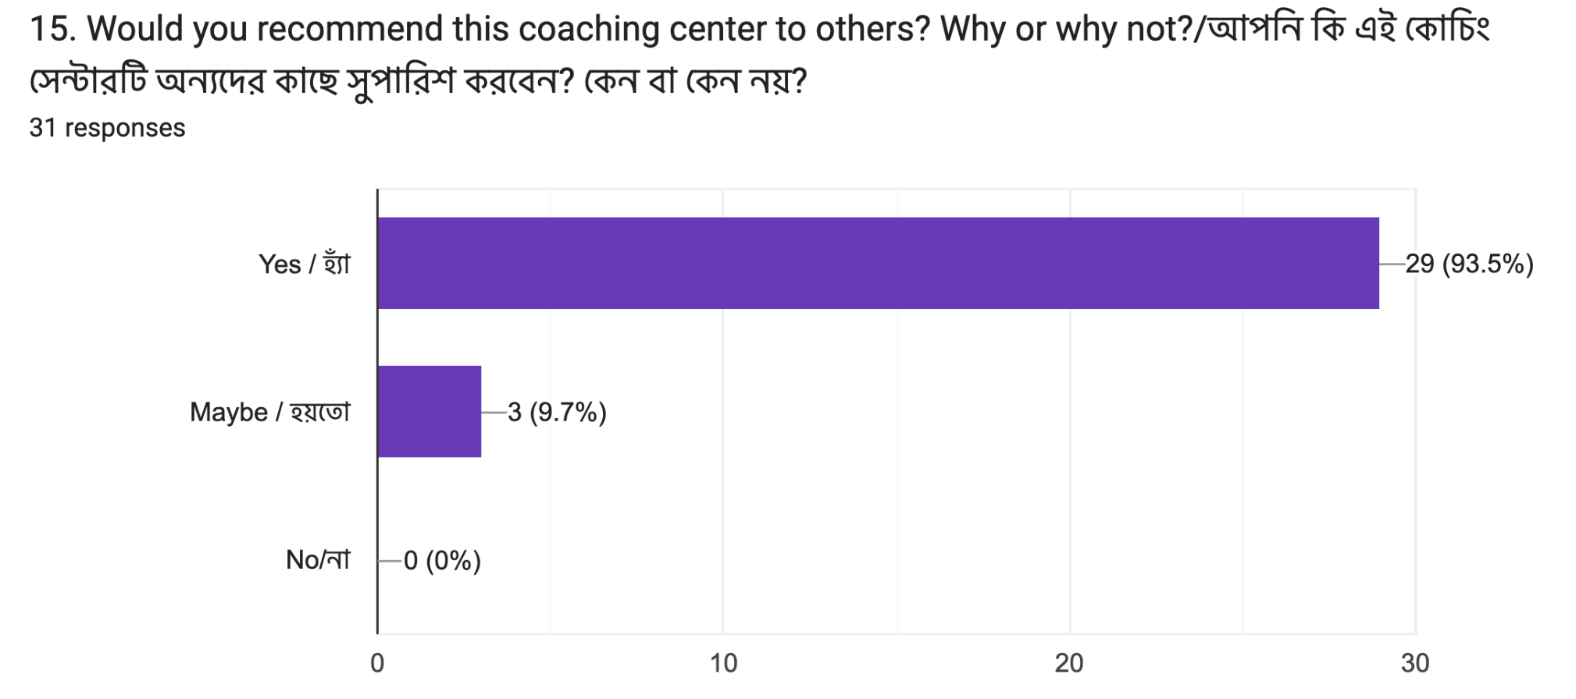

Chapter Four: Recommendations
Below are a few recommendations, based on the findings of the study, that are suggested in order to improve the institution’s performance and strengthen its marketing strategy efficacy:

- The teacher’s reputation being one of the most crucial factors, the institution should continue to maintain its teacher’s quality. It is very important to recruit teachers who are well experienced. The institution must also provide the teachers with proper academic resources in order to support them. Training and performance evaluation after every 6 months can also be a good addition to their internal system’s enhancement.
- The institution should also actively build strong relationships with parents/guardians by ensuring their satisfaction level to be high as this will in turn help the institution gain word-of-mouth marketing naturally by these parents.
- Maintaining a yearly based feedback system can also help the institution to include constant improvements in their system. Opinions from parents/guardians, as well as students, will help the institution to find out its flaws and rectify them.
- Focusing more on students' achievement by maintaining constant good academic results and giving them and the stories behind the achievements, the exposure, can also result in strengthening the institution’s image and attracting new students.
- Focusing on the digital presence is also very important. As people have become more dependent on social media and the internet, maintaining a page and regularly updating the progress, academic plans, its strengths and uniqueness, increases visibility and reach a wider audience.

Chapter Five: Conclusion
The study explored parents/guardians’ preferences in selecting English Medium coaching centers based on teachers reputation and word-of-mouth marketing. The findings show that parents play a crucial role in decision-making and consider multiple factors. Among all the factors, teachers' reputation emerged as the most important factor. Well-known and experienced teachers are building trust among students and parents which in the long run is helping them attract more students. Recommendations help increase the word-of-mouth marketing which significantly affects parents/guardians choice and decision when it comes to selecting a coaching center for their respective children. Growth in academic results, enhancement of a positive learning environment, qualityful teaching, maintaining strong communications, together all of them fosters trust among parents/guardians, which influences their decisions. Therefore, both the teacher's reputation and word-of-mouth marketing are important when it comes to factors in parents' decision making process of selecting English Medium Coaching centers.

Reference
Bosetti, L. (2004) ‘Determinants of school choice: Understanding how parents choose elementary schools in Alberta’, Journal of Education Policy, 19(4), pp. 387–405
Cethalon International School (2025). About Us. Available: https://www.facebook.com/cethaloninternationschool. Accessed: 15 December 2025.


Appendix:
CS003

INTERNSHIP PROPOSAL FORM

Name: | Kaniz Fatima Eve
ID: | 211011010
Department: | Department of Business Administration, ULAB School of Business
Supervisor’s Name (Faculty): | Faisal Mohammad Shahriar
Organization Name: | Cephalon International School
Internship Title: | Parents'/Guardian's Preference of English Medium Coaching Centers: The Effect of Teacher Reputation and Word-of-Mouth Marketing

Student’s signature & date Supervisor’s signature & date
19 April 2026 19 April 2026

Internship Confirmation Letter
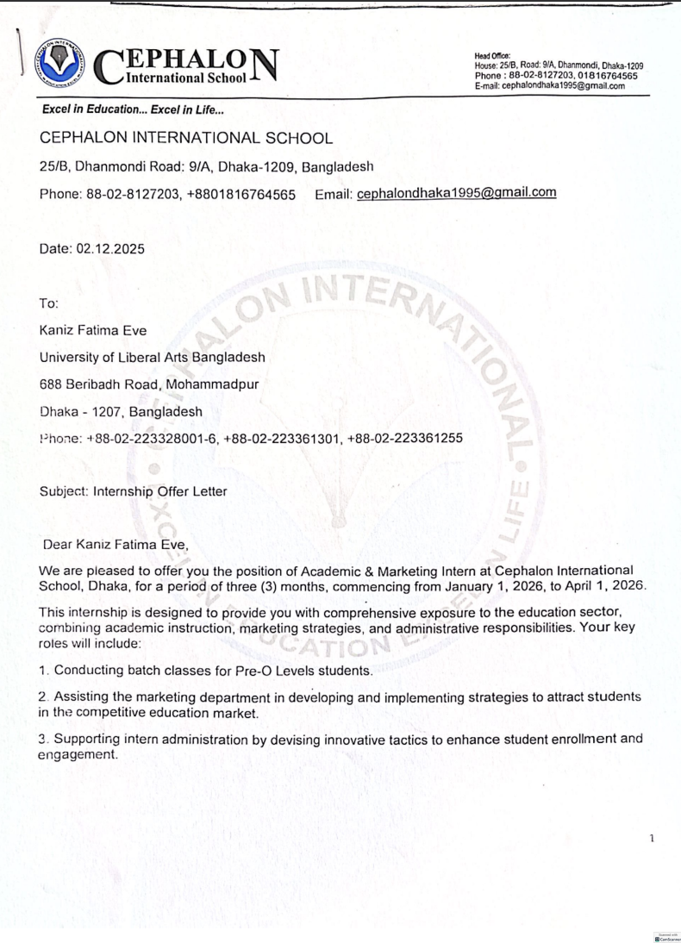

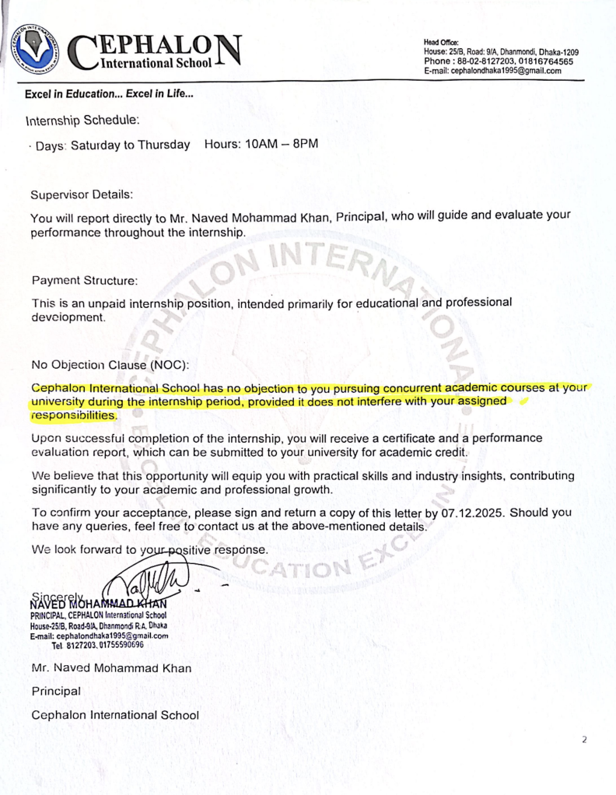
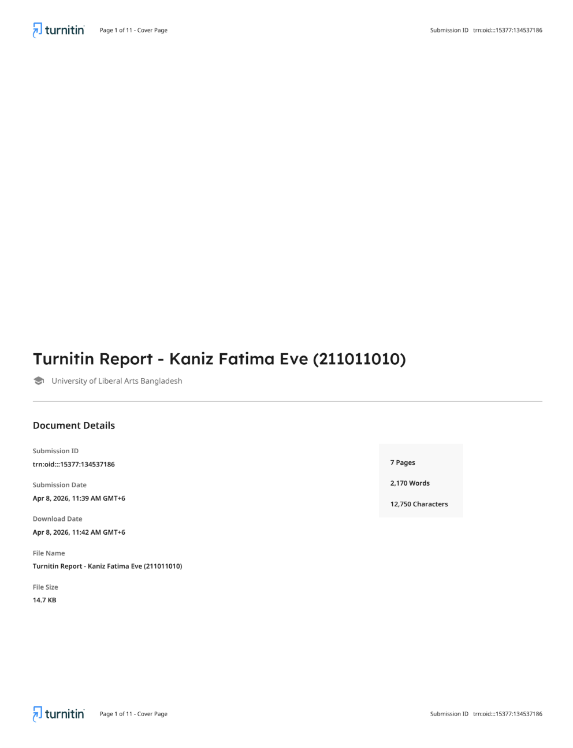

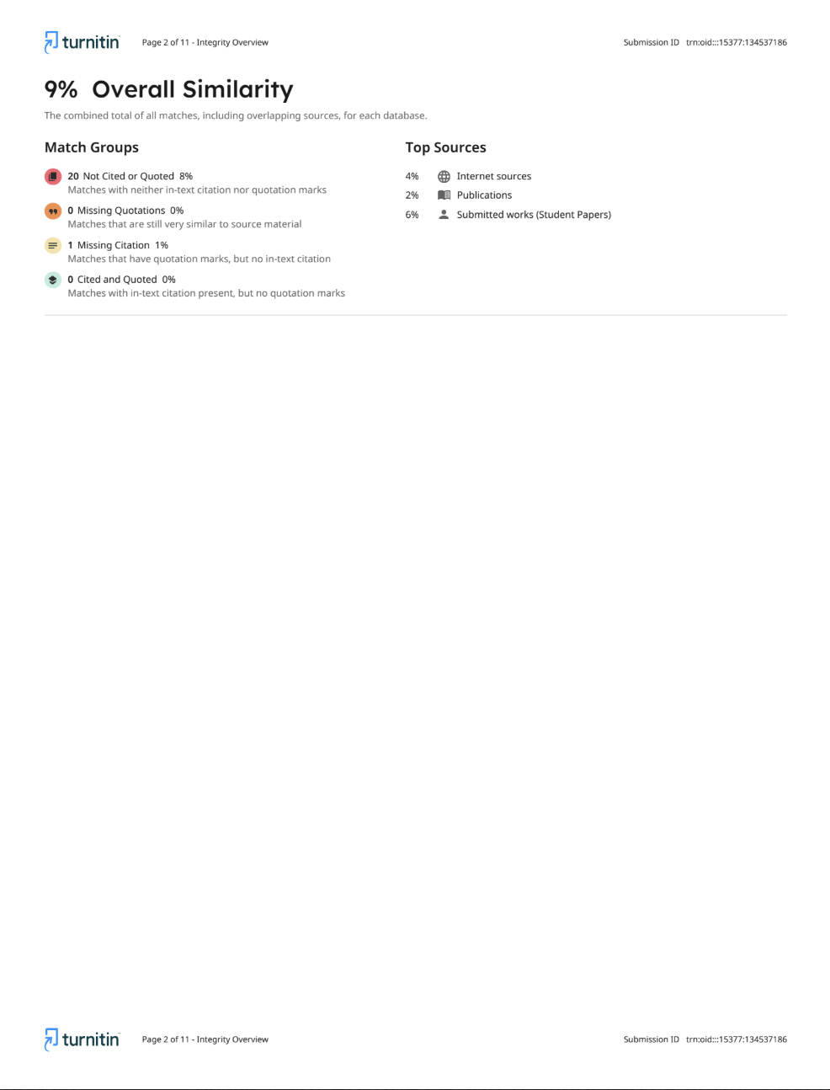

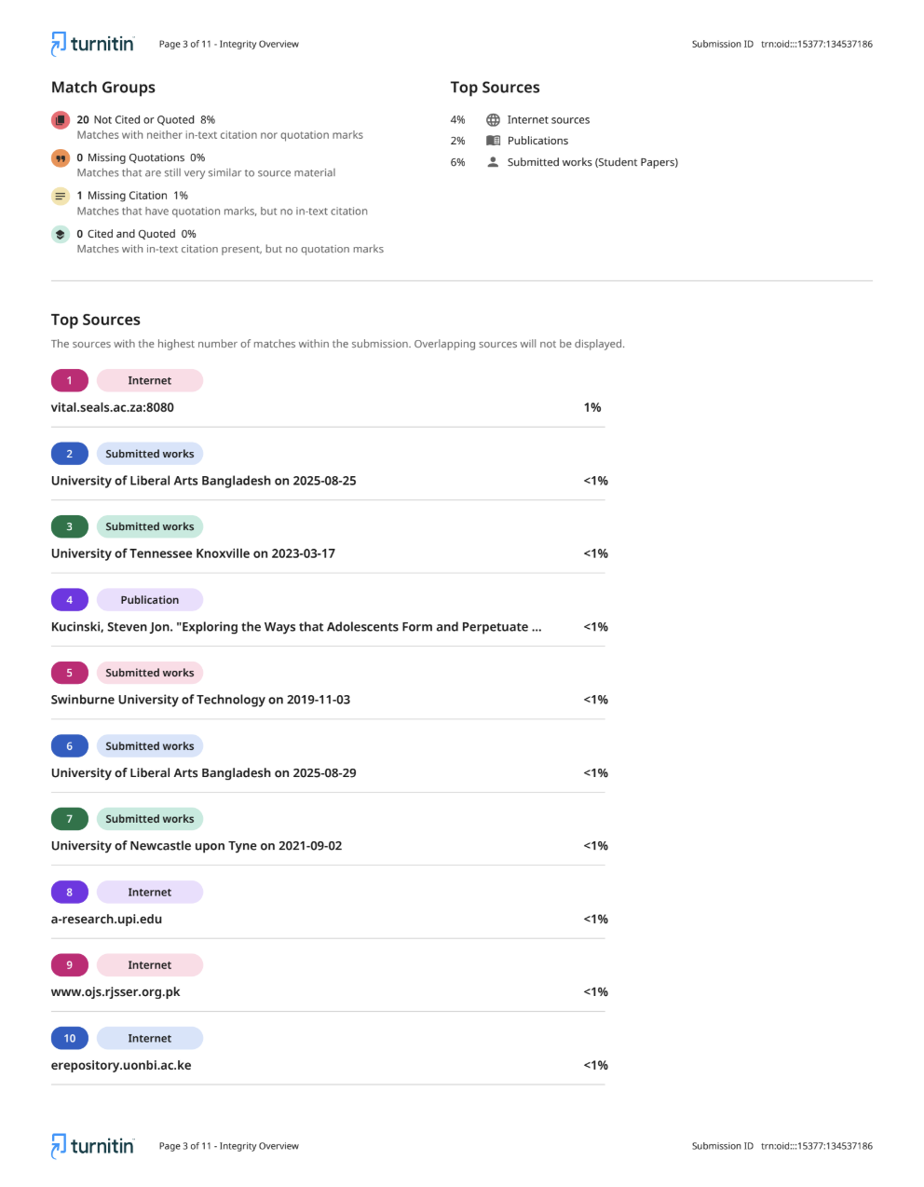

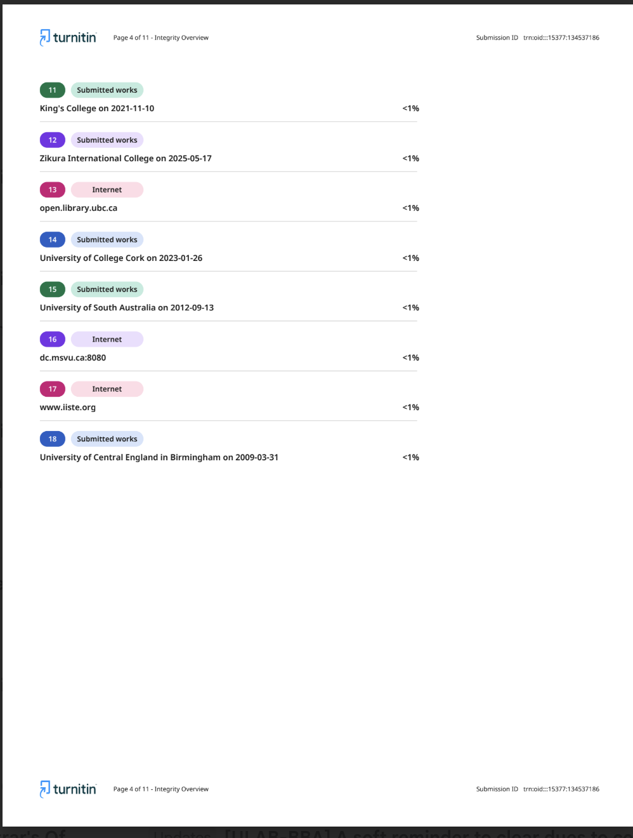

Research Instruments

https://forms.gle/xgJZH4vXmFetbNke9

Parents’/Guardians’ Preference of English Medium Coaching Centers: The Effect of Teacher Reputation and Word-of-Mouth Marketing

Target Respondents: Parents/Guardians of IGCSE O & A Level candidates

Section 1 of 3

1. What is your relationship with the student?/শিক্ষার্থীর সাথে আপনার সম্পর্ক কী?

Select any one option / যে কোন একটি অপশন সিলেক্ট করুন
- Parent/ বাবা/মা
- Sibling / ভাই/বোন
- Relative / আত্মীয়
- Other:

2. Have you played any role in enrollment of the student to this coaching center?/এই কোচিং সেন্টারে শিক্ষার্থীকে ভর্তি করানোর ব্যাপারে আপনার কোন ভূমিকা ছিলো কি?

Select any one option / যে কোন একটি অপশন সিলেক্ট করুন
- Yes / হ্যাঁ
- No / না

Section 2 of 3
Word-of-Mouth and other information sources

3. How long has your child been enrolled in the current coaching center?/ আপনার সন্তান কতদিন ধরে বর্তমান কোচিং সেন্টারে অধ্যয়ন করছে?

Select any one option / যে কোন একটি অপশন সিলেক্ট করুন
- Less than 3 months / ৩ মাস থেকে কম
- 3 to 6 months / ৩ থেকে ৬ মাস
- 6 to 9 months / ৬ থেকে ৯ মাস
- 9 to 12 months / ৯ মাস থেকে ১ বছর
- More than 12 months / এক বছরের বেশি
4. How did you first come to know about this English Medium coaching center?/আপনি প্রথম কীভাবে এই ইংরেজি মাধ্যম কোচিং সেন্টার সম্পর্কে জানতে পারেন?

Select multiple options if applicable / প্রযোজ্য অপশনগুলো সিলেক্ট করুন
- Friend or family / বন্ধু বা পরিবার
- Social media / সোশ্যাল মিডিয়া
- Advertisement / বিজ্ঞাপন
- School or teachers / স্কুল বা শিক্ষক
- Other:

10. Did you receive recommendations from relatives, friends, or other parents before selecting this coaching center? (কোচিং সেন্টার নির্বাচন করার আগে কি আপনি আত্মীয়, বন্ধু বা অন্য অভিভাবকদের কাছ থেকে কোনো পরামর্শ পেয়েছিলেন?)

Select any one option / যে কোন একটি অপশন সিলেক্ট করুন
- Yes / হ্যাঁ
- No / না

Section 3 of 3
Decision and Influences

5. What were the reasons you considered this coaching center for your child?/কোন কারণগুলো আপনাকে এই কোচিং সেন্টারটি বিবেচনা করতে উদ্বুদ্ধ করেছে?

Select multiple options if applicable / প্রযোজ্য অপশনগুলো সিলেক্ট করুন
- Reputation of the teachers / শিক্ষকদের সুনাম
- Recommendation from friends or relatives / বন্ধু বা আত্মীয়দের সুপারিশ
- Recommendation from other parents / অন্যান্য অভিভাবকদের পরামর্শ
- Previous success of students (good results) / পূর্ববর্তী শিক্ষার্থীদের ভালো ফলাফল
- Other:

6. If you have considered other institutions for enrollment, what factors influenced you to select this coaching center?/ আপনি যদি ভর্তির জন্য অন্যান্য প্রতিষ্ঠানও বিবেচনা করে থাকেন, তাহলে কোন বিষয়গুলো এই কোচিং সেন্টারকে বেছে নিতে প্রভাবিত করেছে?

Select multiple options if applicable / প্রযোজ্য অপশনগুলো সিলেক্ট করুন
- Better reputation of the teachers / শিক্ষকদের ভালো সুনাম
- Recommendations from friends, relatives, or other parents / বন্ধু, আত্মীয় বা অন্যান্য অভিভাবকদের সুপারিশ
- Better academic results of previous students / পূর্ববর্তী শিক্ষার্থীদের ভালো ফলাফল
- More convenient location and class schedule / সুবিধাজনক অবস্থান ও ক্লাসের সময়সূচি
- Other:

7. How important do you think is the reputation of teachers while selecting a coaching center?/কোচিং সেন্টার নির্বাচন করার ক্ষেত্রে শিক্ষকের সুনামকে আপনি কতটা গুরুত্বপূর্ণ? কেন?

Select any one option / যে কোন একটি অপশন সিলেক্ট করুন
- Insignificant / গুরুত্বহীন
- Somewhat significant / কিছুটা গুরুত্বপূর্ণ
- Significant / গুরুত্বপূর্ণ
- Highly significant / খুবই গুরুত্বপূর্ণ

8. Did your acquaintance with any teacher or official influence you to select this coaching center?/কোনো শিক্ষক বা কর্মকর্তার সাথে পূর্ব পরিচিতি আপনাকে এই কোচিং সেন্টার বেছে নিতে প্রভাবিত করেছে কি?

Select any one option / যে কোন একটি অপশন সিলেক্ট করুন
- Yes / হ্যাঁ
- No / না

9. What qualities of teachers do you find increasing the reputation of a coaching center?/আপনার মতে শিক্ষকদের কোন গুণাবলিগুলো একটি কোচিং সেন্টারের সুনাম বৃদ্ধি করে?

Select multiple options if applicable / প্রযোজ্য অপশনগুলো সিলেক্ট করুন
- Strong subject knowledge and expertise / বিষয়ভিত্তিক গভীর জ্ঞান ও দক্ষতা
- Ability to explain lessons clearly / পাঠ স্পষ্টভাবে বুঝিয়ে দেওয়ার দক্ষতা
- Consistent record of helping students achieve good results / শিক্ষার্থীদের ভালো ফলাফল অর্জনে সহায়তার ধারাবাহিকতা
- Supportive and approachable attitude towards students / শিক্ষার্থীদের প্রতি সহায়ক ও আন্তরিক আচরণ
- Other:

11. If you have received recommendations, then how much did those influence your decision to select this coaching center? (যদি সুপারিশ পেয়ে থাকেন, তবে সেগুলো এই কোচিং সেন্টারকে বেছে নেয়ার ক্ষেত্রে আপনাকে কতটা প্রভাবিত করেছে?)

Select any one option / যে কোন একটি অপশন সিলেক্ট করুন
- Didn't receive (কোন সূপারিশ পাইনি)
- Not at all (একেবারেই না)
- Very little (খুবই কম)
- To so some extent (কিছুটা)
- Significantly (বেশ খানিকটা)
- Very much (খুবই বেশি)

11. How much did these recommendations influence your final decision?/ এসব সুপারিশ আপনার চূড়ান্ত সিদ্ধান্তে কতটা প্রভাব ফেলেছে?

Select any one option / যে কোন একটি অপশন সিলেক্ট করুন
- Very much/ খুব বেশি
- Moderately/মাঝারি মাত্রায়
- Slightly/সামান্য
- Not at all/একেবারেই নয়
- Other:

12. Do you usually rely on others’ opinions when choosing educational institutions? Why or why not?/শিক্ষা প্রতিষ্ঠান নির্বাচনের ক্ষেত্রে আপনি কি সাধারণত অন্যদের মতামতের ওপর নির্ভর করেন? কেন বা কেন নয়?

- Yes / হ্যাঁ
- Sometimes / কখনও কখনও
- No / না
- Other:

13. What factors do you consider most important when choosing an English Medium coaching center?/একটি ইংরেজি মাধ্যম কোচিং সেন্টার নির্বাচন করার ক্ষেত্রে আপনি কোন বিষয়গুলোকে সবচেয়ে গুরুত্বপূর্ণ মনে করেন?

Select multiple options if applicable / প্রযোজ্য অপশনগুলো সিলেক্ট করুন
- Structured syllabus coverage and exam preparation/সিলেবাস অনুযায়ী নিয়মিত পড়ানো ও পরীক্ষার প্রস্তুতির ব্যবস্থা
- Small class size and individual attention/ছোট ক্লাস ও শিক্ষার্থীদের প্রতি ব্যক্তিগত মনোযোগ
- Regular assessments and progress monitoring/নিয়মিত পরীক্ষা ও শিক্ষার্থীদের অগ্রগতি পর্যবেক্ষণ
- Safe and comfortable learning environment/নিরাপদ ও আরামদায়ক শিক্ষার পরিবেশ
- Other:

14. In your opinion, what makes a coaching center trustworthy?/আপনার মতে, একটি কোচিং সেন্টারকে বিশ্বাসযোগ্য করে তোলে কোন বিষয়গুলো?

Select multiple options if applicable / প্রযোজ্য অপশনগুলো সিলেক্ট করুন
- Transparent communication with parents about student progress/শিক্ষার্থীর অগ্রগতি সম্পর্কে অভিভাবকদের সাথে স্বচ্ছ যোগাযোগ
- Professional and experienced teaching staff/দক্ষ ও অভিজ্ঞ শিক্ষকবৃন্দ
- Positive feedback from current or former students and parents/বর্তমান বা পূর্ববর্তী শিক্ষার্থী ও অভিভাবকদের ইতিবাচক মতামত
- Proper academic management and organized classes/সুশৃঙ্খল একাডেমিক ব্যবস্থাপনা ও নিয়মিত ক্লাস পরিচালনা
- Other:

15. Would you recommend this coaching center to others? Why or why not?/আপনি কি এই কোচিং সেন্টারটি অন্যদের কাছে সুপারিশ করবেন? কেন বা কেন নয়?

Select any one option / যে কোন একটি অপশন সিলেক্ট করুন
- Yes / হ্যাঁ
- Maybe / হয়তো
- No/না
- Other:

